A PROGRESSIVE WEB APPLICATION (PWA)-BASED HIGH-PRIORITY NOTIFICATION AND EVENT MANAGEMENT SYSTEM FOR PEÑARANDA BAND 1870



A CAPSTONE AND RESEARCH PROJECT

BY:
SIMON CHRISTIAN L. DE GUZMAN
JAKE MOISES A. MORALES
MARK PIOLO A. MORENTE
JOHN CHRISTOPHER G. PORTUGAL

APRIL 2026
A PROGRESSIVE WEB APPLICATION (PWA)-BASED HIGH-PRIORITY NOTIFICATION AND EVENT MANAGEMENT SYSTEM FOR PENARANDA BAND 1870

A Capstone and Research Project
Presented to the Faculty of
College of Information and Communications Technology
Cabanatuan City, Nueva Ecija

In Partial Fulfillment of the Requirements for the Degree
Bachelor of Science in Information Technology
With Specialization in Web Systems Technology

By:
Simon Christian L. De Guzman
Jake Moises A. Morales
Mark Piolo A. Morente
John Christopher G. Portugal

APRIL 2026


Republic of the Philippines
Nueva Ecija University of Science and Technology
College of Information and Communications Technology

E N D O R S E M E N T

This is to formally endorse the capstone and research project entitled “A Progressive Web Application (PWA)-Based High-Priority Notification and Event Management System for Peñaranda Band 1870,” prepared and submitted by Simon Christian L. De Guzman, Jake Moises A. Morales, Mark Piolo A. Morente, and John Christopher G. Portugal in partial fulfillment of the requirements for the degree of Bachelor of Science in Information Technology, with a specialization in Web Systems Technology. The undersigned hereby certifies that the project has been reviewed and is recommended for Capstone Proposal Defense.

System and Manuscript Readiness:

ROSE ANNE G. COCHANCO, MSIT
Capstone Adviser

Manuscript Review and Editing:

CRIS NORMAN P. OLIPAS, Ed.D.
Research Editor

Completeness of Deliverables:

CRIS NORMAL P. OLIPAS, Ed.D.
Faculty-in-Charge, ITCAP01-3F

TABLE OF CONTENTS

TITLE PAGE | i
ENDORSEMENT | ii
TABLE OF CONTENTS | iii
LIST OF TABLES | iv
LIST OF FIGURES | v
LIST OF APPENDICES | vi
CHAPTER I: THE PROBLEM AND ITS BACKGROUND | 1
Introduction | 1
Review of Related Literature | 2
Synthesis of Related Literature | 16
Conceptual Framework | 18
Statement of the Problem | 20
Scope and Limitation | 21
Significance of the Study | 22
Definition of Terms | 23
CHAPTER II: METHODOLOGY | 25
Research Design | 25
Research Locale | 25
Research Respondents | 27
Research Instrument | 28
Data Gathering Procedures | 29
Data Analysis Technique | 32
Ethical Considerations | 39
REFERENCES | 40
APPENDICES | 43

LIST OF TABLES

TABLE | TITLE | PAGE
1 | Distribution of Respondents | 27
2 | Interpretation for Notification Management | 34
3 | Interpretation for Event Scheduling and Tracking | 34
4 | Interpretation for User Roles and Access Control | 35
5 | Interpretation for System Responsiveness and Accessibility | 35
6 | Interpretation for Functional Suitability | 36
7 | Interpretation for Usability | 36
8 | Interpretation for Reliability. | 37
9 | Interpretation for Performance Efficiency | 37
10 | Interpretation for Security. | 38
11 | Interpretation for Accessibility Compliance | 38

LIST OF FIGURES

FIGURE | TITLE | PAGE
1 | Conceptual Framework of the SmartBand: A PWA-Based High-Priority Notification and Event Management System | 18
2 | Location of Peñaranda Band 1870 in Poblacion III, Peñaranda, Nueva Ecija | 26
3 | Flowchart of Data Gathering Procedure | 30

LIST OF APPENDICES

APPENDIX |  | PAGE
1 | Application Letter | 44
2 | Survey Questionnaire | 45
3 | Diagram | 49
4 |  | 50
5 |  | 51

Chapter 1
THE PROBLEM AND ITS BACKGROUND

Introduction
Peñaranda Band 1870, a community brass band situated in Peñaranda, Nueva Ecija, relies heavily on synchronized participation and coordination for its rehearsals and civic performances. However, the organization currently encounters significant communication challenges due to its primary reliance on informal group chat applications. In this unstructured setup, urgent announcements are frequently mixed with non-essential casual conversations, making it difficult for users to identify priority information. As a result, members sometimes miss rehearsals and scheduled activities. Compounding this issue is the absence of an acknowledgment mechanism; band officers have no reliable way to confirm whether members have actually received, read, or understood important announcements, which heavily disrupts overall coordination.
These local challenges reflect broader inefficiencies observed in unstructured digital communication. While messaging applications are highly accessible, they do not inherently ensure communication effectiveness. Information overload occurs when users receive excessive messages, causing them to overlook critical updates. Eppler and Mengis (2004) further explain that when messages are not properly prioritized, vital information becomes indistinguishable from routine communication. For organizations that depend on coordinated activities, Media Synchronicity Theory suggests that tasks demand communication systems capable of delivering timely and clear information. Moreover, Grudin (1994) highlights that formal acknowledgment mechanisms are necessary to ensure that messages are successfully received and understood by the intended participants.
Addressing these communication gaps not only improves organizational efficiency but also aligns with the United Nations Sustainable Development Goals (SDGs). Specifically, modernizing the band's communication infrastructure supports SDG 9 (Industry, Innovation, and Infrastructure) by fostering technological innovation and integrating resilient digital infrastructure at the community level. Additionally, it contributes to SDG 16 (Peace, Justice, and Strong Institutions) by promoting effective, accountable, and transparent organizational practices, ensuring that the band's leadership can disseminate information and track member participation reliably.
To resolve the persistent issues of missed notifications, information overload, and a lack of accountability, there is a clear need to transition from informal group chats to a dedicated, centralized platform capable of prioritizing announcements and tracking user acknowledgment. Therefore, this study aims to develop SmartBand, a Progressive Web Application (PWA)-based high-priority notification and event management system tailored specifically for Peñaranda Band 1870. The PWA approach was selected as the most appropriate technological solution because it offers seamless cross-platform accessibility, allowing band members to use the system on smartphones, tablets, or desktop computers without the friction of downloading and installing a native application. Furthermore, PWAs support app-like features such as push notifications and responsive design, ensuring that urgent rehearsal schedules and performance updates are immediately delivered and acknowledged, thereby establishing a structured and highly efficient communication ecosystem for the organization.

Review of Related Literature
The following review presents an extensive discussion of the related literature and studies that provide theoretical, conceptual, and practical foundations for developing a Progressive Web Application (PWA)-based high-priority notification and event management system. The literature includes scholarly books, empirical studies, and existing systems relevant to organizational communication, information systems, notification mechanisms, and digital accessibility.

Organizational Infrastructure and Information Systems
The integration of information systems into organizational operations has become a fundamental component in improving communication, coordination, and overall efficiency. Modern organizations increasingly rely on structured digital systems to facilitate the accurate and timely flow of information among members. According to Laudon and Laudon (2020), Management Information Systems (MIS) enable organizations to collect, process, store, and distribute information systematically, ensuring consistency and reliability. Furthermore, enterprise systems provide centralized platforms that unify communication and operational processes, eliminating fragmented information sources and ensuring that all members access the same data (Turban et al., 2021).
While large-scale enterprise systems are well-documented, the need for structured information systems in small, community-based organizations is equally critical. In community and volunteer settings, organizations that adopt structured web-based systems are better equipped to manage information flow and reduce operational inefficiencies. Transitioning to centralized web-based management platforms has been shown to significantly improve communication efficiency and reduce miscommunication among users compared to informal methods. For instance, the implementation of centralized event and notification platforms in local institutions streamlines scheduling and provides real-time access to information, allowing members to stay updated and participate more actively in organizational activities (Reyes et al., 2022). Empirical studies, such as the deployment of digital governance and coordination systems in the Philippines, further demonstrate that adopting centralized platforms improves efficiency, reduces delays, and enhances information consistency across user groups (Aspa et al., 2024).
Despite these advantages, organizations that rely solely on informal communication methods often experience inefficiencies, such as delayed information dissemination, misinterpretation of messages, and poor coordination (Bawden & Robinson, 2009). Without structured systems, communication becomes fragmented and unreliable. As Dennis et al. (2008) explain through Media Synchronicity Theory, effective communication systems must support both the transmission and the understanding of information; systems lacking structure and synchronization fail to deliver messages effectively, resulting in coordination issues.
For community-based groups like Peñaranda Band 1870, these principles highlight a significant operational gap. The organization's current reliance on informal communication channels, specifically group chats, lacks the synchronization and structure necessary for effective coordination. Because many existing enterprise systems are designed for large corporations and are often too complex or costly for smaller groups (Turban et al., 2021), there is a distinct need for a localized, user-friendly alternative. The development of a centralized web-based information system tailored to Peñaranda Band 1870 is expected to resolve these inefficiencies by organizing communication, prioritizing accessibility, and ultimately enhancing the coordination and participation of its members.

Challenges of Mobile Instant Messaging and Information Overload
The widespread adoption of mobile instant messaging applications has transformed communication in both personal and organizational contexts. Platforms such as WhatsApp, Facebook Messenger, and Telegram have become primary tools for information exchange due to their accessibility, real-time messaging capabilities, and ease of use. However, despite these advantages, numerous studies have identified significant limitations in their effectiveness for structured organizational communication.
One of the primary issues associated with mobile messaging platforms is the mixing of formal and informal communication. According to Joseph et al. (2025) , group chat environments often lack clear boundaries between official announcements and casual conversations, making it difficult for users to distinguish important information from non-essential messages. This blending of communication types reduces message visibility and increases the likelihood that critical information will be overlooked.
A major challenge arising from this communication structure is information overload. Bawden and Robinson (2009) define information overload as a condition in which individuals are exposed to excessive amounts of information, thereby reducing their ability to process and understand relevant content. This issue is particularly prevalent in messaging platforms where multiple conversations occur simultaneously. Supporting this, Eppler and Mengis (2004) explain that unstructured communication environments contribute to cognitive overload, leading to confusion, reduced productivity, and poor decision-making.
In addition, Iqbal and Horvitz (2010) found that poorly timed or excessive notifications can interrupt users and reduce productivity. When users experience constant interruptions, they tend to ignore or delay processing messages, which increases the risk of missing important updates. This behavior is further reinforced by notification fatigue, where users become desensitized to frequent alerts and begin to disregard them entirely. By implementing priority-based notifications, systems can effectively mitigate this fatigue by clearly differentiating message urgency, ensuring that only critical announcements capture immediate attention while non-essential alerts are minimized.
Another related concept is message flooding, the continuous influx of messages on communication platforms. Tang and Hew (2022) describe message flooding as a situation in which users receive an overwhelming number of notifications, leading to selective attention and reduced responsiveness. In organizational contexts, this leads to missed schedules, delayed responses, and poor coordination among members. Furthermore, frequent interruptions caused by messaging applications can disrupt concentration and reduce task efficiency (Guan & Plötz, 2017). This suggests that not only the quantity but also the timing and relevance of notifications play a critical role in communication effectiveness.
Another critical limitation of messaging platforms is the absence of structured prioritization mechanisms. Most messaging applications treat all messages equally, regardless of their importance. According to Sharp et al. (2007) , effective communication systems must prioritize important messages to ensure they capture user attention. Without prioritization, urgent announcements may become buried under less important messages, reducing their visibility and effectiveness.
In addition to prioritization issues, messaging platforms also lack accountability mechanisms. Salazar (2022) emphasizes that most messaging systems do not provide reliable methods to verify whether users have received or acknowledged messages. While some platforms offer “read receipts,” these features are often inconsistent and do not guarantee that users have understood the message. Grudin (1994) further supports this by stating that communication is only effective when there is confirmation of message receipt. Without acknowledgment mechanisms, organizations cannot ensure that important information has been successfully communicated to all members.
Real-world applications further illustrate these challenges. It is a widely reported observation that platforms such as WhatsApp and Facebook Messenger, while heavily used for group communication, are primarily designed for social interaction rather than structured organizational communication. Consequently, users commonly report that these systems lack features such as message categorization, prioritization, and tracking, which are essential for effective coordination.
Moreover, while platforms like Microsoft Teams and Slack offer better organization through channels and threads, it is widely observed that even these platforms can suffer from information overload when multiple conversations occur simultaneously, as unstructured communication environments contribute heavily to cognitive overload (Eppler & Mengis, 2004). Users may still miss important messages if they are not properly highlighted or prioritized.
In a case study of organizational communication in small businesses, reliance on messaging platforms led to inconsistent information dissemination and reduced coordination efficiency (Norman, 2013). The study concluded that structured communication systems are necessary to address these limitations. This pattern is particularly relevant to community-based organizations such as Peñaranda Band 1870.
In the context of Peñaranda Band 1870, the reliance on group chat platforms presents similar challenges. Important announcements are often mixed with casual conversations, leading to missed rehearsals and poor coordination. The absence of acknowledgment mechanisms further exacerbates the problem, as there is no way to confirm whether members have received critical information. Therefore, there is a clear need for a system that addresses these limitations by providing structured communication, prioritizing important messages, and ensuring message acknowledgment.

Effectiveness of Centralized Notification and Event Management Systems
Centralized notification and event management systems have been widely recognized as effective tools for improving communication, coordination, and operational efficiency within organizations. These systems provide a unified platform for organizing, prioritizing, and making information accessible to all users. According to Laudon and Laudon (2020), centralized systems function as a structured backbone, ensuring that members access consistent, up-to-date information, thereby reducing miscommunication and coordination issues.
Similarly, Turban et al. (2021) emphasize that centralized information systems integrate communication processes within organizations, enabling seamless interaction among users. By consolidating data into a single platform, these systems eliminate fragmented communication channels and improve decision-making. This structured approach is particularly important in organizations that rely on coordinating and scheduling activities. Event management systems, in particular, enhance organizational efficiency by integrating scheduling, notification, and tracking features. According to O’Brien and Marakas (2011), these systems streamline planning processes by providing real-time updates and centralized scheduling tools, ensuring participants are informed in a timely manner.
Several empirical studies support the effectiveness of centralized event management systems. For instance, a study by Reyes et al. (2022) focused on an Event Management System with SMS notification, which significantly improved communication efficiency and reduced delays in information dissemination. The system enabled users to receive timely updates and improved coordination among participants. In another study, the implementation of a Campus Activities Management System with SMS reminders demonstrated that automated notification systems increased attendance rates and improved participant engagement (Aspa et al., 2024). The study found that users were more likely to attend events when they received structured, timely reminders. Furthermore, Pieloor et al. (2025) noted that centralized event management platforms improve coordination by integrating scheduling, notifications, and user tracking into a single platform, effectively reducing inefficiencies.
In educational institutions, platforms such as Google Classroom and Moodle are widely utilized to manage communication and distribute information. These platforms provide structured channels for announcements, schedules, and updates, theoretically enhancing communication by providing a centralized space for interaction. Real-world applications further demonstrate this concept; Google Calendar and Microsoft Outlook are widely used to manage events, send invitations, and receive reminders.
While project management tools such as Trello, Asana, and Monday.com also incorporate tracking features, they present limitations for community groups. While they provide excellent visibility into tasks and deadlines, they are not strictly designed for the high-priority communication needs of a community band, often lacking advanced notification prioritization specifically tied to event attendance and immediate acknowledgment.
Despite the broad effectiveness of centralized systems, significant limitations remain regarding message triage. Most existing platforms do not provide mechanisms for prioritizing messages based on urgency. According to Sharp et al. (2007), prioritization is essential in communication systems to ensure that critical messages capture user attention; without it, important notifications may be overlooked. Additionally, while some systems provide basic notification features, they do not verify whether users have understood the information. Grudin (1994) emphasizes that communication systems must include mechanisms for acknowledging messages to ensure effective information exchange.
Theoretically, while centralized platforms significantly improve communication efficiency, systems lacking acknowledgment tracking and prioritization will still face ongoing coordination issues. Existing applications often allow users to access schedules and receive notifications but lack the advanced priority-based messaging necessary to guarantee message receipt.
Furthermore, advancements in web technologies have enabled the development of more accessible and scalable solutions. According to Biørn-Hansen et al. (2017), modern web-based systems provide flexibility, scalability, and ease of access, making them suitable for organizations of various sizes. For Peñaranda Band 1870, the absence of a centralized system results in reliance on group chat platforms, leading to severe inefficiencies. The implementation of a centralized, web-based notification and event management system is expected to address these issues by organizing communication, prioritizing important messages, and providing a structured platform for event management.
Overall, the literature indicates that centralized systems are effective in improving communication and coordination. However, existing systems lack the integration of key features such as priority-based notification paired with acknowledgment tracking. This gap highlights the need for a specialized system that combines these features into a single, accessible platform.

Notification Systems and Acknowledgment Mechanisms
Notification systems are crucial in modern communication technologies, particularly in environments that require the timely dissemination of information and coordinated action among users. A notification system is a mechanism that delivers alerts, messages, or updates to users based on specific events or triggers. According to Sharp et al. (2007), effective notification systems must be designed to capture user attention while minimizing disruption. They emphasize that notifications should be relevant, timely, and prioritized to ensure that users respond appropriately.
In organizational settings, notification systems are essential for ensuring that important information reaches all members. Laudon and Laudon (2020) explain that communication systems must support both the delivery and visibility of information to ensure effective coordination. Without proper notification mechanisms, critical updates may be delayed or overlooked, leading to inefficiencies in organizational processes.
One of the key challenges in notification systems is ensuring that users do not ignore or overlook important messages. Iqbal and Horvitz (2010) found that poorly timed or excessive notifications can interrupt users and reduce productivity. Their study highlights the importance of designing notification systems that balance visibility and user control. Notifications must be delivered at appropriate times and must clearly indicate their level of importance.
Another important concept in notification system design is notification prioritization. According to Mehrotra and Musolesi (2017), intelligent notification systems that prioritize messages based on context and urgency are more effective than systems that treat all notifications equally. Prioritization ensures that critical messages receive immediate attention, while less important messages can be deferred.
Despite advancements in notification systems, many existing platforms lack effective prioritization mechanisms. For example, messaging applications such as WhatsApp and Facebook Messenger deliver notifications in real time but do not differentiate between urgent and non-urgent messages. As a result, important announcements may be buried under less relevant messages, reducing their visibility and impact.
In addition to prioritization, acknowledgment mechanisms are essential to ensuring effective communication. Grudin (1994) emphasizes that communication is only successful when the receiver confirms receipt of the message. Without acknowledgment, there is no guarantee that the message has been received, understood, or acted upon.
This concept is further supported by Dennis et al. (2008) through Media Synchronicity Theory, which states that effective communication requires both transmission and convergence. Transmission refers to the delivery of information, while convergence refers to the shared understanding among participants. Acknowledgment mechanisms facilitate convergence by confirming that messages have been received and understood.
In practical applications, acknowledgment mechanisms are implemented in various forms. For instance, read receipts in messaging platforms such as WhatsApp and Messenger indicate whether a message has been viewed. However, these features are limited and do not provide comprehensive tracking or verification of user understanding. According to Sharp et al. (2007) , acknowledgment systems should go beyond simple read indicators and provide mechanisms for confirming user engagement and response.
Empirical evidence from modern management platforms demonstrates that integrating automated notifications with clear user engagement features significantly increases participation and attendance rates (Aspa et al., 2024). Furthermore, Iqbal and Horvitz (2010) suggest that users are more likely to engage with and process notifications when the system design clearly defines the expected response, preventing important messages from being ignored.
Another critical aspect of notification systems is user interface design. According to Norman (2013), effective design must clearly communicate the importance of notifications through visual cues such as color, size, and placement. High-priority notifications should be visually distinct to immediately capture user attention.
Modern systems have begun to incorporate advanced notification features. For example, Slack allows users to customize notification settings and prioritize messages through mentions and alerts. Similarly, Microsoft Teams provides notification management features that allow users to filter and prioritize messages. However, these systems still rely heavily on user configuration and may not fully address message prioritization automatically.
Another emerging trend is the use of push notification systems in web and mobile applications. As outlined in practitioner guidelines by Google Developers (2020), push notifications enable systems to deliver real-time updates even when the application is not actively in use. This technical capability is strongly supported by peer-reviewed research on Progressive Web Applications (PWAs); for instance, Biørn-Hansen et al. (2017) note that PWA technologies provide robust real-time communication features and offline functionality across devices, making them highly suitable for immediate, high-priority organizational communication.
However, push notification systems also present challenges. Boffi (2025) notes that excessive push notifications can lead to user fatigue and reduced engagement. Therefore, it is essential to design notification systems that balance frequency and relevance.
In the context of organizational communication, integrating notification and acknowledgment mechanisms is critical. Systems that combine these features provide a more reliable and effective communication framework. According to Sharp et al. (2007) , effective systems must ensure not only that messages are delivered but also that users respond appropriately.
In the case of Peñaranda Band 1870, the absence of structured notification and acknowledgment mechanisms results in communication gaps. Important announcements may be overlooked, and there is no way to verify whether members have received or acknowledged messages. This leads to missed rehearsals, poor coordination, and reduced participation.
Therefore, there is a need for a system that integrates priority-based notification and acknowledgment tracking into a single platform. Such a system would ensure that important messages are clearly distinguished, delivered in real time, and confirmed by users. This would significantly improve communication efficiency and coordination within the organization.

Digital Accessibility and Progressive Web Applications
Digital accessibility has become an essential consideration in the development of modern information systems, particularly those intended for diverse user groups. Accessibility ensures that systems can be used effectively by individuals with varying abilities, devices, and levels of technological proficiency. According to the World Wide Web Consortium (W3C, 2025), accessibility refers to the design of web content that is perceivable, operable, understandable, and robust for all users. These principles are formalized in the Web Content Accessibility Guidelines (WCAG), which serve as the global standard for accessible web design.
The importance of accessibility is further emphasized by the Department of Information and Communications Technology (DICT, 2022), which highlights that digital systems must be inclusive and usable across different platforms and user conditions. In developing countries, accessibility is particularly critical due to variations in device capabilities, internet connectivity, and user experience levels. Mehrotra and Musolesi (2017) explain that accessible systems improve usability not only for individuals with disabilities but also for all users. They argue that designing for accessibility leads to better overall user experience, as systems become easier to navigate, understand, and operate.
One of the major challenges in system development is ensuring that applications are accessible across different devices and platforms. Traditional native applications often require installation and are limited to specific operating systems, which may restrict accessibility. In contrast, web-based systems offer greater flexibility but may lack advanced features such as offline access and push notifications.
To address these limitations, Progressive Web Applications (PWAs) have emerged as a hybrid solution that combines the advantages of web and mobile applications. According to Biørn-Hansen et al. (2017), PWAs offer features such as offline functionality, fast load times, and responsive design, making them highly accessible across devices. These applications can be accessed through web browsers without requiring installation, reducing barriers to entry for users. Google Developers (2020) further explains that PWAs support push notifications, enabling real-time communication even when the application is not actively open. This feature is particularly important for systems that rely on timely information dissemination, such as notification and event management systems.
In addition, Biørn-Hansen et al. (2017) note that PWAs offer significant advantages in terms of cost efficiency and cross-platform compatibility. Their research shows that PWAs reduce development and maintenance costs while maintaining performance comparable to native applications, making them highly suitable for organizations with limited resources. PWAs also support responsive design, ensuring applications adapt to different screen sizes and devices. According to Iqbal and Horvitz (2010), responsive design is essential for creating flexible, user-friendly interfaces that provide a consistent experience across devices.
Several well-documented industry case studies demonstrate the effectiveness of PWAs in real-world applications. According to verified industry reports by Google Developers (2020), Twitter Lite, a PWA version of Twitter, was developed to improve accessibility and performance in areas with limited connectivity, successfully reducing data usage and improving user engagement. Similarly, Google Developers (2020) highlights that Alibaba implemented a PWA that resulted in increased user engagement and improved performance compared to its native application, leading to a significant increase in conversion rates. Another case study cited is Pinterest, which adopted PWA technology to enhance the user experience; the implementation resulted in faster loading times and increased user interaction, proving the effectiveness of PWAs in improving overall accessibility and engagement.
In addition to accessibility, PWAs support push notification systems, which are essential for real-time communication. According to Sharp et al. (2007), push notifications enable systems to deliver timely updates and alerts, ensuring that users receive important information immediately. However, the effectiveness of push notifications depends on proper design and implementation. Mehrotra and Musolesi (2017) emphasize that excessive notifications can lead to user fatigue, reducing engagement and responsiveness. Therefore, systems must balance notification frequency and relevance to maintain effectiveness.
Accessibility is also closely linked to usability. According to the ISO/IEC 25010:2023 Software Quality Standards, usability refers to the extent to which a system can be used effectively, efficiently, and satisfactorily by users. Accessible systems enhance usability by enabling users to interact with the system without difficulty. The integration of WCAG principles into system design ensures that applications are inclusive and user-friendly. For example, ensuring that text is readable, interfaces are navigable, and content is understandable improves the overall user experience.
In organizational systems, accessibility is crucial to ensuring that all members can effectively use the system. This is particularly important in community-based organizations where users may have varying levels of technological proficiency. For Peñaranda Band 1870, adopting a PWA-based system offers several advantages. First, it ensures accessibility across devices, allowing members to use the system on smartphones, tablets, or computers. Second, it eliminates the need for installation, making it easier for users to adopt the system. Third, it supports push notifications, enabling real-time communication of important announcements.
Furthermore, integrating WCAG principles into the system design ensures that the application is user-friendly and accessible to all members. This includes designing clear interfaces, ensuring readability, and providing intuitive navigation. Despite the advantages of PWAs, challenges remain in ensuring optimal performance and user engagement. According to Biørn-Hansen et al. (2017), developers must carefully design PWAs to ensure compatibility and reliability across different devices.
Nevertheless, the benefits of PWAs outweigh their limitations, particularly in applications that require accessibility, real-time communication, and cross-platform compatibility. In summary, the literature highlights that accessibility and PWA technology play a critical role in the development of modern communication systems. By combining accessibility principles with advanced web technologies, organizations can develop systems that are inclusive, efficient, and effective.
In the context of this study, the use of a PWA-based system ensures that SmartBand is accessible, responsive, and capable of delivering real-time notifications. This aligns perfectly with the objective of improving communication and coordination within Peñaranda Band 1870.

Synthesis
The reviewed literature presents a comprehensive understanding of the role of information systems, communication platforms, notification mechanisms, and web technologies in improving organizational coordination and communication efficiency. Across the different studies, several consistent themes emerge, highlighting both the strengths and limitations of existing systems.
First, the literature strongly supports the importance of structured information systems in organizational environments. Studies by Laudon and Laudon (2020), O’Brien and Marakas (2011), and Turban et al. (2021) consistently emphasize that centralized systems improve communication by organizing information, reducing fragmentation, and ensuring that all members have access to consistent and reliable data. These systems enhance coordination and decision-making by providing a unified platform for communication.
However, despite the availability of digital communication tools, several studies highlight the limitations of informal messaging platforms. Research by Salazar (2022), Bawden and Robinson (2009), and Iqbal and Horvitz (2010) reveals that messaging applications often lead to information overload, message flooding, and reduced communication effectiveness. These platforms lack structure, making it difficult for users to distinguish important messages from routine communication. As a result, critical information is often overlooked, leading to missed schedules and poor coordination.
Furthermore, studies on centralized notification and event management systems demonstrate their effectiveness in addressing communication challenges. Systems such as Google Calendar, Moodle, and Trello provide structured platforms that improve coordination by integrating scheduling and notification features. Empirical studies (Reyes et al., 2022; Pieloor et al., 2025) confirm that centralized systems enhance communication efficiency, increase participation, and reduce delays in information dissemination.
Despite these advantages, existing systems still exhibit several limitations. Most platforms lack prioritization mechanisms, which are essential for distinguishing urgent messages from routine communication. According to Sharp et al. (2007), prioritization is critical in ensuring that important messages capture user attention. Without this feature, even centralized systems may fail to deliver critical information effectively.
In addition, the absence of acknowledgment mechanisms remains a significant gap in existing systems. Grudin (1994) and Dennis et al. (2008) emphasize that communication is only effective when message receipt is confirmed. While some messaging platforms provide basic read receipts, these features are limited and do not guarantee user understanding or engagement. Empirical evidence, such as the deployment of automated notification systems by Aspa et al. (2024), demonstrates that integrating structured engagement tracking improves accountability and coordination.
Moreover, the literature highlights the importance of accessibility and usability in system adoption. The integration of the World Wide Web Consortium (W3C, 2025) guidelines ensures that systems are usable by individuals with diverse abilities. At the same time, Progressive Web Applications (PWAs) offer a practical solution to improve accessibility and performance. Studies by Biørn-Hansen et al. (2017) show that PWAs offer cross-platform compatibility, offline functionality, and real-time notification capabilities, making them highly suitable for community-based organizations.
Although numerous studies have explored communication systems, a specific literature gap exists regarding the synthesis of these distinct features into a singular tool. For instance, while Reyes et al. (2022) and Aspa et al. (2024) successfully developed centralized event management platforms, their studies reveal systems that lack priority-based message triage. Existing solutions are highly fragmented: they function strictly as unprioritized scheduling calendars (e.g., Google Calendar), unstructured messaging hubs (e.g., Messenger), or enterprise-grade task managers that are too complex and costly for community groups.
Table 1 summarizes how the existing related systems compare against the proposed SmartBand system across the key features this study identifies as critical gaps.
Table 1.
Comparison of Existing Related Systems and the Proposed SmartBand System
System / Study | Key Features (per this study's RRL) | Priority-Based Message Triage | Acknowledgment / Receipt Tracking | Identified Gap
Event Management System with SMS Notification (Reyes et al., 2022) | Sends SMS-based event updates; improved communication efficiency and reduced delays in information dissemination for a community foundation | Not reported | Not reported | Notifies users but does not distinguish urgent vs. routine messages, and does not confirm whether members actually received or understood them
Campus Activities Management System with SMS Reminders (Aspa et al., 2024) | Automated SMS reminders for campus events; shown to increase attendance rates and participant engagement | Not reported | Not reported | Improves attendance through reminders alone, but has no mechanism to flag high-priority announcements or verify acknowledgment
Centralized Event Management Platform for Continuing Education (Pieloor et al., 2025) | Integrates scheduling, notifications, and user tracking into a single platform for institutional coordination | Not reported | Partial — general “user tracking” mentioned, not specific receipt confirmation | Centralizes logistics but does not implement urgency-based prioritization of messages
Development of Events Management System (Joseph et al., 2025) | Cited in this study for its finding that group chats blur official announcements with casual conversation, reducing message visibility | Not specified in available literature | Not specified in available literature | Feature set not detailed in this study's review; verify directly with the source before citing feature-level comparisons
SmartBand (Proposed System) | PWA-based platform combining event scheduling, Web Push notifications with acoustic call-time siren, priority-based message triage, weekly availability management, dedicated accepted events tracking, privacy-protected member master roster, minimal pure-white PDF reporting with official band logo, and acknowledgment tracking; installation-free and cross-platform via PWA architecture. | Yes — core feature | Yes — core feature | Synthesizes scheduling, triage, and receipt verification into one accessible platform, addressing the gaps identified above

As shown in Table 1, none of the reviewed systems combine priority-based message triage with acknowledgment tracking in a single accessible platform—the specific gap SmartBand is designed to address.
This fragmentation highlights the unique value of the proposed system. Unlike existing event management tools, SmartBand uniquely synthesizes three critical components—event scheduling, message triage, and receipt verification—into a single, highly accessible Progressive Web Application (PWA). Specifically, the gap in message triage is addressed by SmartBand’s priority-based notification feature, which visually and functionally distinguishes urgent updates from routine chatter. The gap in communication convergence (Dennis et al., 2008) is addressed by the explicit acknowledgment tracking mechanism, allowing band officers to monitor exactly who has received and confirmed the schedule. Finally, the gap in inclusive deployment is addressed by the PWA architecture and WCAG compliance, ensuring cross-platform accessibility without the friction of app installation. Through this synthesis, SmartBand provides a targeted, comprehensive, and unique solution tailored to the specific communication and coordination challenges of Peñaranda Band 1870.

Conceptual Framework
The conceptual framework of this study models both the theoretical variables and the systematic methodological execution required to address the communication and coordination challenges of Peñaranda Band 1870. Grounded in system development principles and supported by relevant literature, the framework outlines the direct relationships between the existing organizational problems, the required system features, the iterative development process, and the expected outcomes.
To satisfy the academic modeling of these variables, an Input-Process-Output (IPO) model is utilized to define the boundaries of the study, while a comprehensive process framework illustrates the exact developmental and evaluative lifecycle of the proposed web-based application.

Figure 1.
Conceptual Framework of the SmartBand: A PWA-Based High-Priority Notification and Event Management System
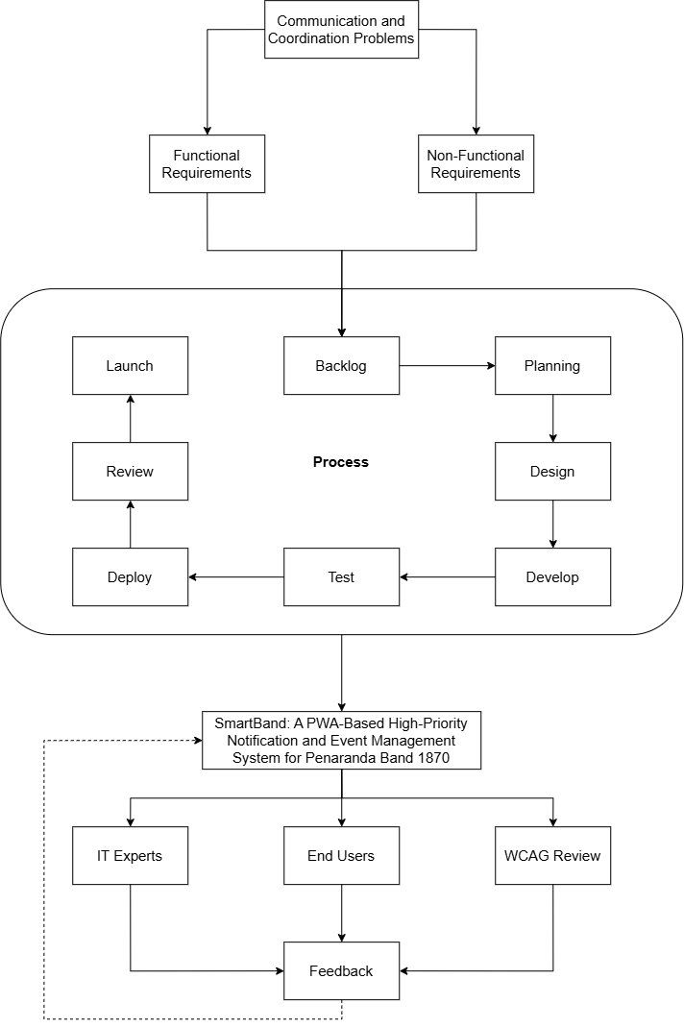

As illustrated in Figure 1, the systematic process initiates with the identification of existing Communication and Coordination Problems within the organization, specifically missed announcements, delayed notifications, message overload in group chats, lack of acknowledgment tracking, and poor event coordination. The synthesis of these operational deficiencies establishes the System Requirements. These are formally categorized into Functional Requirements (high-priority notifications, push notifications, event scheduling, acknowledgment tracking, and user role management) and Non-Functional Requirements (accessibility, reliability, security, performance efficiency, and compatibility).
To construct the solution, the framework employs the Agile Scrum Development Process. Rather than utilizing a rigid, linear methodology, this iterative approach begins with Backlog Grooming to prioritize the system requirements. The development then proceeds through continuous execution cycles comprising Sprint Planning, Design, Develop, Test, Deploy, and Review phases. Upon the successful completion of a sprint cycle, the phase concludes with the Launch of the application.
The culmination of this developmental phase is the SmartBand System, a fully functional Progressive Web Application (PWA)-Based High-Priority Notification and Event Management System. Following its deployment, the application undergoes a rigorous System Evaluation phase divided into three distinct domains. First, an IT Experts Evaluation is conducted to assess technical compliance based on the ISO/IEC 25010:2023 Software Quality Standards. Second, an End Users Evaluation is administered to measure the system's Functional Suitability, Performance Efficiency, Interaction Capability, and Reliability based on the selected ISO/IEC 25010:2023 Software Quality Characteristics, capturing practical usability and overall user experience from the members' perspective. Third, a strict WCAG Accessibility Evaluation is performed to ensure the system is inclusive for all users, specifically assessing if the application's interface and information are Perceivable, Operable, Understandable, and Robust.
A critical component of this framework is the Feedback Synthesis mechanism. Evaluation results from the IT experts, end-users, and accessibility checks are systematically categorized into functional and non-functional deficiencies. These identified issues are subsequently logged as backlog items and prioritized in subsequent Agile sprints for continuous system refinement. This iterative feedback loop guarantees that the final deployment achieves the ultimate objectives of the study: improved communication, improved coordination, efficient notification delivery, and reliable acknowledgment tracking.

Statement of the Problem
This study aims to design, develop, and evaluate a Progressive Web Application (PWA)-Based High-Priority Notification and Event Management System for Peñaranda Band 1870.
Specifically, this study seeks to answer the following questions:
- What communication and coordination challenges do the members of Peñaranda Band 1870 currently experience with their existing informal messaging platforms?
- How do IT experts assess the technical quality of the Progressive Web Application (PWA)-Based High-Priority Notification and Event Management System for Peñaranda Band 1870 based on the ISO/IEC 25010:2023 Software Quality Standards in terms of:
  - Functional Suitability;
  - Performance Efficiency;
  - Compatibility;
  - Interaction Capability;
  - Reliability;
  - Security;
  - Maintainability;
  - Flexibility; and
  - Safety?
- How do the end-users assess the Progressive Web Application (PWA)-Based High-Priority Notification and Event Management System for Peñaranda Band 1870 based on the selected ISO/IEC 25010:2023 Software Quality Characteristics in terms of:
  - Functional Suitability;
  - Performance Efficiency;
  - Interaction Capability; and
  - Reliability?
- How may the system’s accessibility be evaluated by IT experts and end-users based on established accessibility principles, in terms of:
  - Perceivable;
  - Operable;
  - Understandable; and
  - Robust?

Scope and Delimitations
This study focuses on the development and evaluation of a web-based high-priority notification and event management system for Peñaranda Band 1870 located in Peñaranda, Nueva Ecija. The system is designed to provide a centralized platform for sending announcements, delivering notifications, tracking message acknowledgment, and managing scheduled rehearsals and events.
The respondents in the study comprise a total of ninety-eight (98) individuals. This includes all ninety-three (93) registered members of the organization—employing complete enumeration sampling for the band—alongside five (5) selected IT experts, ensuring full representation and an accurate, multi-faceted evaluation of the developed system.
The study covers two major components: (1) identification of communication and coordination problems in the existing method, and (2) evaluation of the developed system based on the ISO/IEC 25010:2023 software quality standards, specifically in terms of functional suitability, performance efficiency, compatibility, interaction capability, reliability, security, maintainability, flexibility, and safety.
The evaluation of the system is based on user feedback gathered after system implementation and testing within the organization.
However, the study is limited to the functionality of the developed system and does not include financial management, instrument inventory monitoring, biometric attendance systems, or integration with external social media platforms. The study also does not measure musical performance, skill development, or behavioral changes of members beyond communication and coordination efficiency.
Furthermore, the system is developed specifically for Peñaranda Band 1870 and is not intended to be generalized for all organizations without further modification and testing. However, while developed explicitly for this group, the system's architecture and foundational features may serve as a replicable model for similar community-based organizations seeking to modernize their communication and coordination infrastructure.
Significance of the Study
The development of the SmartBand Progressive Web Application (PWA)-based high-priority notification and event management system is expected to benefit several specific groups by fundamentally improving communication efficiency and organizational coordination within Peñaranda Band 1870.
Band Members. The system will help members—including instrumental musicians and auxiliary performers such as Majorettes and Color Guard / Flag members—receive clear, timely announcements regarding rehearsals, performances, and schedule changes. Specifically, through the push notification and message prioritization features, members are immediately alerted to urgent updates with synthesized call-time sirens, significantly reducing the likelihood of critical information being buried or missed. Furthermore, the centralized event calendar and dedicated accepted events view allow members to easily track upcoming activities, while access to a read-only master roster lets members view the band lineup while keeping personal contact details private.
Band Officers and Leaders. Officers will benefit from a dedicated, reliable platform for disseminating official announcements. By utilizing the system's acknowledgment tracking feature, officers can explicitly verify message receipt and confirm member attendance, effectively eliminating the need to repeatedly send manual follow-up reminders in unstructured group chats. Additionally, the event management dashboard streamlines the scheduling process, while the one-click PDF reporting module allows officers to instantly generate minimal, official attendance sheets, past gig histories, and rosters branded with the Peñaranda Band 1870 crest logo.
Peñaranda Band 1870 Organization. The organization as a whole will gain a structured digital infrastructure. By consolidating event scheduling, prioritized announcements, and confirmation tracking into a single PWA platform, the system establishes a reliable "single source of truth." This technological integration minimizes miscommunication, improves attendance rates, and streamlines event preparation, thereby enhancing the band's overall operational efficiency and organizational reliability.
Academic and IT Communities. This study contributes significantly to the existing body of technical knowledge regarding the deployment of Progressive Web Applications (PWAs) in small, non-profit, or community-based organizations. By synthesizing priority-based notification routing with structured acknowledgment tracking in a highly accessible web environment, this project provides a replicable technical blueprint for resolving informal communication inefficiencies (such as group chat information overload) without requiring costly enterprise-level software or the friction of native application installations.
Future Researchers. This study will serve as a foundational reference for future researchers developing PWA-based notification mechanisms, organizational management platforms, or specialized communication tools for small community groups. The technical framework, system architecture, and empirical evaluation metrics documented in this research will provide baseline data for further improving structured coordination systems and digital accessibility features in similar grassroots institutions.

Definition of Terms
The following terms are defined both conceptually and operationally as used in this study:
Acknowledgment Tracking. A feature in communication systems that verifies and records whether a specific message has been successfully received and processed by intended users (Sharp et al., 2007; Grudin, 1994). In this study, it refers to the SmartBand system function that records and displays whether a band member has viewed and explicitly confirmed receipt of an announcement.
Administrator. A user who manages system operations, including user accounts and content control (Laudon & Laudon, 2020). In this study, the authorized band officer refers to the person who manages announcements, schedules, and system users.
Announcement. A formal communication used to inform members about organizational activities or updates (Robbins & Judge, 2017). In this study, it refers to official messages sent through the system regarding rehearsals, performances, and events.
Centralized Scheduling. A system that organizes and manages events within a single platform to improve coordination (Laudon & Laudon, 2020). In this study, the term refers to the calendar feature that displays and manages all band activities.
Coordination. The process of organizing group activities to achieve common goals efficiently (Robbins & Judge, 2017). In this study, it refers to band members' organized participation in rehearsals and events.
Event Management System. A system used to organize, schedule, and manage events within an organization (Laudon & Laudon, 2020). In this study, it refers to the feature that allows administrators to create and manage rehearsal and performance schedules.
High-Priority Notification. A notification that is marked as urgent and designed to capture immediate user attention (Preece et al., 2015). In this study, system alerts are visually and functionally distinguished to emphasize important announcements.
Information Dissemination. The process of distributing information to a group of people (Robbins & Judge, 2017). In this study, it refers to how announcements are delivered to band members.
Interaction Capability. The degree to which a system provides user interfaces that enable users to interact effectively, efficiently, and with satisfaction (ISO/IEC 25010:2023). In this study, this term replaces the traditional construct of 'usability' and refers to how intuitively members and officers can learn, navigate, and operate the SmartBand system functions.
Member. An individual who belongs to an organization and participates in its activities (Robbins & Judge, 2017). In this study, it refers to registered members of Peñaranda Band 1870 who receive notifications and interact with the system.
Notification System. A system that delivers messages or alerts to users to inform them of updates or events (Preece et al., 2015). In this study, it refers to the feature that sends announcements and alerts to band members through the web application.
Progressive Web Application (PWA). A web application that provides app-like features such as offline access and push notifications (DICT, 2022). In this study, the SmartBand system is designed to function across devices without installation.
Push Notification. A message sent from a system to a user’s device to provide real-time updates (Preece et al., 2015). In this study, it refers to alerts sent by the SmartBand system to notify members of announcements.
Software Quality. The degree to which a system meets specified requirements and user expectations (ISO/IEC 25010:2023). In this study, the term refers to the evaluation of the system against ISO 25010 criteria.
System Acceptability. The overall assessment of whether a system is practically and socially acceptable to satisfy the needs and requirements of its stakeholders (Nielsen, 1993). In this study, it refers to the respondents’ collective approval and validation of the SmartBand system based on their evaluation of its software quality characteristics, rather than just the evaluation process itself.
System User. An individual who interacts with a system to perform tasks (Laudon & Laudon, 2020). In this study, it refers to both administrators and members who use the system.
Web-Based System. A system that operates through a web browser without requiring installation on a device (Laudon & Laudon, 2020). In this study, it refers to the SmartBand system accessed via internet browsers.
Chapter 2
METHODOLOGY
This chapter presents the research design, locale, respondents, instruments, data gathering procedures, data analysis techniques, and ethical considerations of the study.

Research Design
This study employs a descriptive-developmental research design. The descriptive method is utilized to identify and analyze the existing communication and coordination problems experienced by the organization. Specifically, it examines operational issues such as missed announcements, delayed information dissemination, lack of acknowledgment, and difficulty in tracking schedules. To achieve this, primary data regarding communication inefficiencies and user needs are collected directly from the ninety-three (93) active band members and officers, alongside five (5) IT experts, comprising a total of ninety-eight (98) respondents through structured assessment instruments
The descriptive phase identifies existing communication challenges, which directly inform the functional and non-functional requirements addressed in the developmental phase. For instance, the identified prevalence of missed messages directly dictates the requirement for push notifications and acknowledgment tracking in the proposed solution. The developmental method is subsequently applied in the actual design, creation, and evaluation of the web-based high-priority notification and event management system. According to Richey and Klein (2014), developmental research focuses on the systematic process of designing, developing, and evaluating technological solutions to accurately address real-world problems.
This combined research design is highly appropriate for the study because it not only investigates the current organizational challenges but also provides a systematic framework to build, refine, and validate a practical technological solution. It seamlessly links the problem identification to system creation by following a structured Agile Scrum development process, which encompasses requirement gathering, iterative system design, development, testing, and deployment of the SmartBand Progressive Web Application (PWA).
Furthermore, to fully justify the developmental design, the process culminates in a rigorous evaluation phase. The developed system is evaluated by IT experts and end-users using the updated ISO/IEC 25010:2023 software quality standards. This ensures the system's technical and practical acceptability is comprehensively assessed in terms of functional suitability, performance efficiency, compatibility, interaction capability, reliability, security, maintainability, flexibility, and safety.

Research Locale
The study will be conducted in Poblacion III, Peñaranda, Nueva Ecija, which serves as the primary operational base for Peñaranda Band 1870. As illustrated in Figure 2, this specific locality is where the organization regularly convenes for rehearsals, meetings, and civic performances. The band operates within a concentrated community setting, with members residing within or near the area to enable regular participation. This locale is purposefully selected because it encapsulates the exact organizational environment where the previously discussed communication and coordination inefficiencies occur. Implementing the SmartBand system directly within this specific setting ensures that the proposed solution is designed to address the actual logistical realities of the community group.

Figure 2.
Location of Peñaranda Band 1870 in Poblacion III, Peñaranda, Nueva Ecija
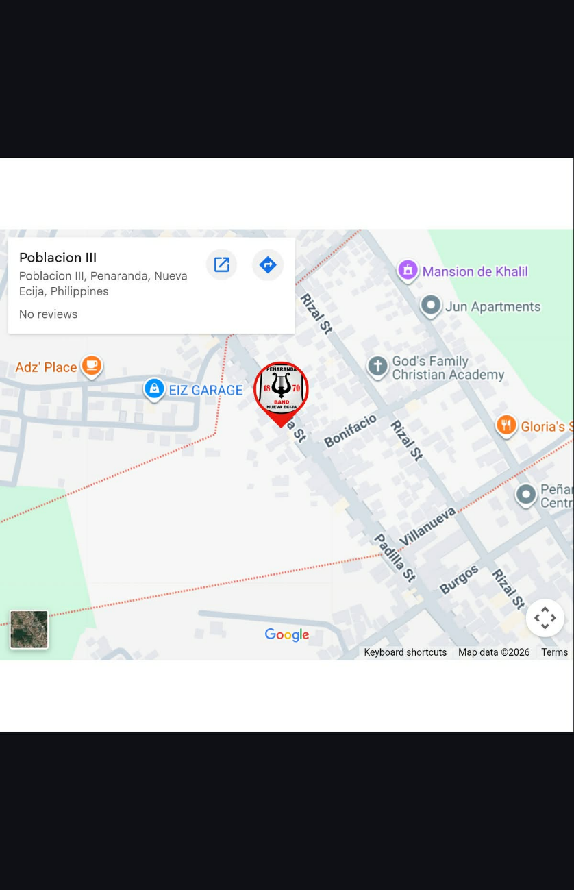
As shown in Figure 2, Peñaranda Band 1870 is situated in Poblacion III, Peñaranda, Nueva Ecija, Philippines. The area is characterized by a community-based environment, with members residing within or near the locality, enabling regular participation in organizational activities. The location's accessibility makes it a practical setting for implementing and testing the proposed system.
The selection of this locale is based on the communication and coordination challenges the organization currently faces. The reliance on group chat platforms may lead to information overload, with important announcements often mixed with non-essential conversations. In addition, the absence of a centralized communication system and acknowledgment mechanism may lead to missed notifications, delayed responses, and inconsistencies in attendance during rehearsals and events. These conditions make the locale appropriate for examining the potential effectiveness of a high-priority notification and event management system.
Furthermore, conducting the study within this locale is expected to provide practical advantages for system deployment and evaluation. Since all respondents are members of Peñaranda Band 1870 and are located within this area, the researchers will be able to facilitate efficient data collection and system testing. The organization's localized nature is also expected to support accurate feedback based on actual system usage. By implementing the SmartBand system in this setting, the study aims to determine its effectiveness in improving communication efficiency, enhancing coordination, and supporting member participation within a community-based organization.

Respondents of the Study
The respondents of the study will consist of a total of ninety-eight (98) individuals. This population is composed of ninety-three (93) registered members of Peñaranda Band 1870, including both the officers and regular members, alongside five (5) selected IT experts.
To appropriately select these respondents, the study will employ a dual sampling approach: complete enumeration sampling for the organizational members and purposive sampling for the technical evaluators. Combining these two sampling methods within the same study is highly appropriate because evaluating a web-based system requires both the practical, everyday perspective of the end-users and the specialized, technical assessment of software professionals.
For the band organization, complete enumeration sampling will be utilized, wherein all ninety-three (93) active members will be included as respondents. This method is justified because the total population is highly manageable in size, which allows the researchers to eliminate sampling error. By surveying the entire population, the study ensures comprehensive data collection that captures the diverse digital literacy levels, communication habits, and logistical perspectives of every individual within the organization. This guarantees a highly accurate evaluation of the SmartBand system's practical effectiveness in improving their specific coordination challenges.
Conversely, purposive sampling will be utilized to select the five (5) IT experts. Because evaluating the system's software architecture requires specialized knowledge, these experts will be selected based on strict criteria: they must have a minimum of three (3) years of professional or academic experience in web systems development, possess a strong understanding of Progressive Web Applications (PWAs), and be highly familiar with the ISO/IEC 25010:2023 Software Quality Standards and Web Content Accessibility Guidelines (WCAG). This targeted selection ensures the technical evaluation is conducted by highly qualified professionals capable of accurately assessing complex metrics such as performance efficiency, security, and maintainability.

The distribution of respondents is presented in Table 2.

Table 2.
Distribution of Respondents
Category | Frequency (n) | Percentage (%)
IT Experts | 5 | 5.10%
Officers | 10 | 10.20%
Members | 83 | 84.70%
Total | 98 | 100

As presented in Table 2, the study involved a total of ninety-eight (98) respondents, composed of IT experts, officers, and members of Peñaranda Band 1870. The majority of the respondents were the members, with a frequency of 83 or 84.70% of the total population. This indicates that the evaluation primarily focused on the actual end-users of the developed system, since the members are the primary recipients of notifications, announcements, and scheduled event updates. Their responses are essential in determining the usability, functionality, and reliability of the system from the user’s perspective.
The officers, with a frequency of 10 or 10.20%, were also included as respondents because they serve as the administrators and coordinators of the organization’s activities. As users responsible for posting announcements, managing schedules, and monitoring member participation, their evaluation provides valuable insights into the effectiveness of the system’s management and notification features.
In addition, 5 IT experts representing 5.10% of the total respondents, were purposively selected to assess the technical quality of the developed application. Their inclusion is important in evaluating the system based on the ISO/IEC 25010:2023 software quality standards and accessibility principles. Their professional assessment strengthens the credibility of the study by providing an expert perspective on the system’s technical performance, security, maintainability, and overall compliance with software quality requirements.
The inclusion of these respondent groups ensured a balanced and comprehensive evaluation of the developed system from both the technical perspective of experts and the practical experience of actual users, thereby supporting the validity and reliability of the study’s findings.

Research Instrument
The primary instruments used in this study are researcher-adapted survey questionnaires designed to gather data for the evaluation of the proposed Progressive Web Application (PWA)-Based High-Priority Notification and Event Management System for Peñaranda Band 1870. The instruments were developed in accordance with the study’s objectives and aligned with the Statement of the Problem to ensure that all relevant system aspects are adequately assessed. The research instrument is composed of three (3) main evaluation tools, supplemented by an open-ended feedback section. To eliminate ambiguity regarding their distribution, the administration of these tools is strictly categorized by respondent group.
The first instrument is based on the updated ISO/IEC 25010:2023 Software Product Quality Model, which is utilized for the technical assessment of the system. This instrument is administered exclusively to the IT experts and evaluates the system in terms of core software quality characteristics, including functional suitability, performance efficiency, compatibility, reliability, security, maintainability, and other relevant technical attributes. This ensures that the system is evaluated from a professional and technical standpoint.
The second instrument is based on selected criteria from the ISO/IEC 25010:2023 Software Quality Model, tailored specifically for usability and user experience assessment. This instrument is administered exclusively to the end-users (band officers and members) and focuses on evaluating the system in terms of functional suitability, performance efficiency, interaction capability, and reliability. This emphasizes the practical usability of the system, particularly in relation to how effectively and efficiently end-users can interact with the application in real-world usage scenarios.
The third instrument is a Web Content Accessibility Guidelines (WCAG)-based questionnaire, which is used to assess the digital accessibility of the system. To ensure a comprehensive evaluation, this specific instrument is administered to both the IT experts and the end-users to determine whether the system is perceivable, operable, understandable, and robust. It evaluates the system’s accessibility compliance across different devices, user capabilities, and usage environments, ensuring inclusivity.
In addition, the questionnaire includes open-ended questions administered to both respondent groups that allow them to provide qualitative feedback regarding their experiences, concerns, and suggestions. To ensure these responses are rigorously evaluated, the qualitative data gathered from this section will be analyzed using Thematic Analysis. The researchers will systematically code the open-ended responses to identify recurring patterns, themes, and user sentiments. This qualitative component supports the quantitative findings by providing deeper, contextual insights into user perception and system performance.
Prior to data collection, all instruments were subjected to a strict validation process to ensure clarity, relevance, and alignment with the study objectives. The instruments were validated by a panel consisting of the research adviser and three (3) external IT professionals holding master's degrees and extensive industry experience in software engineering and web development. Based on their expert feedback, several revisions were incorporated prior to final administration; specifically, highly technical jargon in the end-user questionnaire was simplified to ensure comprehensibility for respondents with varying digital literacy levels, and the WCAG metrics were realigned to specifically target mobile-browser accessibility.

Data Gathering Procedure
This section presents the data-gathering procedure that was followed in conducting the study. The process was carefully designed to ensure that the data collected was accurate, reliable, and relevant to the objectives of the research. It outlined the systematic steps the researchers undertook, from preparing and validating the research instrument to analyzing and interpreting the collected data.
The procedure also ensured that ethical considerations were strictly observed throughout the study, including voluntary participation, confidentiality of responses, and proper coordination with the organization. Each step in the process was intended to establish a structured approach to data collection, allowing the researchers to effectively identify the communication challenges experienced by the members of Peñaranda Band 1870 and to evaluate the proposed SmartBand system.
Furthermore, the procedure integrated both the descriptive and developmental components of the study. It included identifying existing communication problems and evaluating the developed system against ISO/IEC 25010:2023 software quality characteristics and the Web Content Accessibility Guidelines (WCAG). This ensured that the data gathered supported both problem analysis and system assessment.

Figure 3 illustrates the flowchart of the data gathering procedure followed in the study.

Figure 3. Flowchart of Data Gathering Procedure

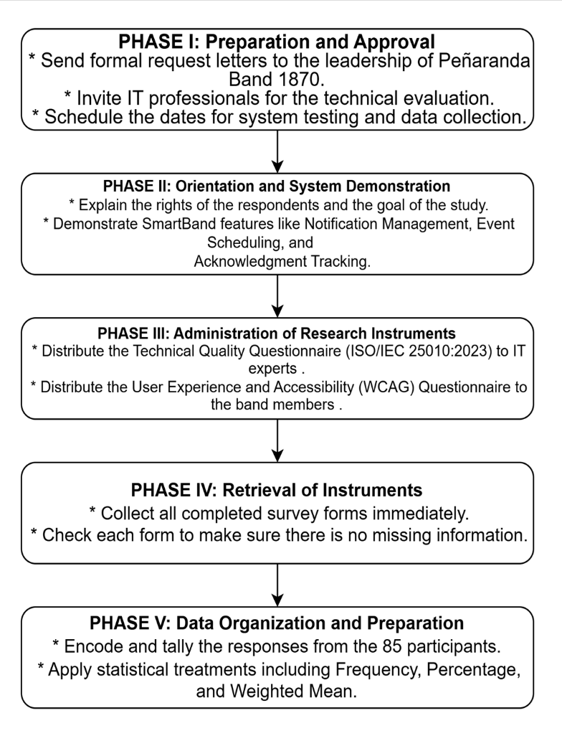

The first phase is the preparation and approval stage. The researchers will prepare a formal letter of request addressed to the leadership of Peñaranda Band 1870, seeking permission to conduct the study within the organization and to involve the band officers and members as respondents. A separate request will also be sent to selected IT professionals, inviting them to participate as technical evaluators of the system. These letters will clearly state the study's purpose, the procedures involved, and the expected participation of the respondents. Upon approval, the researchers will coordinate with the band leadership to schedule data collection at a convenient time that does not disrupt regular rehearsals or band activities.
The second phase involves orientation and system demonstration. Before administering the research instruments, the researchers will conduct a brief orientation session for all respondents. During this session, the study's purpose will be explained, and respondents will be informed of their rights, including the option to participate voluntarily, confidentiality, and the right to withdraw at any time. Following the orientation, the researchers will demonstrate the developed SmartBand Progressive Web Application. This includes showcasing key system features such as the High-Priority Notification Management, Centralized Event Scheduling, and the Message Acknowledgment Tracking mechanism. This step ensures that respondents have sufficient understanding of the system’s functionalities before providing their evaluation.
The third phase is the administration of the research instruments. The appropriate questionnaire will be distributed to each group of respondents based on their role. The Technical Quality Questionnaire, based on ISO/IEC 25010:2023, will be given to IT professionals, while the User Experience and WCAG Accessibility Questionnaire will be administered to the band officers and members. The researchers will be present during the evaluation to clarify any questions and ensure that the respondents complete the questionnaire independently, without external influence.
The fourth phase is the retrieval of the instruments. To ensure a high retrieval rate and data completeness, the researchers will collect completed questionnaires immediately upon respondents' completion. Each questionnaire will be checked for completeness to avoid missing data. Incomplete responses, if there are any, will be politely verified with the respondents before final collection.
The fifth phase is the data organization and preparation for analysis. The data collected from the 98 respondents will be systematically encoded, tallied, and organized into tabular form. The responses will then be subjected to appropriate statistical treatment, such as the computation of weighted means, to facilitate analysis and interpretation. All collected data will be handled with strict confidentiality and will be used solely for academic purposes.

Data Analysis and Techniques
This study employed a quantitative research approach, using descriptive statistical methods to analyze and interpret data collected from the respondents. The quantitative approach was appropriate for this study because it involved the systematic collection of numerical data through a structured survey questionnaire and the measurement of respondents’ perceptions using a Likert scale. Through this approach, the researchers quantified the organization's communication challenges and evaluated the developed SmartBand system against established criteria.
Specifically, the study employed a quantitative descriptive method, focusing on summarizing, organizing, and interpreting numerical data to describe the current conditions and evaluate system performance. This method was suitable because the study did not aim to establish cause-and-effect relationships, but rather to assess and describe the level of communication challenges, system requirements, system acceptability, and accessibility compliance based on participants' responses.
The primary statistical tools used in this study were frequency, percentage, and weighted mean, which are commonly applied to analyzing Likert-scale data. The weighted mean allowed the researchers to determine the average response for each variable by assigning numerical values to participants' responses. To ensure methodological transparency, the weighted mean was computed using the following formula:
WM = (Σfx) / N
Where:
- WM = Weighted Mean
- Σ = Summation symbol
- f = Frequency of responses
- x = Assigned weight or numerical value of the scale
- N = Total number of respondents
This method provided a clear, concise representation of the respondents' overall perceptions. The collected data were systematically organized, tabulated, and analyzed according to each specific variable presented in the Statement of the Problem to ensure that each research question was directly addressed.
For the qualitative data gathered from the open-ended questions in the survey instrument, Thematic Analysis was employed. The researchers systematically transcribed, coded, and categorized the respondents' written feedback to identify recurring themes, operational concerns, and feature suggestions. This qualitative method provided contextual depth to the quantitative findings, ensuring user concerns were properly understood.
For the first research problem concerning the needs assessment and existing communication challenges, the researchers used frequency, percentage, and weighted mean to describe the data using a 4-point scale. The following tables present the interpretation rubrics for the existing communication needs.

Table 3
Scoring Rubric for Functional Suitability
Range | Qualitative Remarks | Verbal Description
4.21 – 5.00 | Highly Suitable | The SmartBand meets or exceeds all functional requirements with a high accuracy, completeness, and efficiency.
3.41 – 4.20 | Suitable | The SmartBand meets most functional requirements with a satisfactory level of accuracy, completeness, and efficiency.
2.61 – 3.40 | Somewhat Suitable | The SmartBand meets some functional requirements but demonstrates low levels of accuracy, completeness, or efficiency.
1.81 – 2.60 | Unsuitable | The SmartBand meets very few functional requirements, with low accuracy, completeness, and efficiency.
1.00 – 1.80 | Highly Unsuitable | The SmartBand fails to meet most or all functional requirements, with very low accuracy, completeness, and efficiency.
As presented in Table 2, the scoring rubric will be used to evaluate the system’s functional suitability, particularly its ability to provide the required features, deliver accurate results, and support intended operations under specified conditions.

Table 4
Scoring Rubric for Performance Efficiency
Range | Qualitative Remarks | Verbal Description
4.21 – 5.00 | Highly Efficient | The SmartBand’s performance is exceptional, meeting or exceeding all efficiency requirements. Users experience no delays or errors, and the system performs consistently well under all operating conditions.
3.41 – 4.20 | Efficient | The SmartBand’s performance is above average and meets most efficiency requirements. Users experience minimal delays or errors, and the system performs well under normal operating conditions.
2.61 – 3.40 | Less Efficient | The SmartBand’s performance is average, with room for improvement. Users may experience occasional delays or errors, but overall, the system functions adequately.
1.81 – 2.60 | Inefficient | The SmartBand’s performance is below average and fails to fully meet efficiency requirements. Users may experience delays or errors that affect productivity.
1.00 – 1.80 | Highly Inefficient | The SmartBand’s performance is significantly below expectations, frequently causing delays, errors, or failures that disrupt normal operation.
As presented in Table 3, the scoring rubric will be utilized to assess the system’s performance efficiency. This evaluation focuses on how well the SmartBand performs under various operating conditions, specifically looking for the absence of delays or errors and its consistency during normal operation.

Table 5
Scoring Rubric for Compatibility
Range | Qualitative Remarks | Verbal Description
4.21 – 5.00 | Highly Compatible | The SmartBand is fully compatible with other hardware or software and can seamlessly integrate without any issues or modifications.
3.41 – 4.20 | Compatible | The SmartBand can work with other hardware or software with minor adjustments or configurations.
2.61 – 3.40 | Somewhat Compatible | The SmartBand can work with other hardware or software but requires significant adjustments or configurations.
1.81 – 2.60 | Less Compatible | The SmartBand struggles to work with other hardware or software and needs major adjustments.
1.00 – 1.80 | Not Compatible | The SmartBand cannot work with other hardware or software and requires complete redesign or replacement.
As presented in Table 4, the scoring rubric will be used to measure the system's compatibility. This focuses on the SmartBand's ability to seamlessly integrate and function with other hardware or software components without requiring major modifications or redesigns.

Table 6
Scoring Rubric for Interaction Capability
Range | Qualitative Remarks | Verbal Description
4.21 – 5.00 | Highly Interactive | Users can perform tasks intuitively and efficiently, with smooth system responses and clear, immediate feedback.
3.41 – 4.20 | Interactive | Users can perform tasks with some guidance or minor delays; system feedback is generally adequate.
2.61 – 3.40 | Less Interactive | Users face difficulties interacting with the system, with delays or unclear feedback reducing task efficiency.
1.81 – 2.60 | Poorly Interactive | Users experience significant difficulties, with delayed responses and confusing feedback.
1.00 – 1.80 | Non-Interactive | Users cannot effectively interact with the system due to poor responsiveness, unclear instructions, or system errors.
As presented in Table 5, the scoring rubric will be used to evaluate the interaction capability of the system. This assessment determines how intuitively users can perform tasks and whether the system provides immediate, clear feedback and smooth responses during user engagement.

Table 7
Scoring Rubric for Reliability
Range | Qualitative Remarks | Verbal Description
4.21 – 5.00 | Highly Reliable | The SmartBand performs consistently without failures, providing accurate and dependable outcomes under all conditions.
3.41 – 4.20 | Reliable | The SmartBand generally operates as expected, with only minor or occasional errors.
2.61 – 3.40 | Slightly Reliable | The SmartBand is prone to errors or interruptions, affecting performance and dependability.
1.81 – 2.60 | Unreliable | The SmartBand frequently experiences errors or interruptions, reducing overall dependability.
1.00 – 1.80 | Non-Reliable | The SmartBand frequently fails or produces inaccurate results, making it unreliable for intended use.
As presented in Table 6, the scoring rubric will be used to determine the reliability of the system. This involves evaluating the SmartBand’s ability to perform consistently and produce accurate, dependable outcomes without frequent interruptions or failures.

Table 8
Scoring Rubric for Security
Range | Qualitative Remarks | Verbal Description
4.21 – 5.00 | Strong Security | The SmartBand has multiple layers of security measures that provide comprehensive protection against unauthorized access, data breaches, and other threats. Security features are regularly updated and tested to ensure effectiveness.
3.41 – 4.20 | Adequate Security | The SmartBand has basic security measures that prevent most common threats; however, some vulnerabilities may exist and require improvement.
2.61 – 3.40 | Weak Security | The SmartBand has significant security vulnerabilities, with gaps that may allow unauthorized access, data breaches, or other threats. Immediate improvements are needed.
1.81 – 2.60 | Very Weak Security | The SmartBand’s security measures are largely ineffective, leaving it vulnerable to breaches or data loss.
1.00 – 1.80 | No Security | The SmartBand has no effective security measures and is highly vulnerable to breaches and data loss. Urgent action is required.
As presented in Table 7, the scoring rubric will be used to assess the system’s security. The evaluation focuses on the effectiveness of the system’s multi-layered security measures in protecting against data breaches and unauthorized access, ensuring that user data remains confidential and secure.

Table 9
Scoring Rubric for Maintainability
Range | Qualitative Remarks | Verbal Description
4.21 – 5.00 | Highly Maintainable | The SmartBand can be easily modified, updated, or corrected with minimal effort due to well-structured and organized design.
3.41 – 4.20 | Maintainable | The SmartBand can be modified or updated with minor effort, maintaining acceptable performance and structure.
2.61 – 3.40 | Less Maintainable | The SmartBand requires considerable effort to modify or update due to complexity or lack of structure
1.81 – 2.60 | Hardly Maintainable | The SmartBand is difficult to modify or fix, requiring significant time and effort for maintenance.
1.00 – 1.80 | Not Maintainable | The SmartBand cannot be effectively modified or maintained due to poor design or extreme complexity.
As presented in Table 8, the scoring rubric will be used to evaluate the maintainability of the system. This measures how easily the SmartBand can be modified, updated, or corrected based on its organizational structure and design complexity.

Table 10
Scoring Rubric for Flexibility
Range | Qualitative Remarks | Verbal Description
4.21 – 5.00 | Highly Flexible | The SmartBand easily adapts to various user needs, environments, or configurations without requiring major changes.
3.41 – 4.20 | Flexible | The SmartBand can adapt to most user needs or environments with minor adjustments or configuration changes.
2.61 – 3.40 | Less Flexible | The SmartBand has limited adaptability and requires significant changes to support different needs or environments
1.81 – 2.60 | Hardly Flexible | The SmartBand struggles to adapt to new user requirements or environments without major redesign.
1.00 – 1.80 | Not Flexible | The SmartBand cannot adapt to different user needs or environments, limiting its usability
As presented in Table 9, the scoring rubric will be used to assess the flexibility of the system. This evaluation determines how well the application adapts to various user requirements, environments, or configurations without necessitating major structural changes.

Table 11
Scoring Rubric for Safety
Range | Qualitative Remarks | Verbal Description
4.21 – 5.00 | Highly Safe | The SmartBand effectively prevents hazards, protects users and data, and functions securely under all conditions.
3.41 – 4.20 | Safe | The SmartBand is generally safe, with only minor risks that do not significantly affect users or data
2.61 – 3.40 | Slightly Unsafe | The SmartBand presents noticeable safety risks that may potentially affect users or data.
1.81 – 2.60 | Unsafe | The SmartBand exposes users or data to significant hazards or risks, affecting reliability and functionality.
1.00 – 1.80 | Highly Unsafe | The SmartBand is unsafe, posing serious hazards to users or data. Urgent corrective actions are required.
As presented in Table 10, the scoring rubric will be used to evaluate the safety of the system. This focuses on the system's ability to prevent hazards and function securely to protect both the users and the integrity of the data under all conditions.

Table 12
Scoring Rubric for Web Accessibility (WCAG 2.0)
Range | Qualitative Remarks | Verbal Description
4.21 – 5.00 | Highly Accessible | The SmartBand is considered fully compliant with web accessibility standards.
3.41 – 4.20 | Accessible | The SmartBand is perceived to have minor issues, but is generally accessible.
2.61 – 3.40 | Moderately Accessible | The SmartBand is perceived to have accessibility barriers.
1.81 – 2.60 | Slightly Accessible | The SmartBand is perceived to have major accessibility issues.
1.00 – 1.80 | Not Accessible | The SmartBand is perceived as unusable for users with disabilities.
As presented in Table 11, the scoring rubric will be used to evaluate the system’s compliance with the Web Content Accessibility Guidelines (WCAG 2.0). This assessment ensures that the SmartBand is inclusive and usable for individuals with diverse needs and abilities, ranging from fully compliant to unusable.

Ethical Considerations
This study strictly adhered to ethical standards in the conduct of research to ensure the protection, rights, and welfare of all participants involved. Ethical considerations were observed throughout the entire research process, including data collection, system testing, analysis, and reporting of results. Furthermore, prior to the study’s execution, the research protocol underwent an institutional ethics review and was approved by the college’s research committee, ensuring full compliance with institutional ethical guidelines and standards.
Prior to data collection, the researchers sought permission from the appropriate authorities of Peñaranda Band 1870. A formal request letter was submitted to inform the organization about the purpose, scope, and procedures of the study. Data collection only proceeded upon the formal approval of this request.
Participation in this study was entirely voluntary. All respondents were informed about the nature and purpose of the study before they were asked to participate. A consent statement was included in the questionnaire to ensure that participants willingly agreed to be part of the research. Respondents also had the right to withdraw from the study at any time without any penalty or consequence.
The researchers ensured the confidentiality and anonymity of all respondents. Personal information was not disclosed, and responses were treated with strict confidentiality. Data collected were used solely for academic purposes and were not shared with any unauthorized individuals or organizations.
In compliance with the Data Privacy Act of 2012 (Republic Act No. 10173), all collected data were securely stored and protected from unauthorized access. Only the researchers had access to the data, and appropriate measures were taken to safeguard both digital and physical records. To enforce proper data retention and disposal, a strict data lifecycle was implemented; all collected data were scheduled to be retained in secure storage for a maximum period of one (1) year following the project's conclusion. Upon the expiration of this retention period, all physical records will be securely shredded, and digital files will be permanently wiped from all drives to ensure they cannot be recovered or reconstructed.
The study also ensured that there was no harm or risk to the participants. The questionnaire was designed to avoid sensitive or intrusive questions, and the system evaluation focused solely on user experience and system performance. Respondents were not subjected to any form of physical, psychological, or social harm during the conduct of the study.
Furthermore, the researchers observed honesty and integrity in reporting the findings. All data were presented accurately without manipulation, fabrication, or misrepresentation. Proper acknowledgment of sources and references was also strictly observed to avoid plagiarism.
Overall, these ethical principles were implemented to ensure that the study was conducted responsibly, respectfully, and in accordance with accepted academic research standards.

Chapter 3
RESULTS AND DISCUSSION

This chapter presents, analyzes, and interprets the data gathered from the development, implementation, and evaluation of the SmartBand Progressive Web Application. Grounded in the descriptive-developmental research design, the discussion begins by presenting the systematic development of the system to address the communication and coordination inefficiencies of Peñaranda Band 1870 identified in the preceding chapters. The organization's reliance on unstructured group chats was translated into specific technical requirements, which guided the development of a centralized, priority-based platform for announcements, notifications, event scheduling, and acknowledgment tracking.
Following the design and development section, which presents the developed user interfaces and system capabilities, the chapter systematically addresses the specific problems of the study. It first presents the communication challenges experienced by the members of Peñaranda Band 1870. It then presents the technical quality evaluation conducted by IT experts and the system acceptability assessment conducted by the end-users, using the ISO/IEC 25010:2023 software quality model. Finally, the chapter presents the accessibility compliance results based on the Web Content Accessibility Guidelines (WCAG), providing an assessment of the application's accessibility and usability for its intended users.

1. Design and Development of SmartBand Progressive Web Application
The development of the SmartBand Progressive Web Application (PWA) followed a systematic approach to address the specific communication and coordination challenges of Peñaranda Band 1870. This phase was guided by the Agile Scrum methodology, which allowed for the iterative refinement of the system's functional requirements throughout the development process. The organization's previous reliance on unstructured group chats was translated into specific technical solutions, with the development focused on building a centralized, cross-platform platform designed to prioritize urgent announcements and efficiently track member participation.
1.1 Plan
During the initial planning phase, the researchers focused on identifying the core communication and coordination challenges experienced by Peñaranda Band 1870. The identified concerns included difficulties in managing announcements, scheduling activities, and coordinating events through existing communication channels. These findings served as the foundation for defining the objectives, scope, and functional requirements of the SmartBand Progressive Web Application (PWA).
Following the identification of the system requirements, the researchers established the project scope and development priorities to guide the systematic implementation of the proposed solution. The planning process considered the functional and nonfunctional requirements of the system, including high-priority notifications, event scheduling, acknowledgment tracking, user role management, accessibility, reliability, security, performance efficiency, and compatibility. These requirements were organized to provide a clear direction for the succeeding design and development phases.
The planning stage was conducted within the Agile Scrum framework established for the project. The identified requirements served as the basis for the development backlog and subsequent sprint activities. Through this approach, the researchers established a structured roadmap for transforming the communication and coordination requirements of Peñaranda Band 1870 into a centralized web-based platform. The resulting plan guided the succeeding design, development, testing, deployment, and evaluation of the SmartBand Progressive Web Application.

Table 13. User Stories and System Requirements Mapping
User Stories | Actor(s) | Functional Requirement | Non-Functional Requirement | Needed UI | Scenario
[USER REGISTRATION & ONBOARDING] As a band musician or auxiliary member (Majorette / Flag), I want to register my account and specify my section so I can be reviewed and verified on the official roster. | Band Member / Auxiliary | The system captures member details (name, contact, instrument/section) and sets account status to "Pending" awaiting verification. | Security: Secure password hashing via Supabase Auth and data privacy compliance. | Landing Page / Registration Modal | A new clarinetist or majorette registers their details to request membership access to the band portal.
[ACCOUNT VERIFICATION & RBAC] As an administrator, I want to review pending registrations so only legitimate band members gain access to system features. | IT Administrator | The system displays unverified users and allows the administrator to verify accounts, assign roles, and reject unauthorized signups. | Security: Strict enforcement of Role-Based Access Control (RBAC) via database Row-Level Security. | Admin Operations Dashboard | The administrator checks the pending queue, verifies a new registrant against the master band list, and approves the account.
[PWA INSTALLATION & OFFLINE ACCESS] As a band member, I want to install the system directly to my smartphone home screen so I can access it quickly and view my schedule even without internet. | Band Member | The system registers a Service Worker and web manifest to enable one-tap PWA installation and cache schedules locally. | Compatibility: Seamless cross-platform support across Android, iOS, and desktop browsers. | App Settings & Install Prompt | A musician installs the SmartBand app to their phone and checks rehearsal times during outdoor parade travel without cellular reception.
[WEEKLY AVAILABILITY MANAGEMENT] As a band member, I want to fill in my weekly availability grid so officers know my free days and times before scheduling gigs. | Band Member | The system provides a 21-slot weekly schedule grid (Morning, Afternoon, Evening) for users to toggle and save their availability. | Interaction Capability: Touch-friendly, intuitive grid layout responsive on mobile screens. | Member Profile / Availability Grid | A member updates their schedule on Sunday night to indicate availability for Wednesday evening and weekend mornings.
[DEDICATED ACCEPTED EVENTS TRACKING] As a band member, I want a dedicated dashboard view of my accepted events so I can immediately view my upcoming gigs, call-times, and locations in one place. | Band Member | The system filters events where the user has RSVP'd "Attending" or "Present" and displays them in a focused, dedicated view. | Performance Efficiency: Instant retrieval of personal schedule commitments without loading unrelated data. | Member Dashboard / Accepted Events View | A trumpet player checks their dashboard to view the exact assembly location and call-time for tomorrow's accepted civic parade.
[BAND DIRECTORY PRIVACY PROTECTION] As a band member, I want to view a read-only master list of all members and their instruments, while keeping personal contact details and admin controls private. | Band Member | The system presents a public roster view displaying verified member names and sections, while concealing phone numbers, birth dates, and editing controls. | Security: Adherence to RA 10173 (Data Privacy Act) and protection against unauthorized data modifications. | Band Directory / Public Roster View | A percussionist checks the band directory to see who plays in the brass section, without being able to edit profiles or view sensitive personal information.
[ATTENDANCE RELIABILITY SCORING] As a band member and officer, I want participation to update an objective Reliability Score so attendance is recognized fairly. | Band Member, Officer | The system automatically computes a percentage score based on attendance roll-calls and announcement acknowledgment history. | Reliability: Consistent mathematical formula without manual bias or calculation errors. | Member Profile / Leaderboard | A musician consistently confirms call-times and attends parades, maintaining a high reliability standing on the band roster.
[PRIORITY ANNOUNCEMENTS & CALL-TIME SIREN] As a band member, I want to receive urgent notices with an acoustic fanfare siren so I never miss critical call-times. | Band Member | The system delivers high-priority web push alerts and synthesizes a 5-second acoustic brass alarm using the Web Audio API. | Performance Efficiency: Instant delivery of urgent notifications with audible call-time alerting. | Device Lock Screen / Announcement Banner | An urgent call-time modification is posted, and all band members' phones sound an acoustic fanfare siren with a prominent banner.
[SECTION AVAILABILITY FILTERING] As a band secretary, I want to filter available members by day, time slot, and section (Brass, Woodwinds, Percussion, Auxiliary) so I can assemble a balanced lineup. | Band Secretary | The system queries member availability records based on day, time, and instrument/auxiliary section filters. | Performance Efficiency: Rapid database query execution and clear presentation of available personnel. | Secretary Management Hub | The secretary searches for available snare drummers and flag members for a Saturday morning festival procession.
[TARGETED RSVP TRACKING & REMINDERS] As an officer, I want to see real-time RSVPs and alert unconfirmed members with one click so we secure an accurate headcount. | Band Secretary | The system tracks member response statuses (Attending, Declined, Tentative) and provides an "Alert Unconfirmed" button for automated reminders. | Reliability: Accurate targeting of non-responding members without disturbing confirmed participants. | Event Management / RSVP Roster | The secretary notices several musicians have not replied to a parade invite and triggers targeted reminder alerts.
[OFFICIAL PDF REPORT GENERATION] As a band secretary or administrator, I want to export clean, minimal pure-white PDF reports with our official band crest logo for physical records and meetings. | Band Secretary, IT Admin | The system generates printable PDF documents for Active Rosters, Past Gig Histories, and Event Attendance Roll-Calls (attending, absent, excused, unavailable) with the band crest logo. | Usability: Clean, minimal pure-white styling optimized for print and official presentation. | Reports Hub / Export PDF Modal | The secretary downloads a clean attendance roll-call PDF for an upcoming church service, complete with the Peñaranda Band 1870 logo header.

1.2 Design
The design phase of the SmartBand Progressive Web Application prioritized user accessibility, mobile responsiveness, and high-performance offline capabilities. Recognizing that band members utilize various mobile devices under different network conditions, the researchers adopted a "mobile-first" design philosophy. The graphical user interface (GUI) was engineered with intuitive navigation, touch-friendly grid layouts, and high-contrast elements to accommodate the diverse digital literacy levels of the ninety-three active members. Furthermore, the Progressive Web App (PWA) architecture was designed to include a web manifest and service workers, enabling users to install the system directly to their device home screens for instant access without traditional app store prerequisites.
To establish a robust structural foundation prior to interface development, the system's logical flow and data architecture were modeled using standard software engineering diagrams. Unified Modeling Language (UML) tools, such as Use Case and Class Diagrams, were utilized to define strict user roles and relational database schemas. Concurrently, Data Flow Diagrams (DFDs) were designed to map the secure routing of information—from member registration and availability inputs to the broadcast of high-priority announcements and the automated calculation of Attendance Reliability Scores. This rigorous architectural planning ensured that the Role-Based Access Control (RBAC) securely separated the operations and data privileges of Band Members, Band Secretaries, and IT Administrators.
Following the structural mapping, the researchers developed high-fidelity user interface prototypes. These interfaces translated the conceptual designs into functional screens that directly address the organization's scheduling and communication inefficiencies. The figures below illustrate the primary user interfaces of the deployed SmartBand system.

Figure 4. Landing Page
Figure 5 to Figure #……

Use Case Diagram
Figure 3 illustrates the functional behavior and operational boundaries of the SmartBand Progressive Web Application tailored for the Peñaranda Band 1870. The system models interactions across three primary human actors—Band Member (encompassing instrumental musicians and auxiliary members such as Majorettes and Color Guard / Flag performers), Band Officer (Secretary / Executive Leader), and IT Administrator—alongside two secondary external service actors: the Web Push API (Browser Service) and the Web Audio API Subsystem (Acoustic Siren Synthesis).
Band Member actors engage with the platform by registering an account, specifying their musical instrument or auxiliary role (Majorette or Color Guard / Flag), authenticating credentials, and installing the application directly onto client devices via Progressive Web Application caching protocols. Within their member portal, members manage their weekly availability grids, access a dedicated dashboard view of their accepted events to keep track of confirmed upcoming gigs, and review their personal reliability score. Band members are also granted access to a read-only master roster displaying fellow members and their sections, while personal contact numbers, birth dates, and administrative management tools are securely withheld to ensure privacy. When a member confirms receipt of an announcement or submits an event RSVP, the Confirm Receipt / RSVP process executes a mandatory <<include>> relationship to Calculate Reliability Index, ensuring continuous, automated updates to their participation metric.
Administrative operations are directed by the Band Officer, whose access requires credential authentication that strictly incorporates an <<include>> Verify Role Status dependency to validate officer privileges. Officers oversee event logistics through the Manage Event Schedules process, which can be conditionally augmented via an <<extend>> relationship with Filter Availability by Section to identify available personnel per instrument or auxiliary group (Woodwinds, Brass, Percussion, Majorettes, Flags). When releasing urgent directives, the Broadcast Announcements process triggers mandatory <<include>> behaviors to Dispatch Web Push Alert through the external Web Push API and Trigger Call-Time Siren via the client-side Web Audio API. Officers also monitor real-time mobilization through Track Attendance Roster, which provides an <<extend>> path to Send Targeted Reminders to unconfirmed musicians. Furthermore, officers utilize the Export PDF Reports process to generate clean, minimal pure-white administrative documentation branded with the official Peñaranda Band 1870 crest logo—including active rosters, past gig histories, and specific event attendance roll-calls that clearly distinguish attending, absent, excused, and unavailable personnel.
System integrity and security oversight are maintained by the IT Administrator. This actor validates new registrants against the official roster through Verify Member Accounts, provisions administrative permissions via Manage Roles (RBAC), and inspects immutable operational records through the Audit System Ledger to guarantee platform accountability.

Figure #. Use Case Diagram

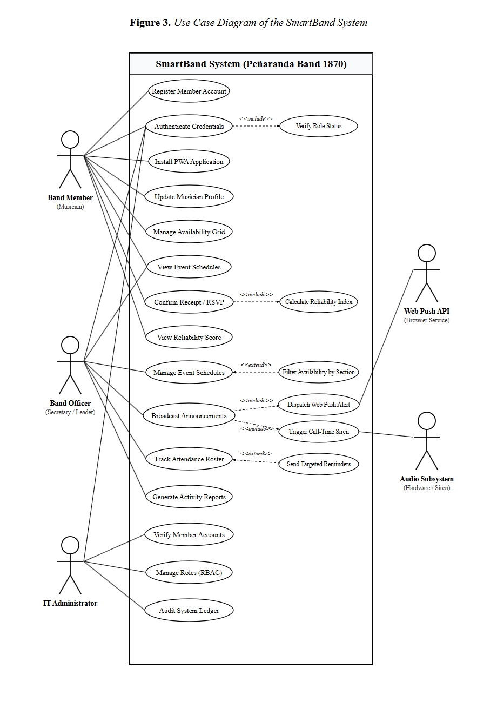

Data Flow Diagrams (DFDs)
Data Flow Diagrams (DFDs) were formulated to model the functional pathways through which information originates, transforms, persists, and distributes across the SmartBand Progressive Web Application. By abstracting operational workflows into structured processes, data stores, and external entities, the diagrams visualize boundary interactions between band members, officers, administrators, external push services, audio hardware subsystems, and the relational database.
Context Diagram (Level 0 DFD)
The Context Diagram (Level 0 DFD) models the SmartBand system as a singular central process (Process 0.0), delineating the macro-level operational boundaries of the platform. The system interfaces directly with three human external entities—the Band Member (Musician), the Band Officer (Secretary / Leader), and the Band IT Administrator—alongside two external peripheral services: the Web Push Notification Service (Push Gateway) and the Client Audio Subsystem (Device Hardware). The Band Member inputs registration credentials, profile details, weekly availability blocks, and event acknowledgment confirmations, receiving event schedules, high-priority notifications, attendance reliability scores, and section rosters. The Band Officer supplies announcement broadcasts, rehearsal call-times, schedule updates, and targeted reminder requests, receiving section availability tallies, live attendance rosters, and executive analytics. The Band IT Administrator submits verification approvals, role configurations, and master roster updates while inspecting audit logs. Externally, the system dispatches push payloads to the Web Push Service and call-time audio triggers to the device's Audio Subsystem.
Figure 38. Context Diagram (Level 0 DFD)
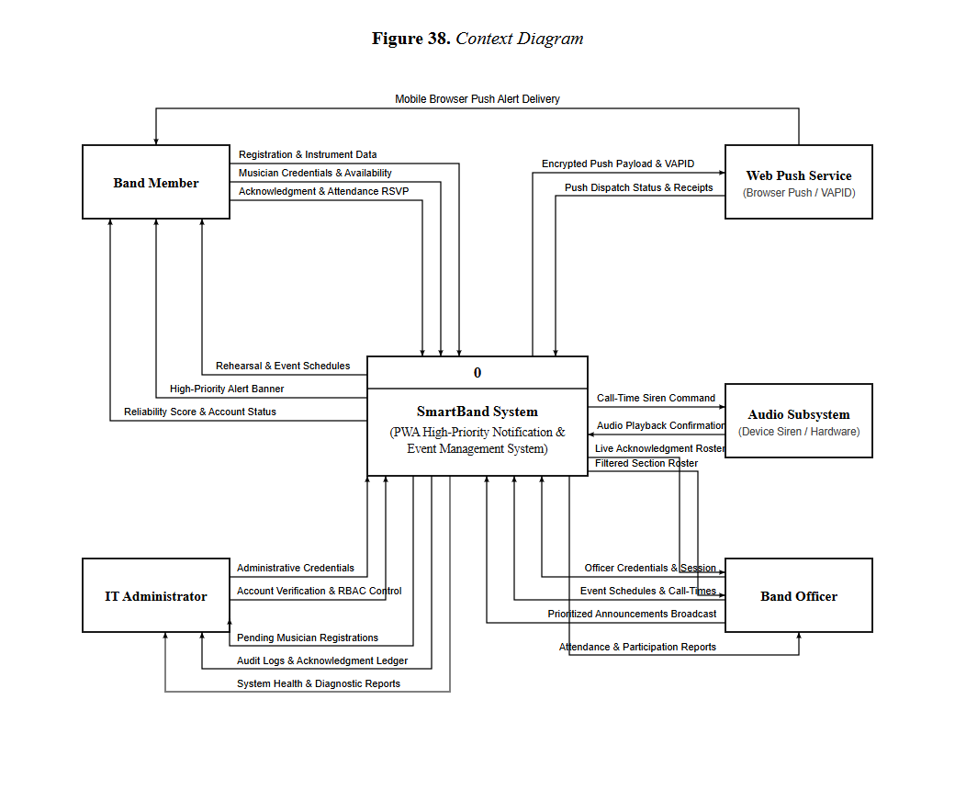

Level 1 Data Flow Diagram
The Level 1 Data Flow Diagram decomposes the macro system into seven primary operational processes. Process 1.0 (Register and Verify Users) ingests member applicant data (including musical sections and auxiliary units such as Majorettes and Color Guard / Flag), stores pending accounts in the database, and enables administrator verification against the official municipal roster. Process 2.0 (Authenticate Users) verifies credentials, enforces Role-Based Access Control (RBAC), and issues encrypted session tokens. Process 3.0 (Manage Member Availability & Profiles) captures recurring weekly availability matrices across morning, afternoon, and evening slots and maintains instrument specializations. Process 4.0 (Manage Event Schedules & RSVPs) enables officers to create, update, and categorize rehearsals, civic parades, and performances, while providing members with dedicated tracking of accepted events. Process 5.0 (Manage Announcements & Priority Triage) classifies directives by urgency (Low, Medium, High). Process 6.0 (Dispatch Push Notifications & Call-Time Siren) routes high-priority alerts through the Web Push API and triggers synthesized brass fanfare alarms via the Web Audio API. Process 7.0 (Track Acknowledgments, Attendance & Generate PDF Reports) logs two-way receipt confirmations, computes individual Reliability Indexes, tracks on-site roll-call attendance, and exports minimal pure-white PDF reports with the official band crest logo.
Figure 39. Level 1 Data Flow Diagram
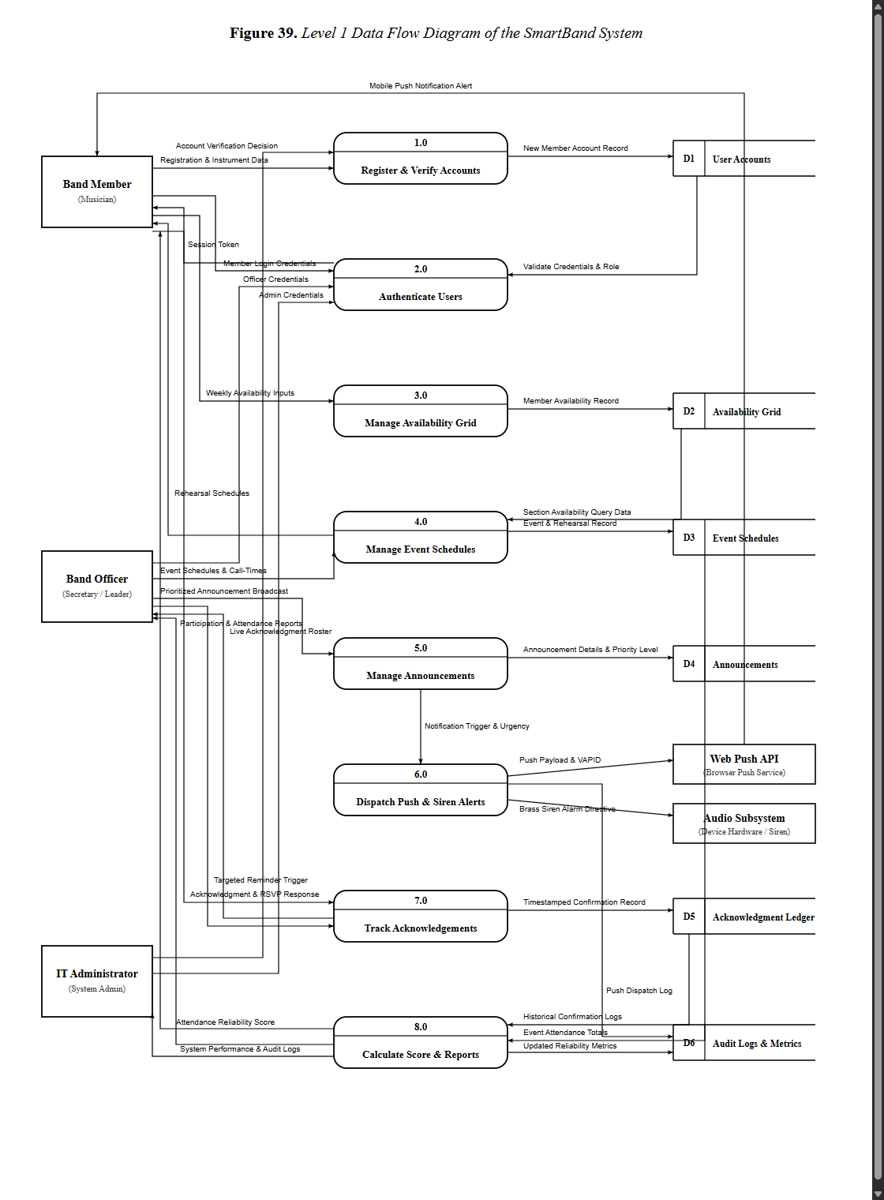

Level 2 Data Flow Diagrams
Level 2 Data Flow Diagrams specify the internal transformations governing key operational processes within the architecture:
Level 2 DFD for Process 1 (Register and Verify Users):
Decomposes member onboarding into three sub-processes. Sub-process 1.1 (Capture Member Details) validates contact numbers, instrument choices, and auxiliary roles (Majorette, Color Guard / Flag), writing new records with a "Pending" status to the database. Sub-process 1.2 (Inspect Pending Queue) retrieves unverified registrants for administrative review. Sub-process 1.3 (Verify Against Master List) matches submissions against the municipal band roster, updates verification flags, and assigns initial membership privileges.

Figure 40. Level 2 DFD - Process 1: Register and Verify Users
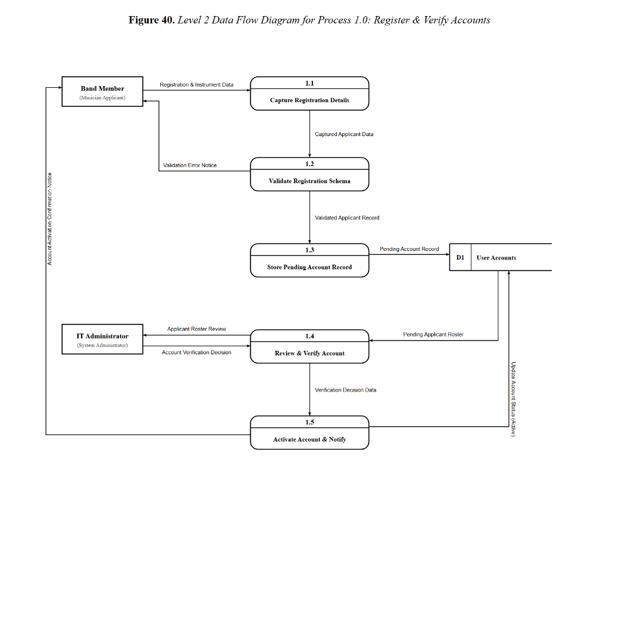

Level 2 DFD for Process 2 (Authenticate Users):

Models user access control. Sub-process 2.1 (Validate Credentials) verifies email and hashed password pairs. Sub-process 2.2 (Verify Role Permissions) queries assigned RBAC entitlements. Sub-process 2.3 (Issue Session Token) generates an encrypted session token and directs the user to their role-specific operational dashboard (Member, Secretary, or Admin).

Figure 41. Level 2 DFD - Process 2: Authenticate Users

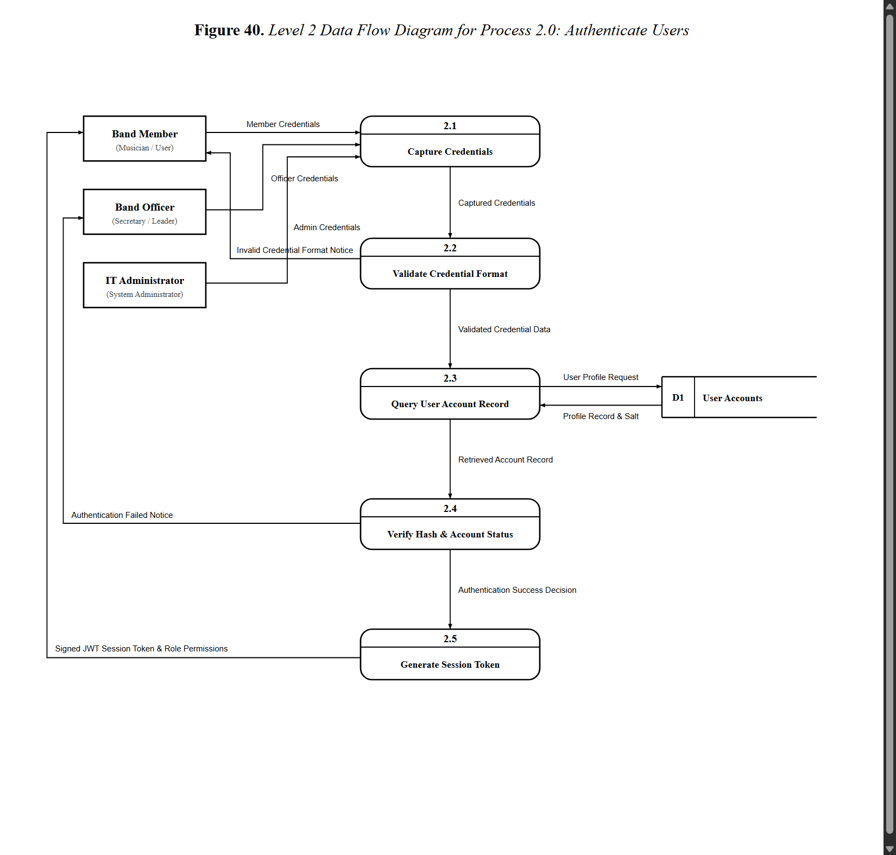

Proposed Class Diagram

The Proposed Class Diagram formalizes the object-oriented structure of the SmartBand web application, defining class attributes, methods, inheritance hierarchies, and operational associations across domain layers. The central abstract entity User encapsulates common credentials, contact details, and role specifications, from which Musician, AuxiliaryMember (Majorette, Color Guard / Flag), BandOfficer (Secretary, President), and ITAdministrator derive specialized behaviors. Domain model classes—including Instrument, WeeklyAvailability, EventSchedule, Announcement, AcknowledgmentLedger, AttendanceRecord, ReliabilityScore, and AuditLog—encapsulate business rules and database persistence. These domain entities interact with specialized service handlers, such as PushNotificationService for VAPID payload dispatching, AudioAlarmService for client-side call-time audio synthesis via the Web Audio API, AvailabilityFilterService for section querying, PDFReportService for generating clean printable rosters and roll-calls with the official crest logo, and ReliabilityCalculationEngine for automated turnout scoring.

Figure 42. Proposed Class Diagram

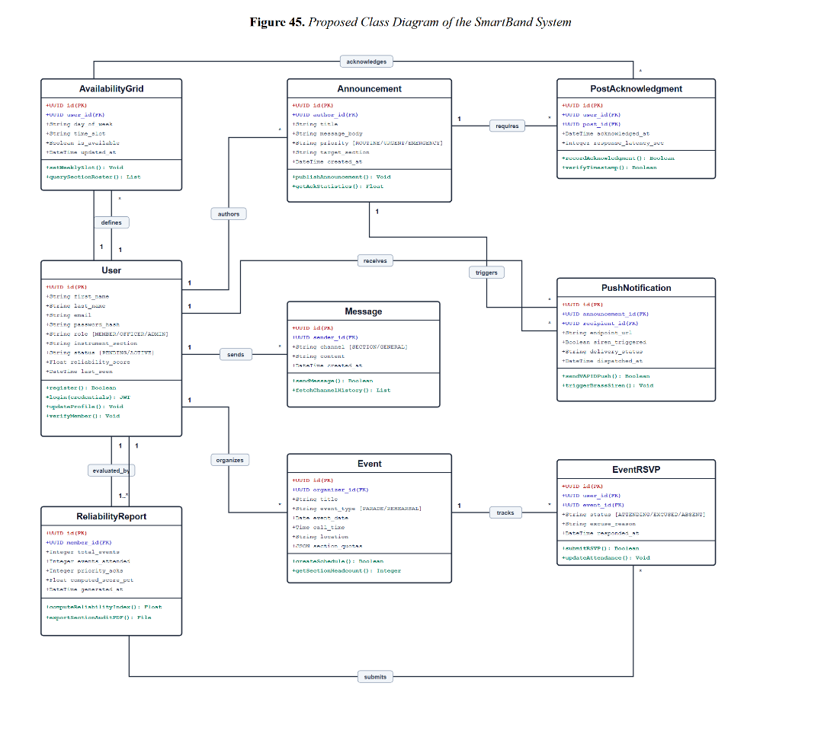

Entity Relationship Diagram (ERD)

To establish a robust relational data model supporting the multi-tier operational workflows of Peñaranda Band 1870, an Entity Relationship Diagram (ERD) was developed. The model defines the structural schema, primary keys, foreign referential constraints, and business cardinalities across twelve normalized operational entities.
The users entity serves as the primary authentication and identity root of the architecture, maintaining unique email credentials, password digests, user roles (super_admin, secretary_admin, executive, member), seniority ranks (Junior, Senior), and verification status. An associated profiles entity maintains personal biographies, telephone numbers, and emergency contact records. Musician and auxiliary unit capabilities are modeled through instruments, which records section classifications across Woodwinds, Brass, Percussion, and Auxiliary (Majorette, Color Guard / Flag). Routine availability is tracked via weekly_availabilities (realized in production via member_availability), which records member availability across day-of-week and time-slot blocks.
Event operations are governed through events, storing event titles, categories (Rehearsal, Parade, Vigil, Funeral, Meeting), assembly locations, call-times, and allocated budget estimates. Members confirm participation via event_rsvps, which fuels a dedicated accepted events interface on the member dashboard and tracks roll-call status (Attending, Present, Absent, Excused, Declined). Official directives are maintained in announcements, which features a priority level attribute (Low, Medium, High). Two-way communication convergence is preserved in acknowledgment_ledgers, which pairs announcements with individual members, recording response statuses (Confirmed, Unavailable, Excused) and timestamps. Turnout records feed directly into reliability_scores to maintain historical participation metrics, while jsPDF leverages this data to render minimal pure-white PDF reports branded with the official band crest logo. Administrative oversight is secured through audit_logs.

Figure 43. Entity Relationship Diagram (ERD)
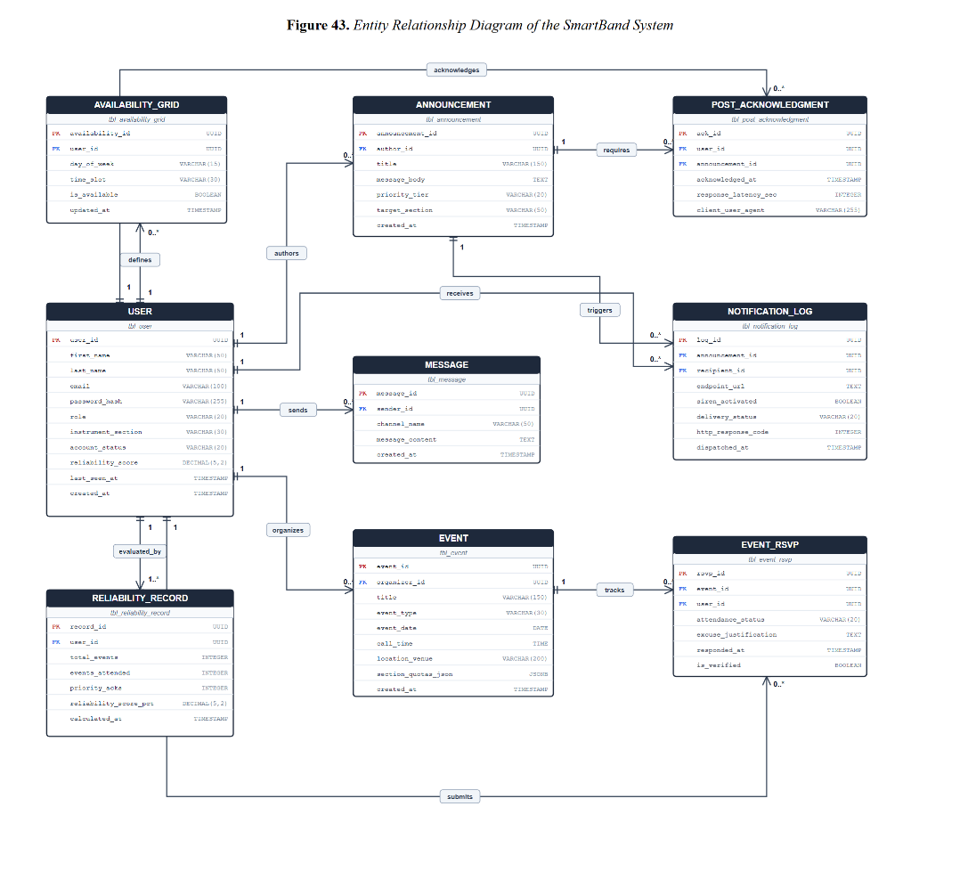

Database Normalization

Database normalization was systematically performed to structure the SmartBand data model into Third Normal Form (3NF). This engineering process eliminated data redundancy, resolved insertion, update, and deletion anomalies, and enforced strict referential integrity across all relational entities.

Unnormalized Form (UNF)
The unnormalized state represents raw, denormalized records containing multi-valued attributes, repeating groups, and combined transactional data. In this baseline form, user profiles, instrument specializations, recurring availability slots, event schedules, priority announcements, and attendance confirmations were consolidated into single flat table structures.

Figure 44. Unnormalized Form (UNF)
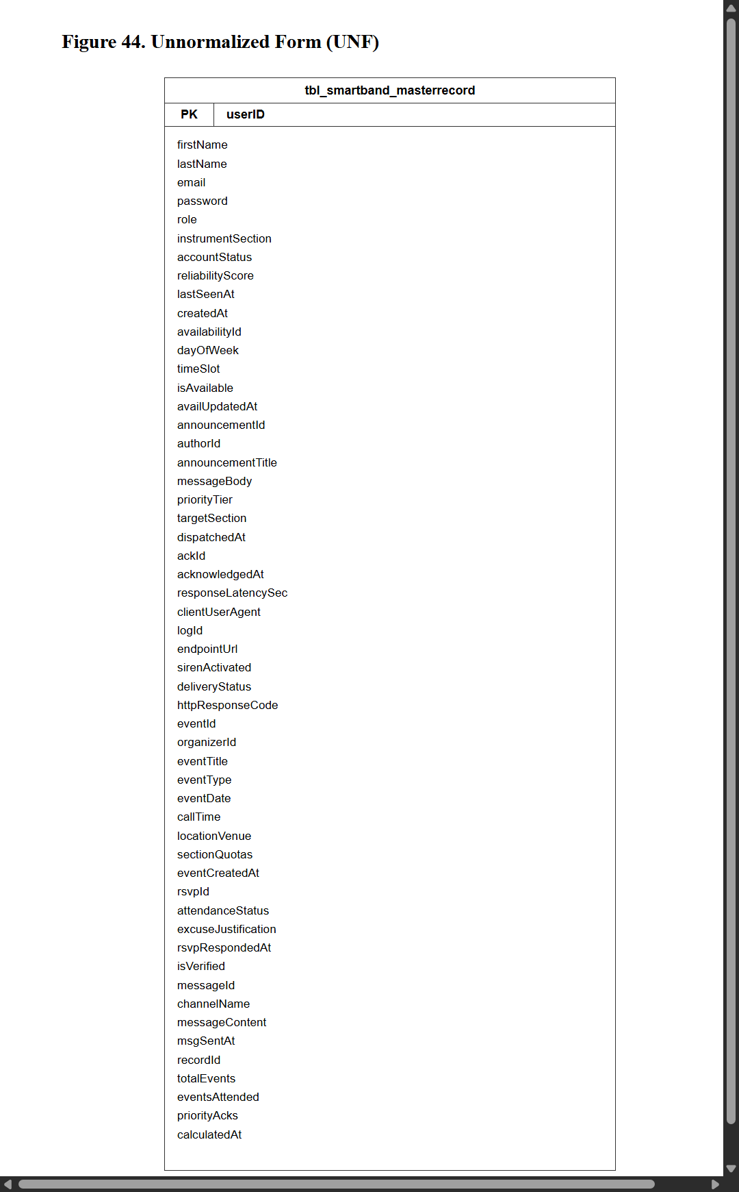

First Normal Form (1NF)

Conversion to First Normal Form (1NF) resolved repeating groups and ensured that every attribute contains only atomic, indivisible values. Multi-valued fields (such as multiple available time slots and secondary instruments) were separated into discrete rows, and a composite primary key structure was identified to uniquely distinguish every operational transaction record.

Figure 45. First Normal Form (1NF)

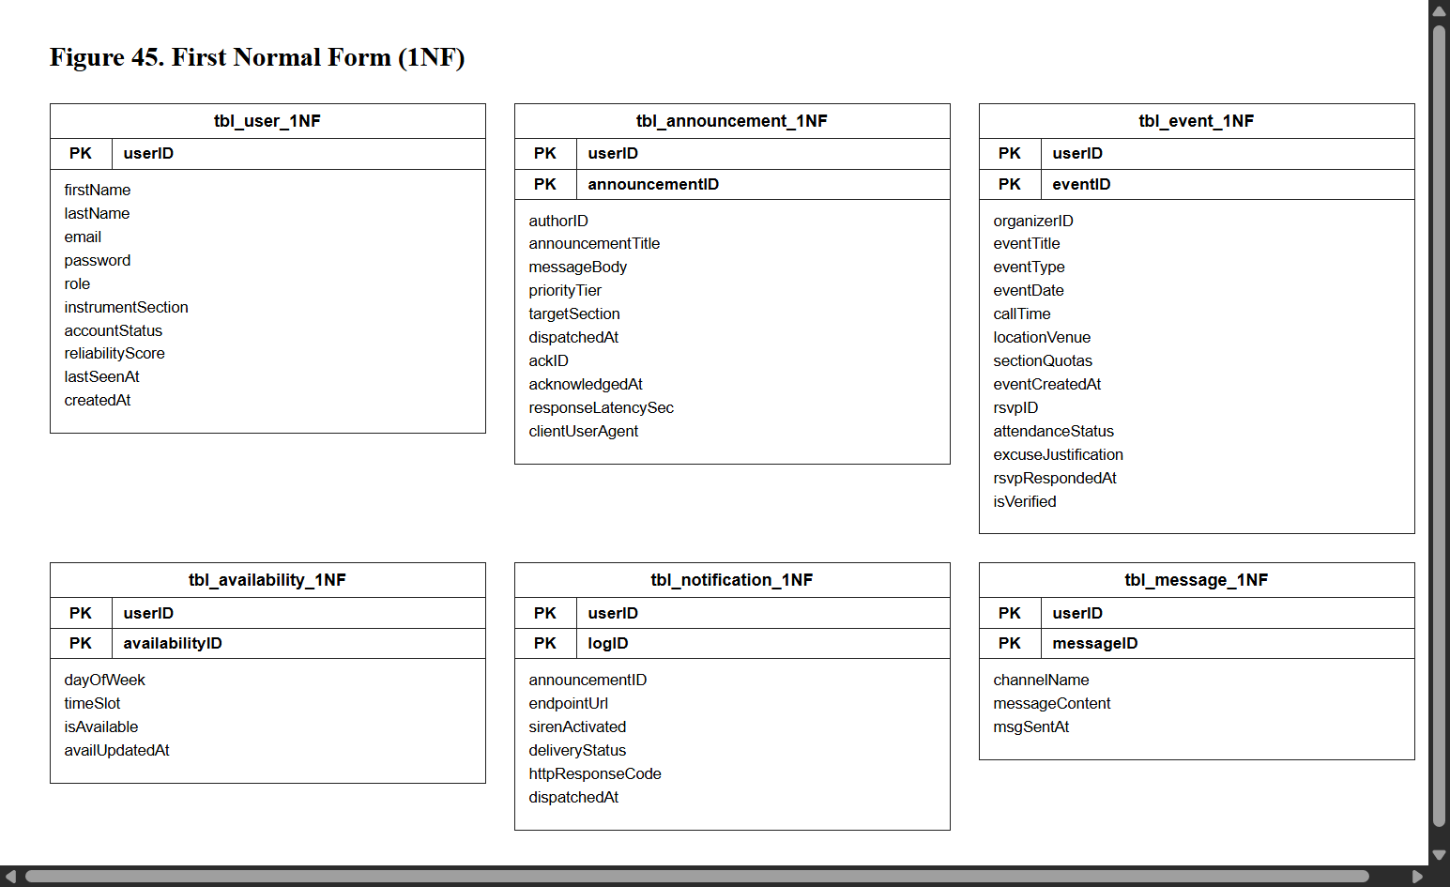

Second Normal Form (2NF)

Transition to Second Normal Form (2NF) eliminated partial functional dependencies. Attributes depending only on a subset of composite candidate keys were decomposed into independent relations. User profiles, instrument categories, event commitments, and announcement records were segregated into distinct entities, each governed by its own standalone primary key with foreign key Crow's Foot relationships.

Figure 46. Second Normal Form (2NF)

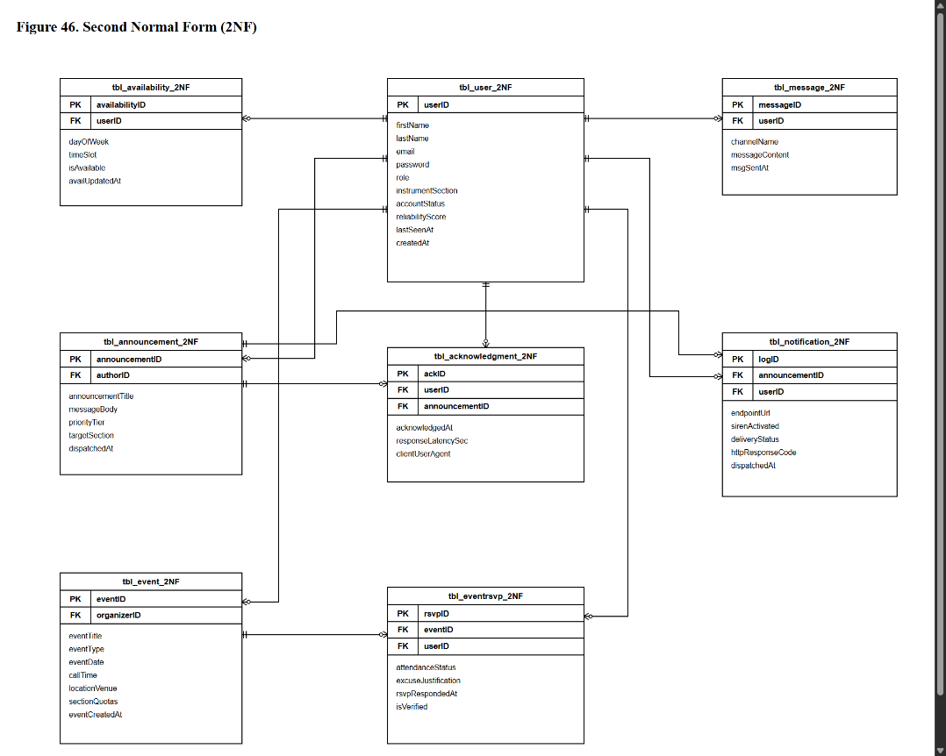

Third Normal Form (3NF)

Advancement to Third Normal Form (3NF) eliminated transitive functional dependencies, ensuring every non-key column depends solely on the primary key ("the key, the whole key, and nothing but the key"). Calculated turnout percentages, section headcount summaries, and reliability score aggregates were decoupled from base transactional tables and handled via application business logic. Consistent snake_case naming conventions and standard id primary/foreign key relationships were enforced across all twelve final database entities.

Figure 47. Third Normal Form (3NF)

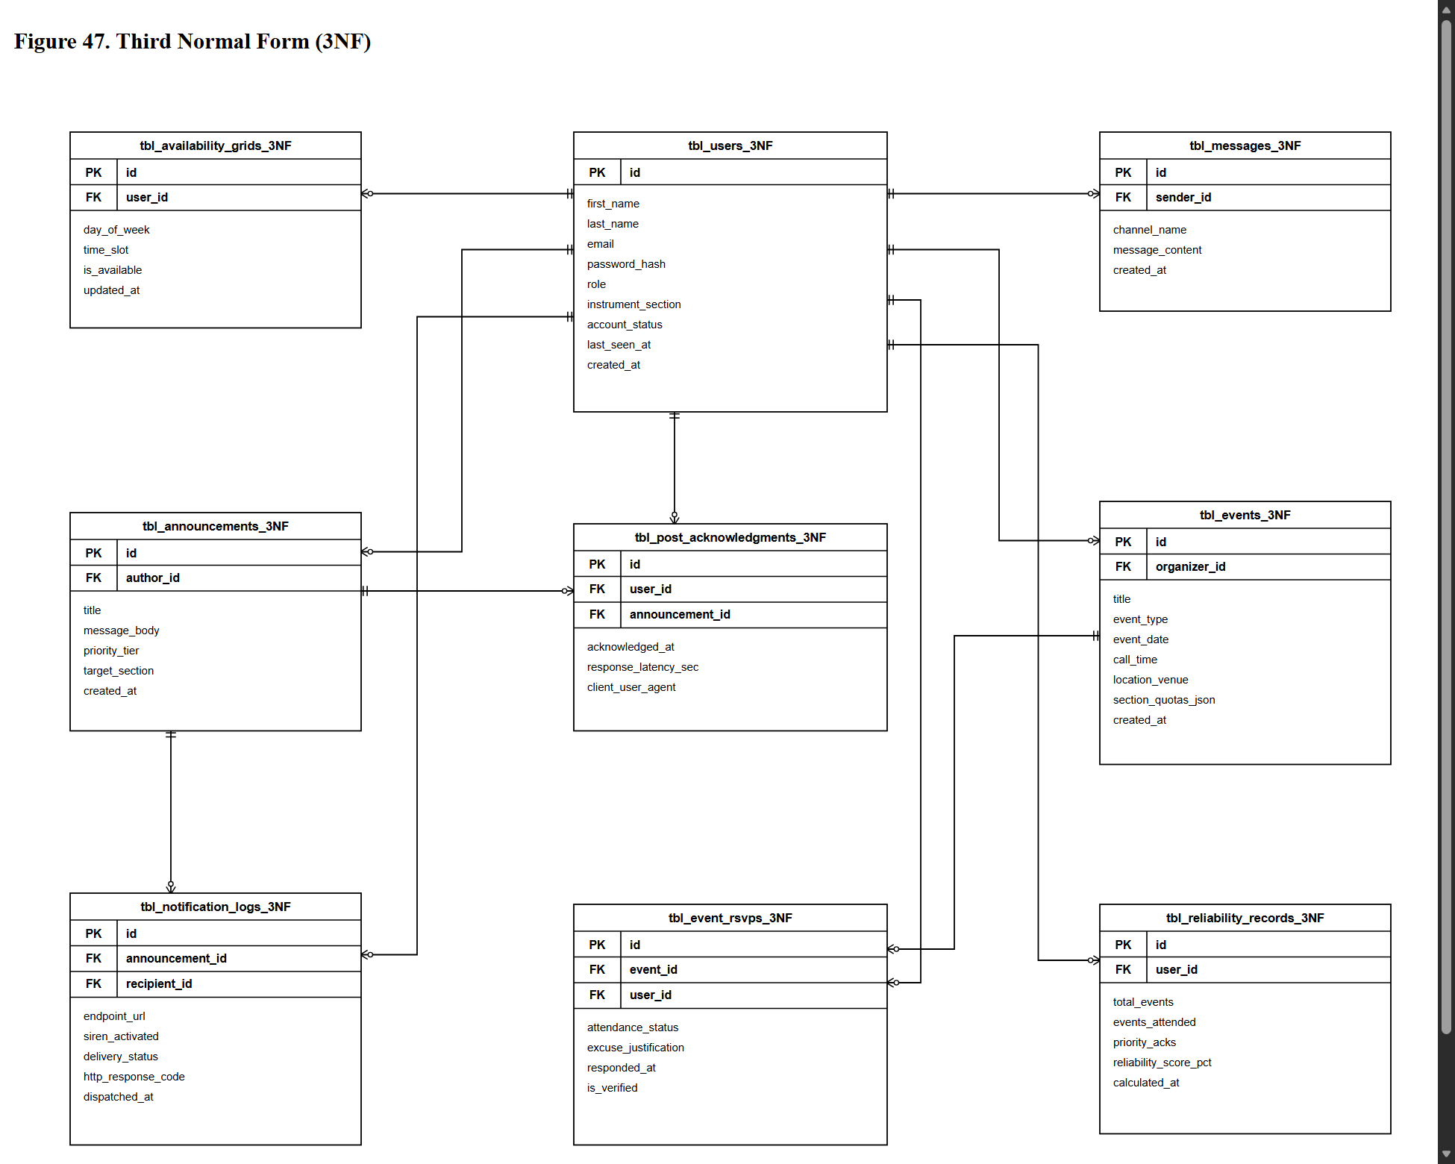

The following Data Dictionary (Tables 13.1 through 13.12) specifies the normalized conceptual database entities, attributes, constraints, and data definitions for the SmartBand platform. In the production implementation, these conceptual structures are engineered directly into the Supabase Cloud PostgreSQL database infrastructure—using the profiles table (integrated with auth.users), member_availability, events, event_rsvps, announcements, push_subscriptions, and the privacy-enforcing public_roster view—protected by strict Row-Level Security (RLS) policies.
Table 13.1. tbl_users
Table Description: Serves as the central authentication, profile, and identity root of the SmartBand application. It stores demographic details, role-based access privileges, instrument assignments, cryptographic credential hashes, and operational account statuses for all active musicians, band officers, and system administrators.
Field Name | Data Type | Length / Constraint | Key | Description
id | UUID | 36 / NOT NULL, DEFAULT gen_random_uuid() | PK | Universally unique identifier serving as the immutable primary key for each user account. (Example: 'a0eebc99-9c0b-4ef8-bb6d-6bb9bd380a11')
first_name | VARCHAR | 50 / NOT NULL | - | Legal first name of the band musician, officer, or system administrator. (Example: 'Juan')
last_name | VARCHAR | 50 / NOT NULL | - | Legal surname / family name of the user. (Example: 'Dela Cruz')
email | VARCHAR | 100 / NOT NULL, UNIQUE | - | Personal or organizational email address utilized as the unique username for system authentication. (Example: 'j.delacruz@penarandaband1870.ph')
password_hash | VARCHAR | 255 / NOT NULL | - | Cryptographically salted and stretched password digest generated via bcrypt algorithm (2a cost factor 12). (Example: '...3mQ9qZ7')
contact_number | VARCHAR | 15 / NULL | - | Primary mobile phone number in Philippine cellular format (09XXXXXXXXX) used for emergency communication. (Example: '09171234567')
role | VARCHAR | 20 / NOT NULL, DEFAULT 'member', CHECK (role IN ('member', 'secretary_admin', 'executive', 'super_admin')) | - | System authorization role enforcing Role-Based Access Control (RBAC) boundaries (Super Admin, Secretary Admin, Executive, and Member). (Example: 'member')
instrument_section | VARCHAR | 30 / NOT NULL, CHECK (instrument_section IN ('Woodwinds', 'Brass', 'Percussion', 'Auxiliary', 'Administration')) | - | Primary musical or auxiliary section grouping (Woodwinds, Brass, Percussion, Auxiliary, Administration) governing broadcast targeting and roster queries. (Example: 'Brass')
primary_instrument | VARCHAR | 50 / NOT NULL | - | Specific musical instrument or auxiliary role designated to the member within Peñaranda Band 1870 (e.g., Bb Trumpet 1st, Bb Clarinet, Snare Drum, Majorette, Color Guard / Flag). (Example: 'Bb Trumpet 1st')
account_status | VARCHAR | 20 / NOT NULL, DEFAULT 'pending', CHECK (account_status IN ('pending', 'verified', 'declined', 'suspended')) | - | Administrative verification and lifecycle status governing login access permissions. (Example: 'verified')
reliability_score | DECIMAL | 5,2 / NOT NULL, DEFAULT 100.00, CHECK (reliability_score BETWEEN 0.00 AND 100.00) | - | Cached cumulative reliability percentage derived from event attendance and prompt notification acknowledgments. (Example: 96.50)
last_seen_at | TIMESTAMP | 8 bytes / NULL | - | System timestamp tracking the user's most recent active interaction or telemetry heartbeat. (Example: '2026-09-25 14:32:10')
created_at | TIMESTAMP | 8 bytes / NOT NULL, DEFAULT CURRENT_TIMESTAMP | - | System timestamp recording the exact chronological date and time the user account was registered. (Example: '2026-01-15 08:30:00')
updated_at | TIMESTAMP | 8 bytes / NOT NULL, DEFAULT CURRENT_TIMESTAMP | - | System timestamp tracking the most recent modification made to the user's profile attributes. (Example: '2026-09-20 10:15:22')

Table 13.2. tbl_availability_grids
Table Description: Manages individual musician weekly availability schedules across standard operational shifts. This table enables executive officers (Band Secretary and Conductor) to query real-time section rosters and assemble balanced instrumentation lineups for rehearsals and upcoming civic engagements.
Field Name | Data Type | Length / Constraint | Key | Description
id | BIGINT | 8 bytes / NOT NULL, GENERATED ALWAYS AS IDENTITY | PK | Synthetic numeric primary key uniquely indexing each availability matrix timeslot record. (Example: 1001)
user_id | UUID | 36 / NOT NULL | FK | Foreign key referencing the authenticated musician to whom this availability slot belongs (tbl_users(id) ON DELETE CASCADE). (Example: 'a0eebc99-9c0b-4ef8-bb6d-6bb9bd380a11')
day_of_week | VARCHAR | 10 / NOT NULL, CHECK (day_of_week IN ('Monday', 'Tuesday', 'Wednesday', 'Thursday', 'Friday', 'Saturday', 'Sunday')) | - | Specific day of the recurring weekly schedule being configured by the musician. (Example: 'Wednesday')
time_slot | VARCHAR | 15 / NOT NULL, CHECK (time_slot IN ('Morning', 'Afternoon', 'Evening')) | - | Standard operational band shift interval (Morning: 8-12, Afternoon: 1-5, Evening: 6-10). (Example: 'Afternoon')
is_available | BOOLEAN | 1 byte / NOT NULL, DEFAULT true | - | Binary flag indicating whether the musician affirms availability (true) or unavailability (false). (Example: true)
updated_at | TIMESTAMP | 8 bytes / NOT NULL, DEFAULT CURRENT_TIMESTAMP | - | Chronological timestamp tracking when the member last updated this specific schedule cell. (Example: '2026-09-21 16:45:00')

Table 13.3. tbl_events
Table Description: Catalogs all official musical performances, civic processions, religious parades, church services (Misa/Bantay/Lamay/Libing), concerts, and rehearsals scheduled by band leadership. It maintains mandatory call-times, venues, compensation allocations, and instrument section quotas.
Field Name | Data Type | Length / Constraint | Key | Description
id | BIGINT | 8 bytes / NOT NULL, GENERATED ALWAYS AS IDENTITY | PK | Unique synthetic numeric primary key identifying the scheduled band event or service. (Example: 501)
organizer_id | UUID | 36 / NOT NULL | FK | Foreign key identifying the band officer (Secretary, President, or Conductor) who created the event (tbl_users(id) ON DELETE RESTRICT). (Example: 'b1ffcd88-8b1a-4fe7-aa5c-5aa8ac270b22')
title | VARCHAR | 150 / NOT NULL | - | Official public name or descriptive title of the performance or rehearsal engagement. (Example: 'PeÃ±aranda Town Fiesta Procession & Civic Parade')
event_type | VARCHAR | 30 / NOT NULL, CHECK (event_type IN ('Ensayo', 'Parade', 'Bantay/Lamay', 'Libing', 'Concert', 'Civic Service')) | - | Operational classification defining the formal protocol and liturgical nature of the gig. (Example: 'Parade')
event_date | DATE | 4 bytes / NOT NULL | - | Calendar date on which the engagement is scheduled to take place (YYYY-MM-DD format). (Example: '2026-10-12')
call_time | TIME | 8 bytes / NOT NULL | - | Mandatory assembly, uniform inspection, and instrument tuning time required prior to performance. (Example: '05:30:00')
start_time | TIME | 8 bytes / NOT NULL | - | Official step-off or musical presentation commencement time. (Example: '06:30:00')
location_venue | VARCHAR | 200 / NOT NULL | - | Physical venue address, parade route assembly point, or church landmark. (Example: 'PeÃ±aranda Municipal Plaza & Saint Francis Church')
section_quotas_json | JSONB | Variable / NOT NULL, DEFAULT '{woodwinds: 12, brass: 18, percussion: 4}' | - | Structured JSON document delineating required musician headcounts across instrument sections. (Ex: '{woodwinds: 15, brass: 20, percussion: 5}')
budget_compensation | DECIMAL | 10,2 / NULL, DEFAULT 0.00 | - | Individual musician financial allowance, honorarium, or transportation subsidy in Philippine Pesos (PHP). (Example: 750.00)
status | VARCHAR | 20 / NOT NULL, DEFAULT 'scheduled', CHECK (status IN ('scheduled', 'in_progress', 'completed', 'cancelled')) | - | Current operational lifecycle status of the scheduled event. (Example: 'scheduled')
created_at | TIMESTAMP | 8 bytes / NOT NULL, DEFAULT CURRENT_TIMESTAMP | - | System timestamp recording when the event record was committed to the database. (Example: '2026-09-22 09:00:00')
updated_at | TIMESTAMP | 8 bytes / NOT NULL, DEFAULT CURRENT_TIMESTAMP | - | System timestamp tracking the most recent modification made to the event specifications. (Example: '2026-09-24 11:20:00')

Table 13.4. tbl_announcements
Table Description: Manages official broadcast bulletins, urgent notices, call-time modifications, and musical directives published by band leadership. It features tiered priority classifications that govern automated dispatch mechanisms and emergency siren triggers.
Field Name | Data Type | Length / Constraint | Key | Description
id | BIGINT | 8 bytes / NOT NULL, GENERATED ALWAYS AS IDENTITY | PK | Unique synthetic numeric primary key indexing each official announcement publication. (Example: 201)
author_id | UUID | 36 / NOT NULL | FK | Foreign key identifying the band officer or administrator who published the announcement (tbl_users(id) ON DELETE RESTRICT). (Example: 'b1ffcd88-8b1a-4fe7-aa5c-5aa8ac270b22')
title | VARCHAR | 150 / NOT NULL | - | Concise header summarizing the subject and core premise of the announcement bulletin. (Example: 'URGENT: Revised Call-Time for Saint Francis Fluvial Parade')
message_body | TEXT | Variable / NOT NULL | - | Full informational content including operational guidelines, uniform codes, and assembly rules. (Example: 'All brass and woodwinds assemble at church patio by 05:00 AM sharp in Gala White Uniform.')
priority_tier | VARCHAR | 15 / NOT NULL, DEFAULT 'Low', CHECK (priority_tier IN ('Low', 'Medium', 'High')) | - | Urgency classification governing dispatch speed and siren triggering (High initiates audible brass alert). (Example: 'High')
target_section | VARCHAR | 30 / NOT NULL, DEFAULT 'All', CHECK (target_section IN ('All', 'Woodwinds', 'Brass', 'Percussion')) | - | Instrument cohort filter restricting visibility to designated musical sections or the entire band. (Example: 'All')
requires_ack | BOOLEAN | 1 byte / NOT NULL, DEFAULT true | - | Boolean switch designating whether members are required to submit a two-way digital acknowledgment. (Example: true)
created_at | TIMESTAMP | 8 bytes / NOT NULL, DEFAULT CURRENT_TIMESTAMP | - | Exact system date and time when the announcement bulletin was committed and published. (Example: '2026-09-24 18:00:00')
expires_at | TIMESTAMP | 8 bytes / NULL | - | Optional calendar expiration timestamp after which the notice is archived from active alert boards. (Example: '2026-10-15 23:59:59')

Table 13.5. tbl_post_acknowledgments
Table Description: Implements the two-way cryptographic acknowledgment ledger of the SmartBand platform. It captures auditable read receipts, response latency durations, and device signatures when musicians confirm receipt of high-priority directives, eliminating unilateral messaging ambiguity.
Field Name | Data Type | Length / Constraint | Key | Description
id | BIGINT | 8 bytes / NOT NULL, GENERATED ALWAYS AS IDENTITY | PK | Unique synthetic numeric primary key identifying each specific acknowledgment transaction. (Example: 8001)
announcement_id | BIGINT | 8 bytes / NOT NULL | FK | Foreign key identifying the parent announcement bulletin being acknowledged (tbl_announcements(id) ON DELETE CASCADE). (Example: 201)
user_id | UUID | 36 / NOT NULL | FK | Foreign key referencing the authenticated musician who submitted the verification receipt (tbl_users(id) ON DELETE CASCADE). (Example: 'a0eebc99-9c0b-4ef8-bb6d-6bb9bd380a11')
acknowledged_at | TIMESTAMP | 8 bytes / NOT NULL, DEFAULT CURRENT_TIMESTAMP | - | Precise system timestamp recording the second when the musician confirmed acknowledgment. (Example: '2026-09-24 18:03:14')
response_latency_sec | INTEGER | 4 bytes / NOT NULL, CHECK (response_latency_sec >= 0) | - | Computed duration in seconds elapsed between announcement dispatch and user acknowledgment submission. (Example: 194)
client_user_agent | VARCHAR | 255 / NULL | - | Browser environment and operating hardware header captured to substantiate acknowledgment authenticity. (Example: 'Mozilla/5.0 (Linux; Android 14; SM-S918B) Chrome/128.0.0.0 Mobile')

Table 13.6. tbl_event_rsvps
Table Description: Manages member attendance commitments, pre-event availability confirmations, formal absence excuse justifications, and post-event on-site roll-call verifications conducted by band officers.
Field Name | Data Type | Length / Constraint | Key | Description
id | BIGINT | 8 bytes / NOT NULL, GENERATED ALWAYS AS IDENTITY | PK | Unique primary key identifying each specific event participation commitment record. (Example: 3001)
event_id | BIGINT | 8 bytes / NOT NULL | FK | Foreign key referencing the scheduled event or rehearsal being tracked (tbl_events(id) ON DELETE CASCADE). (Example: 501)
user_id | UUID | 36 / NOT NULL | FK | Foreign key referencing the musician submitting the RSVP or undergoing attendance audit (tbl_users(id) ON DELETE CASCADE). (Example: 'a0eebc99-9c0b-4ef8-bb6d-6bb9bd380a11')
attendance_status | VARCHAR | 20 / NOT NULL, CHECK (attendance_status IN ('attending', 'declined', 'absent', 'excused', 'present')) | - | Formal attendance standing indicating prospective commitment or verified physical attendance. (Example: 'attending')
excuse_justification | TEXT | Variable / NULL | - | Qualitative explanation submitted by the musician when declining an engagement or requesting an excused absence. (Example: 'Official university examination scheduled at NEUST PeÃ±aranda Campus.')
responded_at | TIMESTAMP | 8 bytes / NOT NULL, DEFAULT CURRENT_TIMESTAMP | - | System timestamp tracking when the member submitted their initial RSVP confirmation or decline. (Example: '2026-09-23 14:12:00')
is_verified | BOOLEAN | 1 byte / NOT NULL, DEFAULT false | - | Administrative verification flag affirmed by the Secretary during physical roll-call at assembly. (Example: true)
verified_by | UUID | 36 / NULL | FK | Foreign key identifying the band officer who validated the musician's physical presence at the venue (tbl_users(id) ON DELETE SET NULL). (Example: 'b1ffcd88-8b1a-4fe7-aa5c-5aa8ac270b22')

Table 13.7. tbl_notification_logs
Table Description: Captures low-level delivery telemetry, HTTP gateway response codes, endpoint transmission statuses, and acoustic siren activation commands dispatched via the Web Push protocol to recipient client devices.
Field Name | Data Type | Length / Constraint | Key | Description
id | BIGINT | 8 bytes / NOT NULL, GENERATED ALWAYS AS IDENTITY | PK | Synthetic primary key uniquely identifying each outbound push notification transmission log. (Example: 12001)
announcement_id | BIGINT | 8 bytes / NOT NULL | FK | Foreign key referencing the parent announcement payload that triggered this transmission (tbl_announcements(id) ON DELETE CASCADE). (Example: 201)
recipient_id | UUID | 36 / NOT NULL | FK | Foreign key designating the targeted band musician receiving the notification dispatch (tbl_users(id) ON DELETE CASCADE). (Example: 'a0eebc99-9c0b-4ef8-bb6d-6bb9bd380a11')
endpoint_url | TEXT | Variable / NOT NULL | - | W3C Web Push subscription endpoint URL registered by the client device's browser service. (Example: 'https://fcm.googleapis.com/fcm/send/eR5k90xP_...89x')
siren_activated | BOOLEAN | 1 byte / NOT NULL, DEFAULT false | - | Boolean indicator confirming whether the 5-second acoustic brass call-time siren command was dispatched. (Example: true)
delivery_status | VARCHAR | 20 / NOT NULL, DEFAULT 'pending', CHECK (delivery_status IN ('pending', 'delivered', 'failed', 'expired')) | - | Network delivery resolution status reported back by the browser push service provider. (Example: 'delivered')
http_response_code | INTEGER | 4 bytes / NULL | - | Standard HTTP status code returned by the push gateway (e.g., 201 Created, 404 Not Found, 410 Gone). (Example: 201)
dispatched_at | TIMESTAMP | 8 bytes / NOT NULL, DEFAULT CURRENT_TIMESTAMP | - | Exact system timestamp when the backend application server dispatched the notification packet. (Example: '2026-09-24 18:00:02')

Table 13.8. tbl_reliability_records
Table Description: Stores mathematical snapshot evaluations of musician reliability and participation metrics. It aggregates event attendance history, timely priority acknowledgments, and calculated compliance scores to support objective administrative decision-making and gig roster selection.
Field Name | Data Type | Length / Constraint | Key | Description
id | BIGINT | 8 bytes / NOT NULL, GENERATED ALWAYS AS IDENTITY | PK | Unique synthetic primary key identifying each specific reliability audit evaluation record. (Example: 401)
user_id | UUID | 36 / NOT NULL | FK | Foreign key referencing the band musician whose cumulative performance metrics are evaluated (tbl_users(id) ON DELETE CASCADE). (Example: 'a0eebc99-9c0b-4ef8-bb6d-6bb9bd380a11')
total_events | INTEGER | 4 bytes / NOT NULL, DEFAULT 0, CHECK (total_events >= 0) | - | Cumulative count of mandatory events and rehearsals scheduled for the musician's section. (Example: 24)
events_attended | INTEGER | 4 bytes / NOT NULL, DEFAULT 0, CHECK (events_attended >= 0) | - | Verified count of scheduled events physically attended and validated during roll-call. (Example: 23)
priority_acks | INTEGER | 4 bytes / NOT NULL, DEFAULT 0, CHECK (priority_acks >= 0) | - | Count of High-Priority announcements acknowledged within the prescribed 30-minute threshold. (Example: 18)
reliability_score_pct | DECIMAL | 5,2 / NOT NULL, CHECK (reliability_score_pct BETWEEN 0.00 AND 100.00) | - | Formally computed composite score percentage representing attendance integrity and acknowledgment punctuality. (Example: 95.83)
calculated_at | TIMESTAMP | 8 bytes / NOT NULL, DEFAULT CURRENT_TIMESTAMP | - | System timestamp recording when this performance evaluation snapshot was executed and stored. (Example: '2026-09-25 00:00:00')

Table 13.9. tbl_messages
Table Description: Persists real-time sectional communications, logistical inquiries, and peer coordination messages dispatched within designated SmartBand in-app messaging channels, maintaining section-level discourse records.
Field Name | Data Type | Length / Constraint | Key | Description
id | BIGINT | 8 bytes / NOT NULL, GENERATED ALWAYS AS IDENTITY | PK | Synthetic primary key uniquely identifying each posted sectional chat communication. (Example: 6001)
sender_id | UUID | 36 / NOT NULL | FK | Foreign key referencing the authenticated member or officer transmitting the message (tbl_users(id) ON DELETE CASCADE). (Example: 'a0eebc99-9c0b-4ef8-bb6d-6bb9bd380a11')
channel_name | VARCHAR | 50 / NOT NULL, CHECK (channel_name IN ('general', 'woodwinds', 'brass', 'percussion', 'auxiliary', 'officers', 'announcements')) | - | Dedicated communication channel or section stream wherein the message was submitted. (Example: 'brass')
message_content | TEXT | Variable / NOT NULL | - | Textual payload of the communication dispatched between ensemble members. (Example: 'Please prepare the march sheet for San Antonio de Padua tomorrow.')
created_at | TIMESTAMP | 8 bytes / NOT NULL, DEFAULT CURRENT_TIMESTAMP | - | Chronological timestamp when the message was received and committed by the application server. (Example: '2026-09-24 19:15:30')

Table 13.10. tbl_push_subscriptions
Table Description: Manages W3C Push API client device registrations, storing cryptographic subscription endpoints, elliptic curve public keys, and authentication tokens required to deliver offline web push notifications and call-time sirens.
Field Name | Data Type | Length / Constraint | Key | Description
id | BIGINT | 8 bytes / NOT NULL, GENERATED ALWAYS AS IDENTITY | PK | Unique synthetic numeric primary key identifying each device push subscription profile. (Example: 901)
user_id | UUID | 36 / NOT NULL | FK | Foreign key referencing the authenticated user owning the subscribing mobile or desktop device (tbl_users(id) ON DELETE CASCADE). (Example: 'a0eebc99-9c0b-4ef8-bb6d-6bb9bd380a11')
endpoint | TEXT | Variable / NOT NULL, UNIQUE | - | Full HTTPS endpoint URI provided by the push vendor (e.g., Firebase Cloud Messaging, Mozilla autopush). (Example: 'https://fcm.googleapis.com/fcm/send/cx98_K12...99')
p256dh_key | VARCHAR | 255 / NOT NULL | - | Base64-encoded P-256 elliptic curve Diffie-Hellman public key used for end-to-end push payload encryption. (Example: 'BNcRdreALRF88qV345...km19=')
auth_token | VARCHAR | 255 / NOT NULL | - | Cryptographic authentication secret shared between client browser and push dispatcher server. (Example: 'tB_87vFf990k_Qx1')
user_agent | VARCHAR | 255 / NULL | - | Client browser and operating platform identification string used for multi-device management. (Example: 'Mozilla/5.0 (Windows NT 10.0; Win64; x64) Chrome/128.0.0.0')
created_at | TIMESTAMP | 8 bytes / NOT NULL, DEFAULT CURRENT_TIMESTAMP | - | System timestamp recording when the device subscription was successfully registered. (Example: '2026-09-18 10:20:00')

Table 13.11. tbl_instruments
Table Description: Master reference catalog of musical instruments utilized across PeÃ±aranda Band 1870, enforcing standardized nomenclature, notation clef associations, and section categorizations across the system.
Field Name | Data Type | Length / Constraint | Key | Description
id | INTEGER | 4 bytes / NOT NULL, GENERATED ALWAYS AS IDENTITY | PK | Synthetic numeric primary key uniquely identifying each instrument master record. (Example: 14)
instrument_name | VARCHAR | 50 / NOT NULL, UNIQUE | - | Standardized musical name, voicing, or auxiliary role (e.g., Flute, Clarinet, Alto Saxophone, French Horn, Trumpet, Trombone, Tuba, Percussion, Majorette, Color Guard / Flag). (Example: 'Majorette')
section | VARCHAR | 30 / NOT NULL, CHECK (section IN ('Woodwinds', 'Brass', 'Percussion', 'Auxiliary')) | - | Musical instrument family or auxiliary unit classification determining operational sectioning. (Example: 'Auxiliary')
clef | VARCHAR | 20 / NOT NULL, CHECK (clef IN ('Treble', 'Bass', 'Alto', 'Percussion')) | - | Standard musical notation clef read by the musician for rehearsal repertoire allocation. (Example: 'Treble')
is_active | BOOLEAN | 1 byte / NOT NULL, DEFAULT true | - | Boolean flag indicating whether this instrument is actively deployed in the current band roster. (Example: true)

Table 13.12. tbl_audit_logs
Table Description: Maintains an immutable historical ledger of administrative transactions, security actions, account verifications, role modifications, and event deletions, satisfying institutional governance and system auditability.
Field Name | Data Type | Length / Constraint | Key | Description
id | BIGINT | 8 bytes / NOT NULL, GENERATED ALWAYS AS IDENTITY | PK | Unique synthetic numeric primary key identifying each security audit log record. (Example: 15001)
user_id | UUID | 36 / NULL | FK | Foreign key referencing the authenticated administrator or officer executing the logged operation (tbl_users(id) ON DELETE SET NULL). (Example: 'b1ffcd88-8b1a-4fe7-aa5c-5aa8ac270b22')
action_type | VARCHAR | 50 / NOT NULL | - | Standardized action category code (USER_VERIFIED, USER_SUSPENDED, EVENT_DELETED, ROLE_CHANGED). (Example: 'USER_VERIFIED')
table_affected | VARCHAR | 50 / NOT NULL | - | Physical database table targeted by the mutating administrative transaction. (Example: 'tbl_users')
record_id | VARCHAR | 50 / NULL | - | Primary key identifier of the specific target entity modified during the action. (Example: 'a0eebc99-9c0b-4ef8-bb6d-6bb9bd380a11')
details_json | JSONB | Variable / NULL | - | Structured JSON document recording previous attributes, modified values, and operational metadata. (Example: '{previous_status: pending, new_status: verified}')
ip_address | VARCHAR | 45 / NULL | - | Client IP address (IPv4 or IPv6 format) originating the administrative transaction request. (Example: '112.198.102.45')
created_at | TIMESTAMP | 8 bytes / NOT NULL, DEFAULT CURRENT_TIMESTAMP | - | Immutable chronological timestamp recording the exact moment the audit entry was written. (Example: '2026-09-24 10:14:05')

1.3 Development
Following the completion of system modeling and wireframing, the researchers initiated the development phase to construct the operational software artifacts of the SmartBand: A Progressive Web Application (PWA)-Based High-Priority Notification and Event Management System for Peñaranda Band 1870. Development execution adhered to Agile Scrum iterations, converting functional user stories into modular, role-governed software services tailored for band musicians, operational officers (Band Secretary and President), and system administrators. The engineering architecture was structured around a decoupled yet unified cloud-native Progressive Web Application ecosystem, providing sub-second reactive interface rendering, W3C Web Push notification delivery with automated 5-second acoustic brass call-time siren synthesis, a two-way cryptographic read receipt ledger, interactive weekly availability matrix querying, and automated attendance reliability score calculation.
Programming Languages
The technologies used in SmartBand were chosen to make the system fast, secure, easy to use on mobile devices, and simple to maintain. Modern JavaScript (ES2022+) was used to handle user interactions, background offline tasks, and sound notifications. The application was built using Vue.js 3 Single File Components to keep the page structure, design, and logic well organized. PostgreSQL was used to store and manage database records, HTML5 provided the semantic page layout, and CSS3 delivered clean, responsive styling across smartphones, tablets, and computers.
Table 14.
Programming Languages Used in SmartBand Progressive Web Application
Programming Language | Description / Role in the System
JavaScript (ES2022+) | Powers asynchronous client-side DOM manipulation, Service Worker lifecycle event interceptors (install, activate, push, notificationclick), client-side Web Audio API oscillator synthesis, and non-blocking asynchronous Fetch API communications.
TypeScript (v5.x) | Implements strict static typing across client component interfaces, serverless API route handlers, and database relational entity mappings; eliminates common runtime TypeError and undefined exceptions during high-concurrency event broadcast operations.
SQL (PostgreSQL Dialect) | Used for relational data definition, manipulation, querying, and indexing within the PostgreSQL database engine, ensuring strict referential integrity across member availability grids, event schedules, urgent announcements, and attendance audit trails.
HTML5 | Defines the semantic structure, form validation boundaries, layout hierarchy of user-facing views, and Web App Manifest links (manifest.webmanifest) essential for mobile browser PWA installation triggers.
CSS3 | Provides modern responsive presentation, visual layout constraints, interactive UI state transitions, and responsive flexbox/grid containers across diverse desktop, tablet, and smartphone display viewports compliant with WCAG 2.1 Level AAA visual contrast standards.

These core technologies operate in tight synchrony across the deployment stack. TypeScript and SQL govern persistent transactional integrity and API contracts, while ECMAScript ES2022+ and modern CSS3 drive the high-velocity, responsive user interfaces and background worker threads on musician mobile devices.
Integrated Development Environment
Visual Studio Code (VS Code) was used as the primary development environment for writing the system code. It provided an efficient workspace for editing Vue.js components, writing JavaScript logic, designing responsive layouts with Tailwind CSS, testing Service Workers, and running database migrations.
The IDE environment was augmented with specialized development extensions, including ESLint for static syntax analysis and unhandled promise detection, Prettier for deterministic code formatting, Tailwind CSS IntelliSense for real-time utility class validation and autocomplete, TypeScript and JavaScript Language Features for real-time compiler diagnostics, GitLens for commit tracking and collaborative feature-branch merges, and PostgreSQL tools for direct query execution and schema inspection. The integrated terminal within VS Code facilitated the continuous execution of local Node.js development servers, automated compilation pipelines, and Git version control operations.
Back-End Framework
The backend for SmartBand was designed to easily handle moments when many musicians use the system at the same time—such as when an urgent call-time is announced. Instead of managing and paying for a traditional server, the researchers used Supabase, a cloud Backend-as-a-Service platform powered by PostgreSQL. This provides automated APIs, live data updates, and secure user authentication without requiring complex server maintenance.
Table 15.
Back-End Framework Used in SmartBand Progressive Web Application
Framework / Tool | Description / Role in the System
Supabase Cloud (BaaS) | Serves as the cloud backend for the system. It hosts the database, user authentication, automated APIs, and real-time features without needing a separate physical server.
Supabase Authentication | Handles member login, account creation, and password security. Newly registered members are put on hold automatically until an administrator approves their account.
Supabase Realtime Engine | Keeps data synchronized live across all devices. When an officer posts an announcement or records attendance, members see the updates instantly without refreshing the page.

Using Supabase allows the app to fetch information quickly and receive live updates over WebSockets. This ensures that attendance confirmations and urgent announcements appear immediately on all devices without needing to refresh the page.
Front-End Frameworks and Interface Technologies
The user interface was built to be simple and easy to use for all musicians, from veteran senior players to young students. To make the system fast and easy to install without an app store, the researchers used the Progressive Web Application (PWA) standard combined with Vue.js 3, Vite, Vue Router, Pinia, Tailwind CSS, and Lucide icons.
Table 16.
Front-End Frameworks and Interface Technologies Used in SmartBand
Framework / Tool | Description / Role in the System
Progressive Web App (PWA) | Allows band members to install the system directly to their phone or desktop home screen like a mobile app, without needing an app store.
Vue.js 3 (Composition API) | The main frontend framework used to build interactive, fast-loading user interfaces like the attendance tracker, event calendar, and availability schedule.
Vite 8 | The build tool used to compile and bundle the web application. It makes development fast and keeps the app file size small so it loads quickly on mobile data.
Vue Router 4 | Handles navigation between different pages in the app (such as Home, Schedule, Members, Profile, and Admin) and prevents unauthorized users from opening protected pages.
Pinia 2 | Manages shared app data in memory, such as the logged-in user's role, account profile, offline status alerts, and notification sounds.
Tailwind CSS 3 | Used for styling the entire user interface. It provides clean responsive layouts, light and dark themes, and large, accessible touch buttons for smartphones.
Lucide Vue Next | Provides lightweight, clean icons for musical instruments, navigation menus, and status alerts across the application.

Combining the PWA standard with Vue.js 3 and Tailwind CSS creates a clean, lightweight app that installs directly to the home screen, loads in under a second, and works smoothly on any smartphone.
Database and Storage Technologies
SmartBand uses a hybrid storage setup: a centralized cloud database for official band records, combined with local device storage so musicians can still view their schedules offline. The system uses a Supabase PostgreSQL database protected by Row-Level Security rules, Supabase Storage for profile photos, and the browser's Cache Storage and LocalStorage for offline access.
Table 17.
Database and Storage Technologies Used in SmartBand
Technology / Storage Engine | Description / Role in the System
Supabase PostgreSQL 15 | The main cloud database used to store member profiles, scheduled events, announcements, attendance records, and weekly availability.
Row-Level Security (RLS) | Security rules set inside the database. It protects privacy by allowing regular members to only see general member lists, while reserving personal contact details, reliability scores, and management controls for band officers.
Supabase Storage | Cloud storage buckets used to store member profile pictures and official band images, like the Peñaranda Band 1870 crest logo.
Cache Storage (Workbox) | Saves the app's core design and scripts in the phone's browser cache so the app can open quickly and work even when the device is offline.
LocalStorage & IndexedDB | Saves upcoming schedules, announcements, and user settings on the member's device so musicians can still check gig call-times during rural parades without internet access.

This multi-tiered storage model ensures that centralized institutional records maintain strict relational integrity in cloud storage, while client devices cache necessary operational schedules to remain functional during rural marching processions without cellular connectivity.
Libraries, APIs, and Supporting Services Used
Several software libraries and web APIs were added to support key features. These include the Supabase JavaScript library to connect to the cloud database, jsPDF to create clean printable attendance sheets with the official band crest logo, the Web Audio API for call-time alarm sounds, and the Push API for phone notifications.
Table 18.
Libraries, APIs, and Supporting Services Used in SmartBand
Library / API / Service | Description / Role in the System
@supabase/supabase-js | The software library that connects the Vue.js frontend to the Supabase cloud backend to load data, save changes, and listen for live updates.
jsPDF & jspdf-autotable | Creates printable PDF reports directly in the browser, such as official event roll-call sheets, past gig history, and band directories with the official crest logo.
Web Audio API | Plays an instant 5-second acoustic brass fanfare siren on the phone to alert members of urgent call-times without needing to download sound files.
Push & Notifications API | Delivers push notification alerts to musicians' phone lock screens for urgent rehearsals, schedule changes, and attendance reminders.
Service Worker API | Runs in the background of the browser to manage offline caching and receive push notifications when the web app is closed.
HTML5 Canvas API | Prepares and renders the official band logo image so it can be cleanly embedded at the top of PDF attendance reports.
Vercel Cloud Platform | Hosts the live web application on the cloud with secure HTTPS, fast worldwide loading speeds, and automatic updates.

Integrating the W3C Web Audio API, Push API, and VAPID cryptographic standards empowers the web application to replicate native mobile capabilities, ensuring urgent notices break through passive device silences.
Analytical Components
Operational decision support was implemented through dedicated analytical calculation and prediction modules within the SmartBand platform. To eliminate subjective attendance evaluations, the researchers formulated mathematical scoring algorithms that evaluate member responsiveness, compute instrument section headcount quotas, and verify turnout reliability.
Table 19.
Analytical Components Used in SmartBand
Component / Analytical Model | Description / Role in the System
Attendance Reliability Index Engine | Executes the weighted composite scoring formula: R_i = ((w_a * A_c + w_r * P_a) / (w_a * A_t + w_r * P_t)) * 100, where w_a = 0.40 and w_r = 0.60, generating an objective reliability percentage (0.00% to 100.00%) displayed transparently on member profiles and rosters.
Response Latency Tracking Engine | Calculates chronological response elapsed time: Delta_T = T_acknowledged - T_dispatched in seconds and minutes, flagging non-responsive personnel on the Band Secretary operations dashboard for automated follow-up reminders.
Section Quota & Turnout Analyzer | Evaluates real-time section deficits: Deficit_s = Quota_s - Sum(VerifiedRSVP_s) across Woodwinds, Brass, Percussion, and Auxiliary (Majorettes and Flags) to warn officers when critical sections fall below parade marching thresholds.
Evaluation Statistical Aggregator | Computes automated descriptive statistics (Mean and Standard Deviation) over 5-point Likert survey responses for ISO/IEC 25010 software product quality and WCAG 2.1 accessibility compliance assessments.

These analytical engines deliver continuous operational intelligence to band officers, identifying non-responsive members and streamlining section assembly for civic parades.
Security and Privacy Components Implemented
Given that the system stores personal demographic details, contact numbers, instrument section assignments, and attendance records, comprehensive security and privacy safeguards were engineered across every system layer in compliance with Republic Act No. 10173 (Philippine Data Privacy Act of 2012).
Table 20.
Security and Privacy Components Implemented
Mechanism / Standard | Description / Role in the System
Role-Based Access Control (RBAC) | Restricts operational privileges across four distinct roles: Band Member (view personal schedules, access dedicated view for accepted events, toggle weekly availability, submit RSVPs, and view a read-only master roster of members and instruments with contact info hidden), Band Secretary (manage announcements and events, query rosters, update member ranks, conduct roll-calls, export PDF reports), Band Executive/President (executive attendance and schedule oversight), and Super Administrator (verify pending registrations, assign roles/titles, manage accounts, and inspect audit logs).
Cryptographic Password Hashing (Bcrypt) | Leverages Supabase Auth cryptographic password hashing (Bcrypt/Argon2 with secure per-user salt) and isolated identity storage (auth.users), preventing plaintext password exposure and client-side credential tampering.
Push Payload End-to-End Encryption | Encrypts all push notification payloads using Elliptic Curve Diffie-Hellman P-256 public keys (RFC 8291/8292 VAPID), ensuring intermediate push relays (Google FCM, Apple Push) cannot inspect announcement content.
Transport Layer Security (TLS 1.3) | Enforces 256-bit encryption on all client-server communications; browser vendors mandate TLS 1.3 as an uncompromising security prerequisite for Service Worker registration and Web Push operations.
Philippine Data Privacy Act (RA 10173) | Incorporates explicit user consent agreements during onboarding, restricts data collection strictly to musical operational requirements, enforces immutable audit logging (tbl_audit_logs), and prevents PII leakage to unauthenticated endpoints.
SQL Injection Prevention | Replaces raw dynamic SQL concatenation with strictly typed, parameterized database queries across all twelve relational tables, neutralizing SQL injection attack vectors.

These multi-layered mechanisms protect personal data confidentiality, enforce strict administrative separation of duties, and protect the system against common web vulnerabilities.
Major Functional Outputs Produced During the Develop Phase
As the development phase transitioned to execution, the Agile Scrum framework structured system coding into discrete iterative sprints. Each sprint produced verifiable, production-ready functional modules that directly addressed the operational problems of Peñaranda Band 1870.
Table 21.
Major Functional Outputs Produced During the Develop Phase
Functional Module | Operational Output | Technical Implementation
Member Onboarding & Verification | Clean, organized digital list of verified band members, stopping unauthorized account access. | Built using Supabase Auth and the profiles table. New signups are put on hold automatically until the IT Admin verifies them.
Weekly Availability Grid & Event Hub | Lets officers see who is free before scheduling gigs, and gives members a dedicated dashboard view of their confirmed accepted events. | Built with a 21-slot weekly schedule in member_availability, an event management tool in the events table, and a dedicated accepted events view for band members.
Priority Announcements & Call-Time Siren | Prevents urgent gig call-times from getting buried or missed in noisy group chats. | Built with the announcements table, push notifications, and an instant 5-second brass alarm siren using the Web Audio API.
Roll-Call Attendance & PDF Reports | Replaces paper sign-in sheets and unproven chat messages with a fast, verified roll-call attendance tool and clean printable documentation. | Built using the event_rsvps table, attendance status toggles (Present, Absent, Excused), and one-click minimal pure-white PDF reports (Active Roster, Past Gig History, and Event Attendance Roll-Calls showing who attended, was absent, or unavailable) branded with the official Peñaranda Band 1870 crest logo.
Attendance Reliability Scoring | Gives fair, objective attendance ratings to musicians to encourage regular turnout and accountability. | Automatically calculates an attendance reliability percentage score saved in profiles.reliability_score, with offline schedule access.

The functional outputs successfully transitioned the conceptual designs into an active, field-tested web application, establishing a verified digital roster for all ninety-three band members and auxiliary performers.

REFERENCES

Aspa, R., Ditche, M., Andrew, J., Atos, D., Bagaporo, M., & Sarmiento, J. (2024). Campus activities management system with SMS reminders. GSJ, 12(6). https://www.globalscientificjournal.com/researchpaper/CAMPUS_ACTIVITIES_MANAGEMENT_SYSTEM_WITH_SMS_REMINDERS.pdf
Bawden, D., & Robinson, L. (2009). The dark side of information: Overload, anxiety and other paradoxes and pathologies. Journal of Information Science, 35(2), 180–191. https://doi.org/10.1177/0165551508095781
Biørn-Hansen, A., Majchrzak, T. A., & Grønli, T. M. (2017). Progressive web apps: The possible web-native unifier for mobile development. In Proceedings of the 13th International Conference on Web Information Systems and Technologies (WEBIST 2017) (pp. 344–351). SciTePress. https://doi.org/10.5220/0006353703440351
Boffi, A. (2025, August 11). Progressive web apps: The web's answer to native applications. https://doi.org/10.13140/RG.2.2.29867.14883
Dennis, A. R., Fuller, R. M., & Valacich, J. S. (2008). Media, tasks, and communication processes: A theory of media synchronicity. MIS Quarterly, 32(3), 575–600. https://doi.org/10.2307/25148857
Department of Information and Communications Technology. (2022). E-government masterplan 2022. https://dict.gov.ph
Eppler, M. J., & Mengis, J. (2004). The concept of information overload: A review of literature from organization science, accounting, marketing, MIS, and anthropology. The Information Society, 20(5), 305–325. https://doi.org/10.1080/01972240490507974
Google Developers. (2020). Progressive web apps. https://web.dev/progressive-web-apps/
Grudin, J. (1994). Groupware and social dynamics: Eight challenges for developers. Communications of the ACM, 37(1), 92–105. https://doi.org/10.1145/175222.175230
Guan, Y., & Plötz, T. (2017). Ensembles of deep LSTM learners for activity recognition using wearables. Proceedings of the ACM on Interactive, Mobile, Wearable and Ubiquitous Technologies, 1(2), 1–28. https://doi.org/10.1145/3090076
Iqbal, S. T., & Horvitz, E. (2010). Notifications and awareness. Proceedings of the 2010 ACM Conference on Computer Supported Cooperative Work – CSCW '10. https://doi.org/10.1145/1718918.1718926
ISO/IEC. (2023). ISO/IEC 25010:2023 — Systems and software engineering — Systems and software quality requirements and evaluation (SQuaRE) — Product quality model (2nd ed.). International Organization for Standardization. https://www.iso.org/standard/78176.html
Joseph, M., Nabong, R. M., Carlo, J., Labucana, A. C., Sabo, J. B., Barce, M. B., & Geleen, M. (2025). Development of events management system. Zenodo. https://doi.org/10.5281/zenodo.18086069
Laudon, K. C., & Laudon, J. P. (2020). Management information systems: Managing the digital firm (16th ed.). Pearson.
Mehrotra, A., & Musolesi, M. (2017). Intelligent notification systems: A survey of the state of the art and research challenges. arXiv. https://doi.org/10.48550/arxiv.1711.10171
Nielsen, J. (1993). Usability engineering. Academic Press.
Norman, D. (2013). The design of everyday things (Revised and expanded ed.). Basic Books.
O'Brien, J. A., & Marakas, G. M. (2011). Management information systems (10th ed.). McGraw-Hill.
Pieloor, J. J., Parcasio, D. C., & Flores, M. L. (2025). Centralized event management platform for digital transformation in continuing education. Cognizance Journal of Multidisciplinary Studies, 5(10), 433–448. https://doi.org/10.47760/cognizance.2025.v05i10.041
Reyes, F., Abdulgani, M., Aliuden, M. F., Mantikayan, J., Guiamalon, T., Dilna, S., Mohamad, H., & Nawal, S. Z. (2022). Event management system with SMS notification for Mindanao People's Care Foundation, Inc. Psychology and Education: A Multidisciplinary Journal, 3(7), 600–609. https://doi.org/10.5281/zenodo.6983883
Richey, R. C., & Klein, J. D. (2014). Design and development research. Routledge. https://doi.org/10.4324/9780203826034
Robbins, S. P., & Judge, T. A. (2017). Organizational behavior (17th ed.). Pearson.
Salazar, C. A. (2022). Emerging organizational culture from the benefits and drawbacks of Facebook Messenger group chat trend. Jurnal Aplikasi Manajemen, 20(1), 1–11. https://doi.org/10.21776/ub.jam.2022.020.01.01
Sharp, H., Rogers, Y., & Preece, J. (2007). Interaction design: Beyond human-computer interaction. John Wiley & Sons.
Tang, Y., & Hew, K. F. (2022). Effects of mobile instant messaging on student engagement: A systematic review. Educational Technology Research and Development, 70(6), 1–30. https://doi.org/10.1007/s11423-022-10113-z
Turban, E., Pollard, C., & Wood, G. (2021). Information technology for management: Driving digital transformation to enhance local and global performance, growth and sustainability (12th ed.). John Wiley & Sons.
World Wide Web Consortium. (2025, May 6). Web content accessibility guidelines (WCAG) 2.1. https://www.w3.org/TR/2025/REC-WCAG21-20250506/

LIST OF APPENDICES

Appendix A
Application Letter



Appendix B
Survey Questionnaire
SURVEY QUESTIONNAIRE

Dear Respondent,
We are Bachelor of Science in Information Technology students from Nueva Ecija University of Science and Technology (NEUST) conducting a study entitled “A Progressive Web Application (PWA)-Based High-Priority Notification and Event Management System for Peñaranda Band 1870.”
This study aims to evaluate the effectiveness of the proposed SmartBand system in improving communication and coordination within the organization. Your responses will be used solely for academic purposes.
In compliance with the Data Privacy Act of 2012 (RA 10173), all information you provide will be kept confidential. This survey will take approximately 10–15 minutes to complete. Please answer honestly based on your experience.

Consent Statement
Participation in this study is voluntary. By proceeding, you agree to participate.
- I agree to participate in this survey.

PART I. RESPONDENT PROFILE
Instruction: Please provide the following information.
Name (optional)
Pangalan
Age  Edad | - 18 and below  - 19 – 28 years old  - 29 – 38 years old  - 39 – 48 years old  - 49 – 58 years old  - 59 and above
Role  Katungkulan | - Officer  - Member
PART II. ASSESSMENT OF CURRENT COMMUNICATION PROBLEMS
Instruction: Rate the following statements based on your experience.
4 – Excellent | 3 – Very Good | 2 – Fair | 1 – Poor
- Timeliness of Notification | 4 | 3 | 2 | 1
- Important announcements are often received late.
Madalas na huli kong natatanggap ang mahahalagang anunsyo.
- I am not always informed on time about rehearsals or events.
Hindi ako laging napapaalam agad tungkol sa ensayo o mga gawain.
- Delays in communication affect my preparation for activities.
Ang pagkaantala ng komunikasyon ay nakakaapekto sa aking paghahanda.
- Clarity and Prioritization | 4 | 3 | 2 | 1
- Important messages are mixed with non-essential conversations.
Nahahalo ang mahahalagang mensahe sa hindi importanteng usapan.
- It is difficult to identify urgent announcements in group chats.
Mahirap matukoy ang agarang anunsyo sa group chat.
- Some announcements are unclear or incomplete.
May mga anunsyo na hindi malinaw o kulang ang detalye.
- Event Scheduling | 4 | 3 | 2 | 1
- I sometimes miss scheduled activities due to lack of information.
Minsan ay hindi ako nakakadalo dahil kulang ang impormasyon.
- Event schedules are not well organized or easy to track.
Hindi maayos o madaling sundan ang iskedyul ng mga gawain.
- Changes in schedules are not properly communicated.
Hindi maayos na naipapaalam ang pagbabago ng iskedyul.
- Message Acknowledgment | 4 | 3 | 2 | 1
- There is no way to confirm if I have received announcements.
Walang paraan upang makumpirma kung natanggap ko ang anunsyo.
- Officers cannot verify if members have read messages.
Hindi masuri ng mga opisyal kung nabasa ng mga miyembro ang mensahe.
- Miscommunication occurs because messages are not acknowledged.
Nagkakaroon ng maling komunikasyon dahil walang kumpirmasyon.
Part III. System Evaluation (ISO/IEC 25010)
Instruction: Evaluate the SmartBand system.
- – Excellent | 3 – Very Good | 2 – Fair | 1 – Poor
- Functional Suitability | 4 | 3 | 2 | 1
- The system provides needed features.
Naibibigay ng sistema ang kinakailangang mga feature.
- Notification features function properly.
Maayos gumagana ang notification features.
- Event scheduling meets user needs.
Natutugunan ng event scheduling ang pangangailangan.
- Usability | 4 | 3 | 2 | 1
- The system is easy to use.
Madaling gamitin ang sistema.
- The interface is clear.
Malinaw ang disenyo ng sistema.
- Navigation is simple.
Madaling i-navigate ang sistema.
- Reliability | 4 | 3 | 2 | 1
- The system works without errors.
Gumagana ang sistema nang walang error.
- Notifications are reliable.
Maaasahan ang mga notification.
- The system performs well.
Maayos ang performance ng sistema.
- Performance Efficiency | 4 | 3 | 2 | 1
- The system responds quickly.
Mabilis tumugon ang sistema.
- Notifications are delivered on time.
Naipapadala agad ang notification.
- The system works efficiently.
Epektibo ang sistema kahit maraming gumagamit.
- Security | 4 | 3 | 2 | 1
- User data is protected.
Protektado ang impormasyon ng user.
- Access is properly controlled.
Maayos ang kontrol sa access ng sistema.
- Only authorized users can manage.
Tanging awtorisadong user lamang ang maaaring mag-manage.
PART IV. ACCESSIBILITY
- Perceivable | 4 | 3 | 2 | 1
- Content is easy to read.
Madaling basahin ang nilalaman.
- Information is clearly presented.
Malinaw ang pagpapakita ng impormasyon.
- Operable | 4 | 3 | 2 | 1
- The system is easy to navigate.
Madaling i-navigate ang sistema.
- Features are accessible.
Madaling ma-access ang mga feature.
- Understandable | 4 | 3 | 2 | 1
- Instructions are clear.
Malinaw ang mga panuto.
- The system is predictable.
Madaling maintindihan ang galaw ng sistema.
- Robust | 4 | 3 | 2 | 1
- Works on different devices.
Gumagana sa iba’t ibang device.
- Works on different browsers.
Gumagana sa iba’t ibang browser.
PART IV. OPEN-ENDED QUESTIONS
- What problems did you experience?
Ano ang mga problemang naranasan mo?

- What improvements can you suggest?
Ano ang mga mungkahing pagpapabuti?

Thank you for your participation! Your responses are greatly appreciated.
Maraming salamat sa inyong pakikilahok! Lubos naming pinahahalagahan ang inyong mga sagot.
Appendix C
Proposed Use Case Diagram

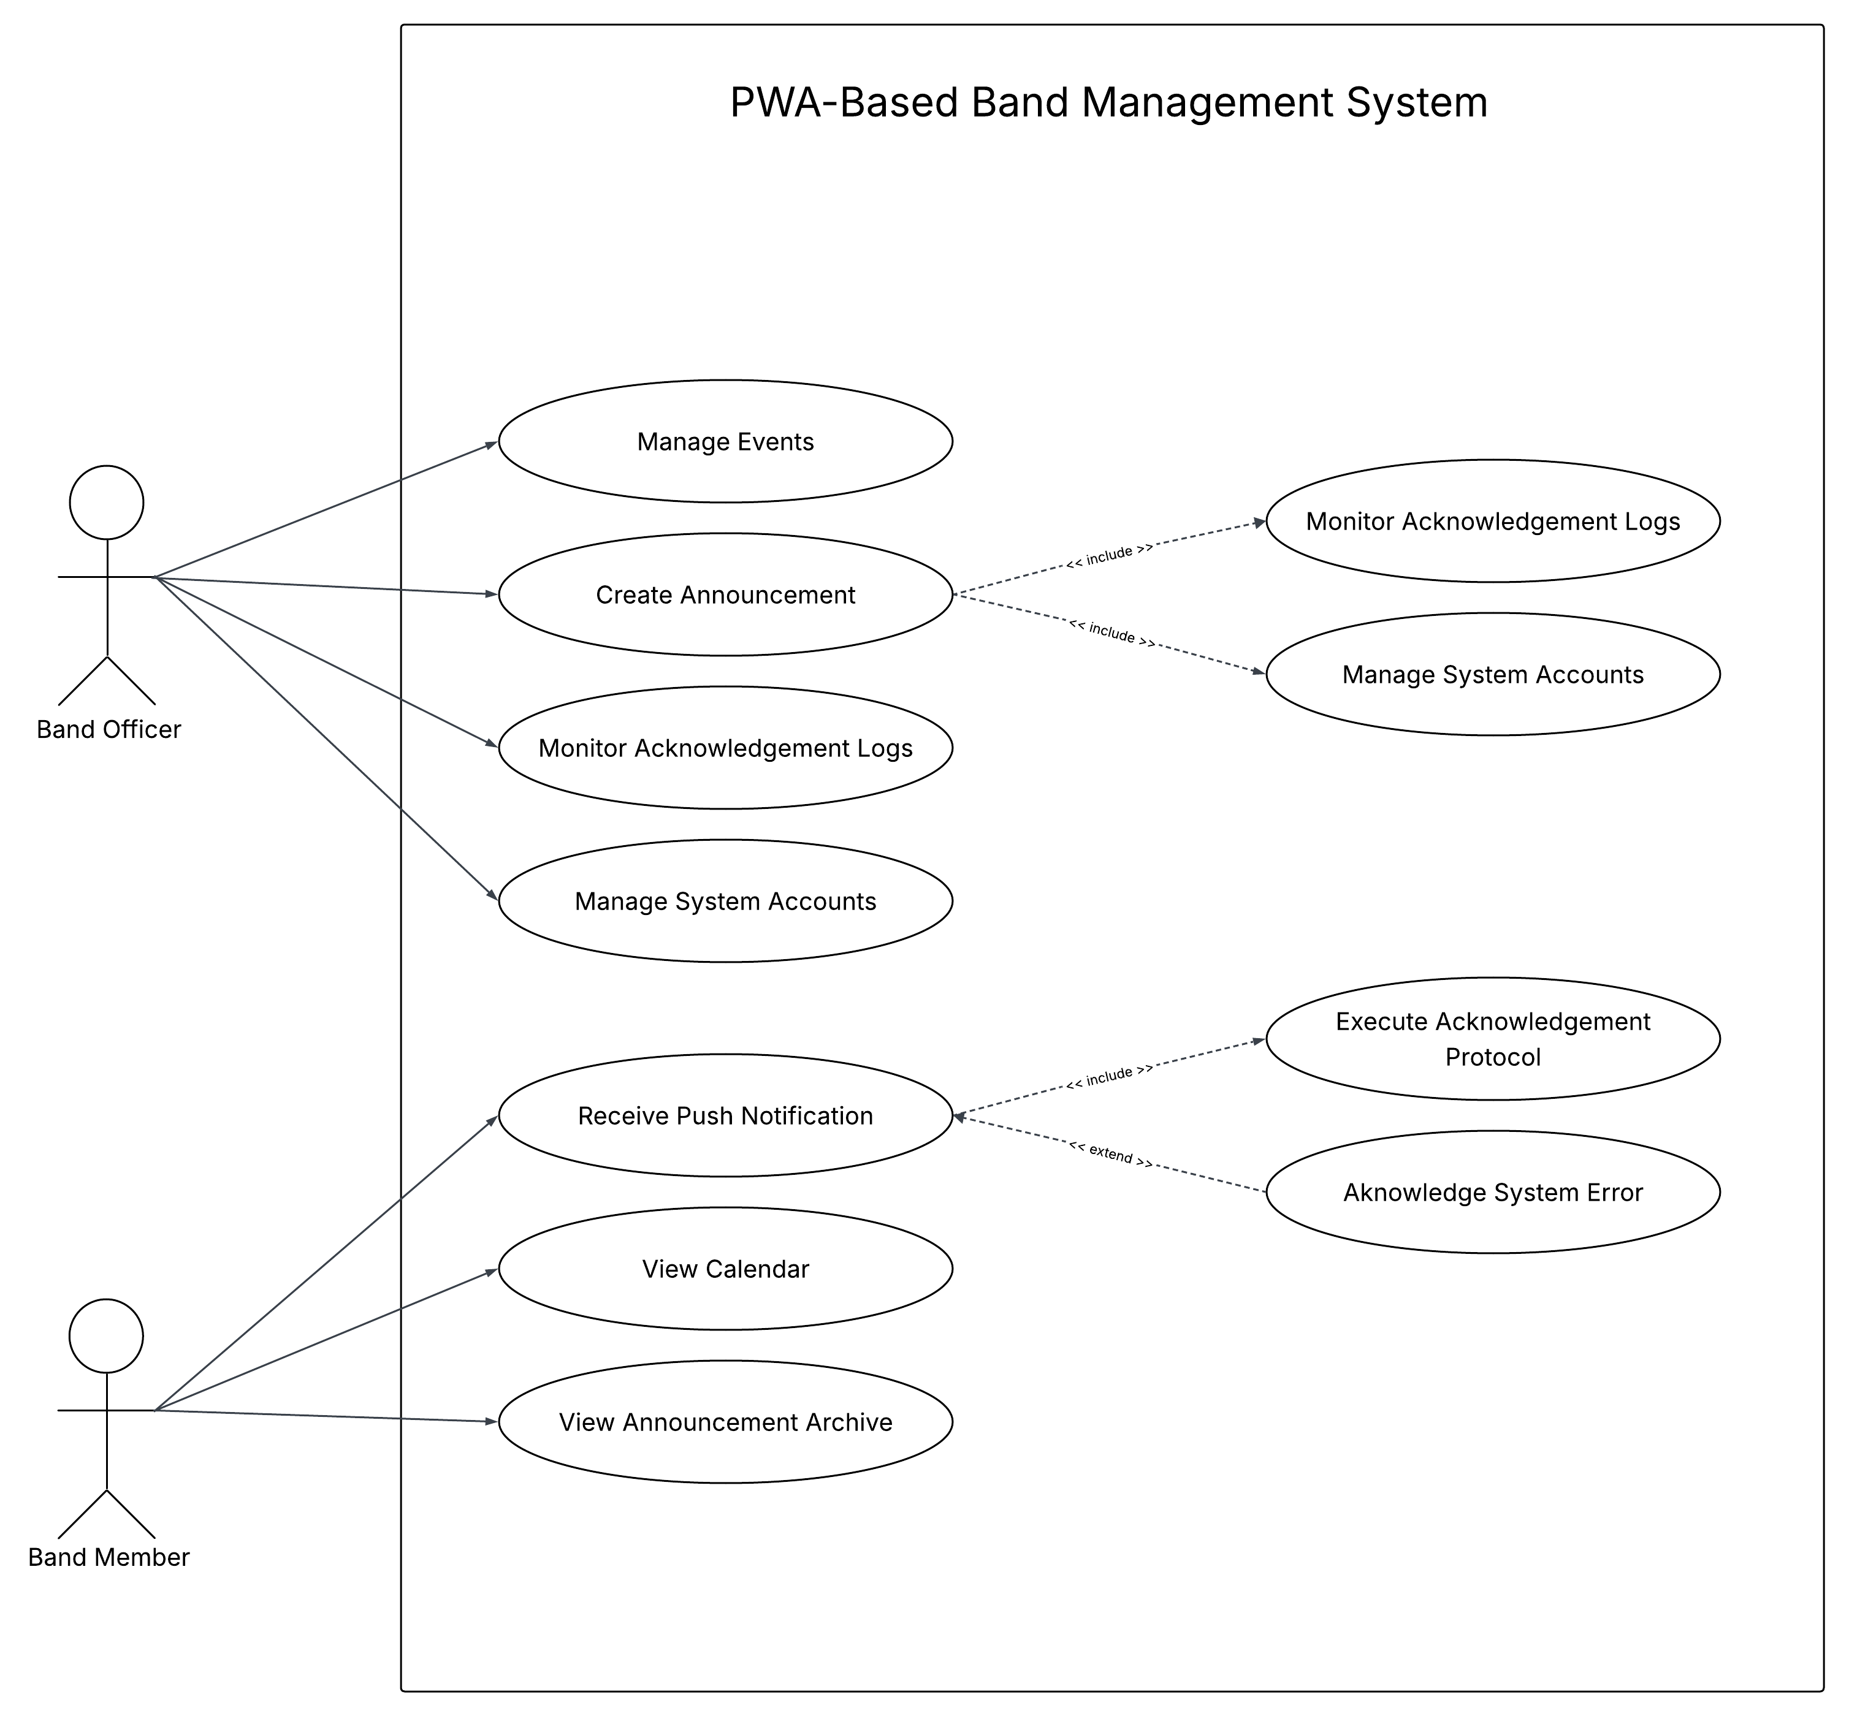

Appendix D
Proposed Data Flow Diagram
- Context Diagram

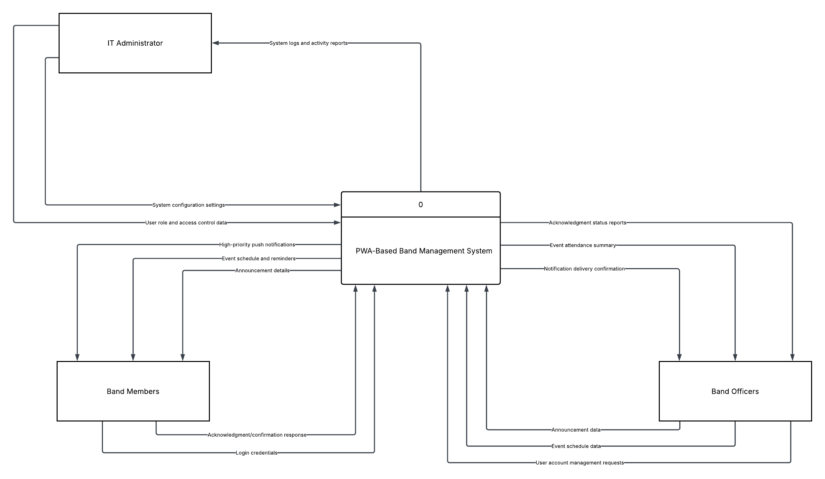

Appendix E
- Level 1

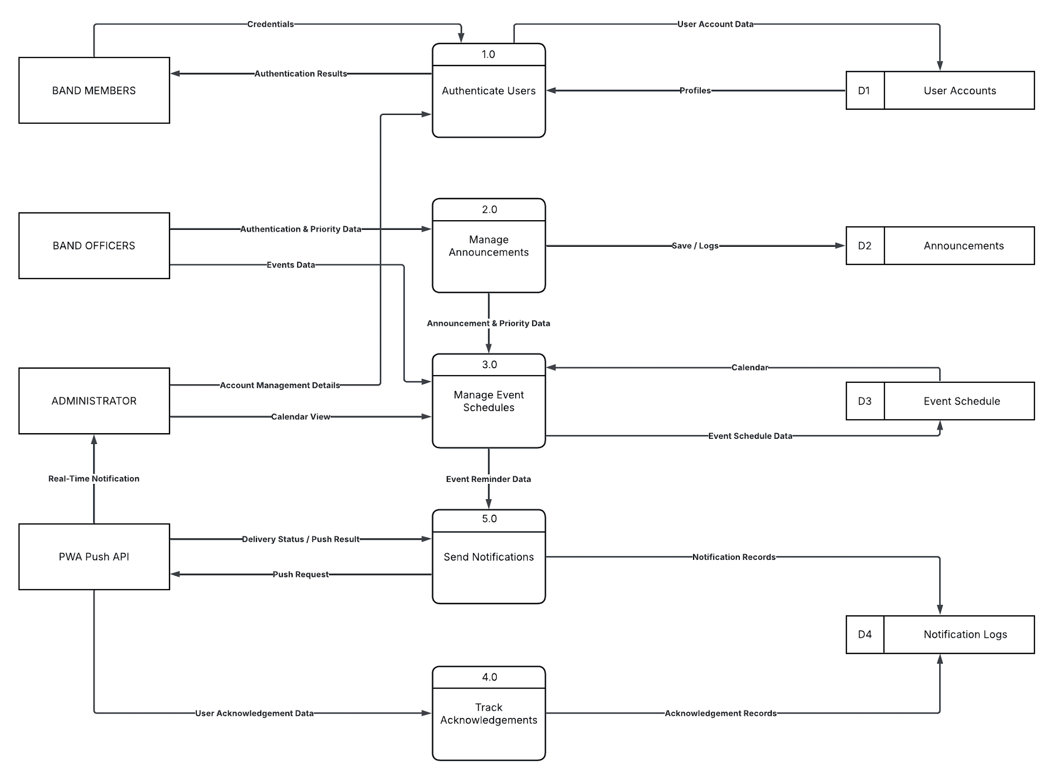

- Data Flow Diagram Level 2

DATA FLOW DIAGRAM LVL 2:
Authenticate Users 1.0

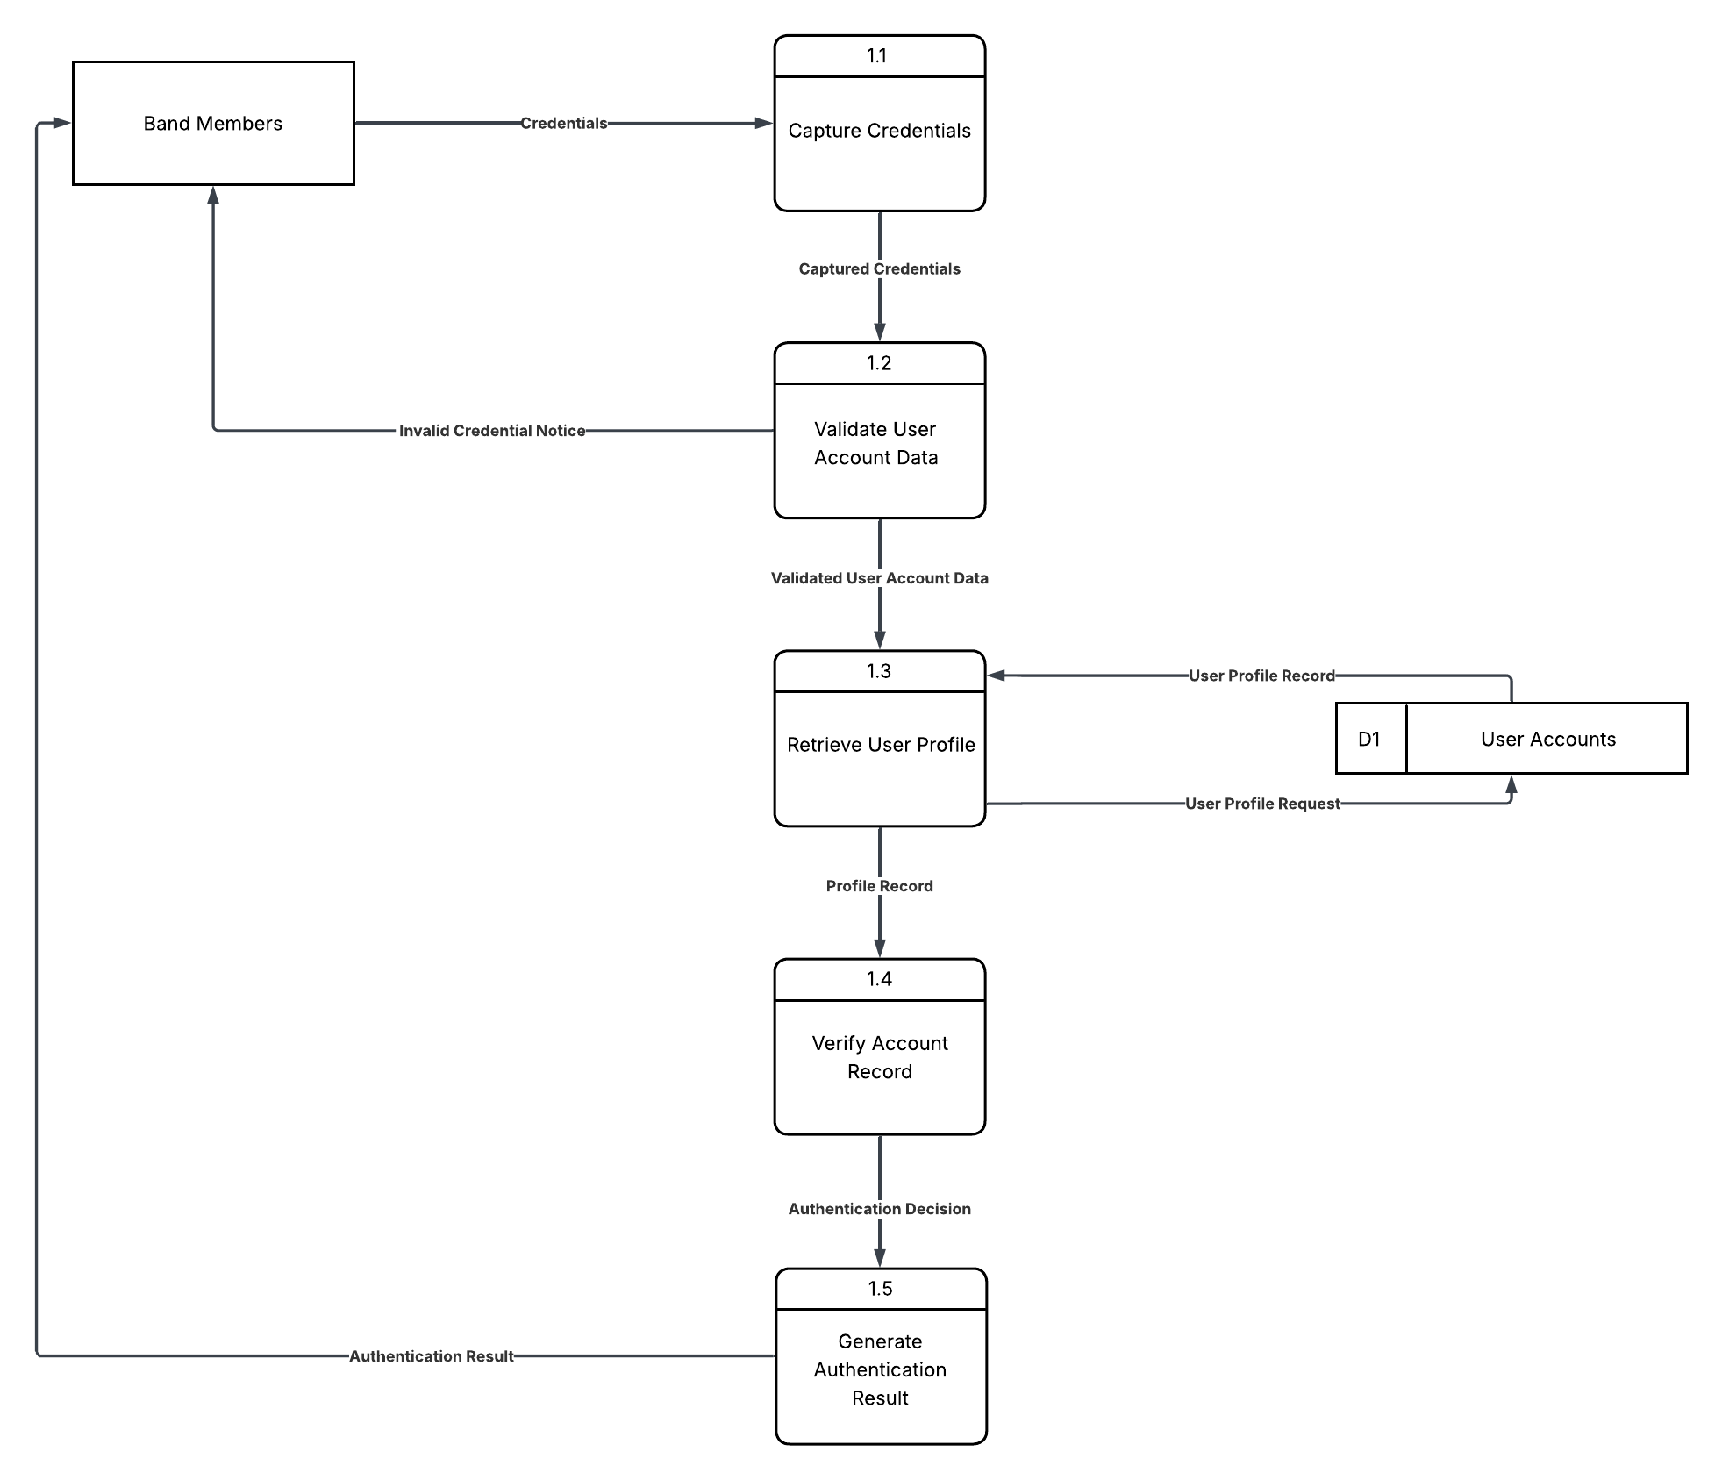

DATA FLOW DIAGRAM LVL 2:
Manage Announcements 2.0

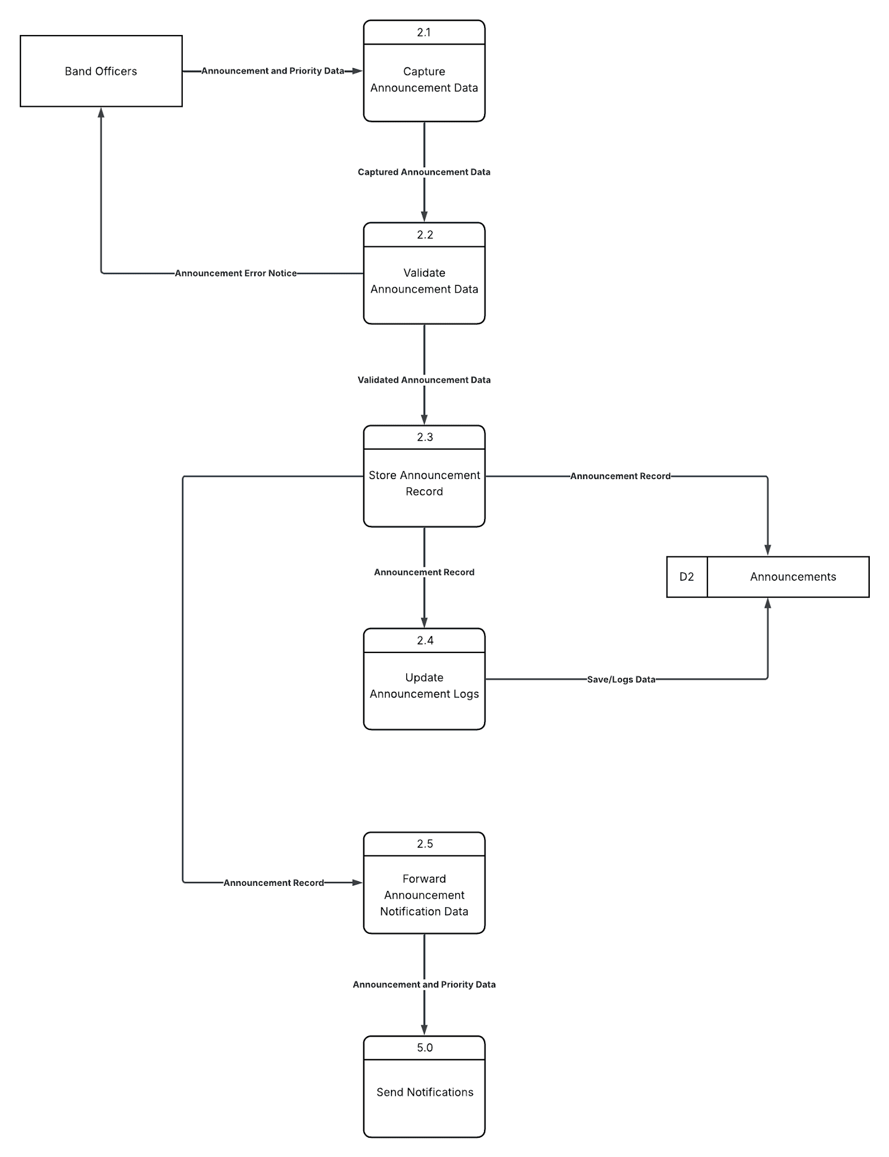

DATA FLOW DIAGRAM LVL 2:
Manage Event Schedules 3.0

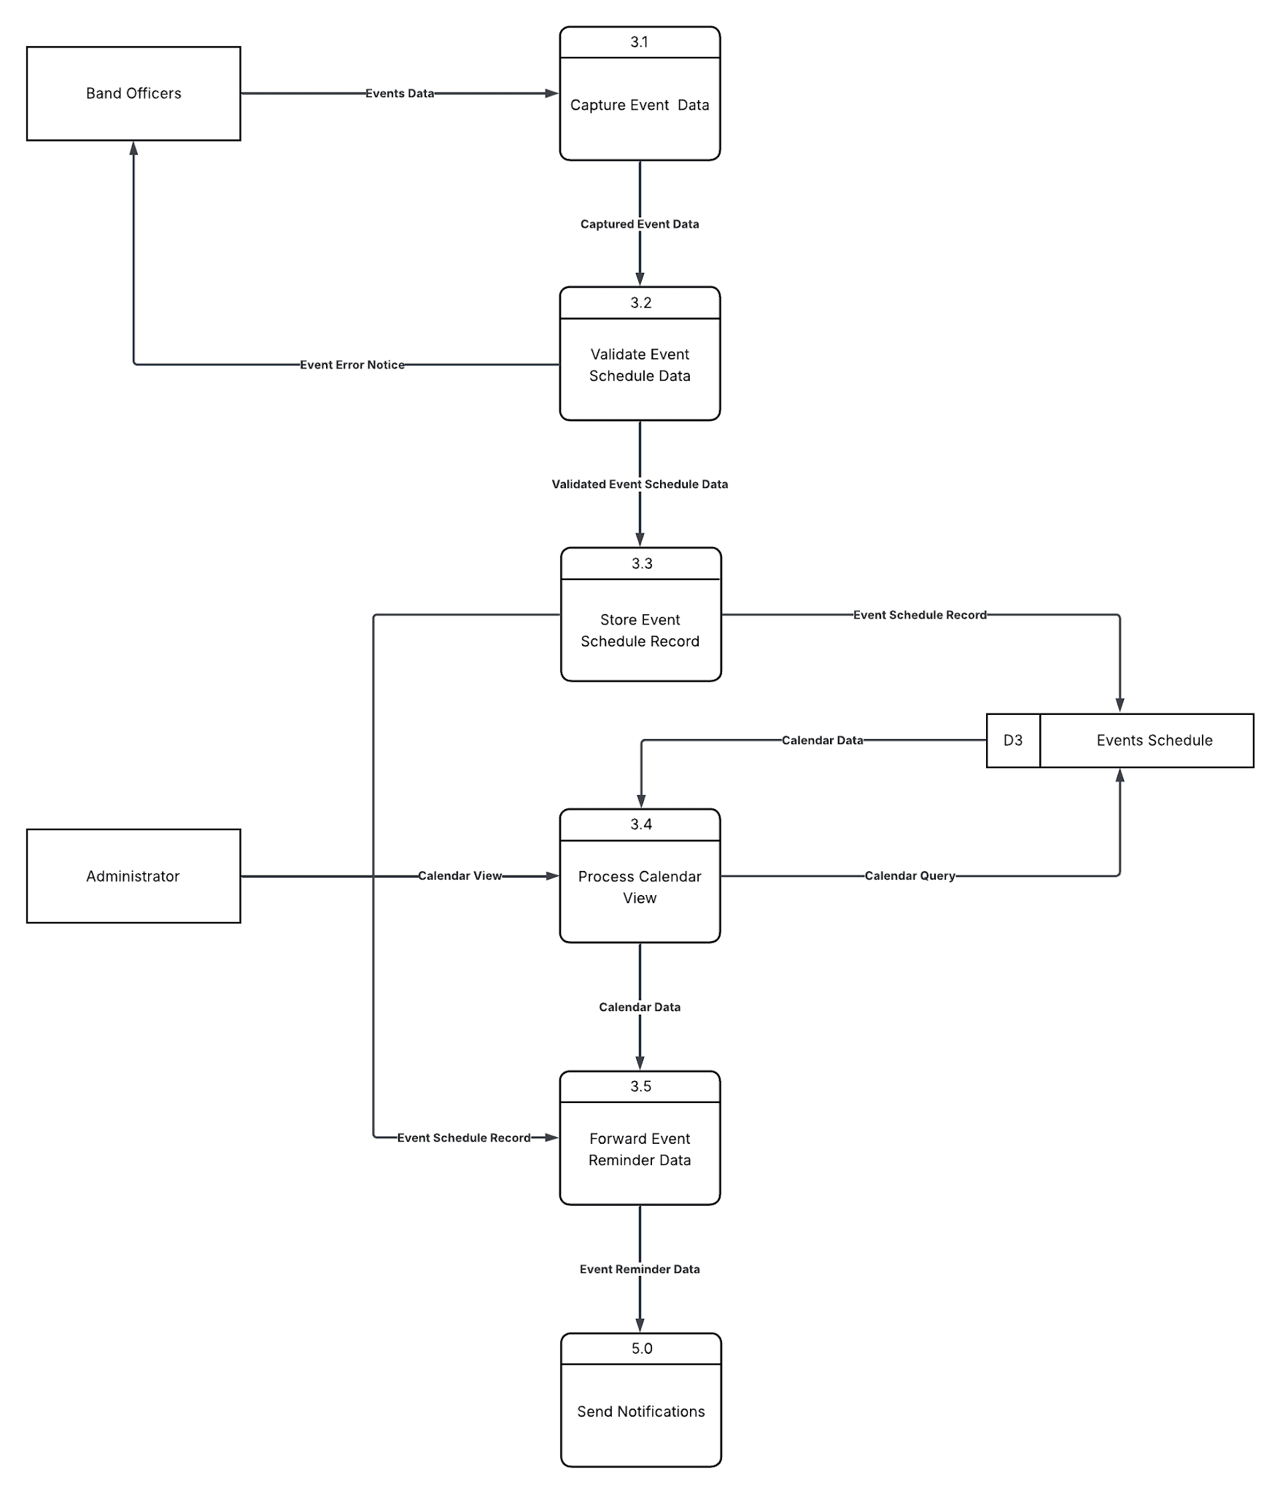

DATA FLOW DIAGRAM LVL 2:
Track Acknowledgements 4.0

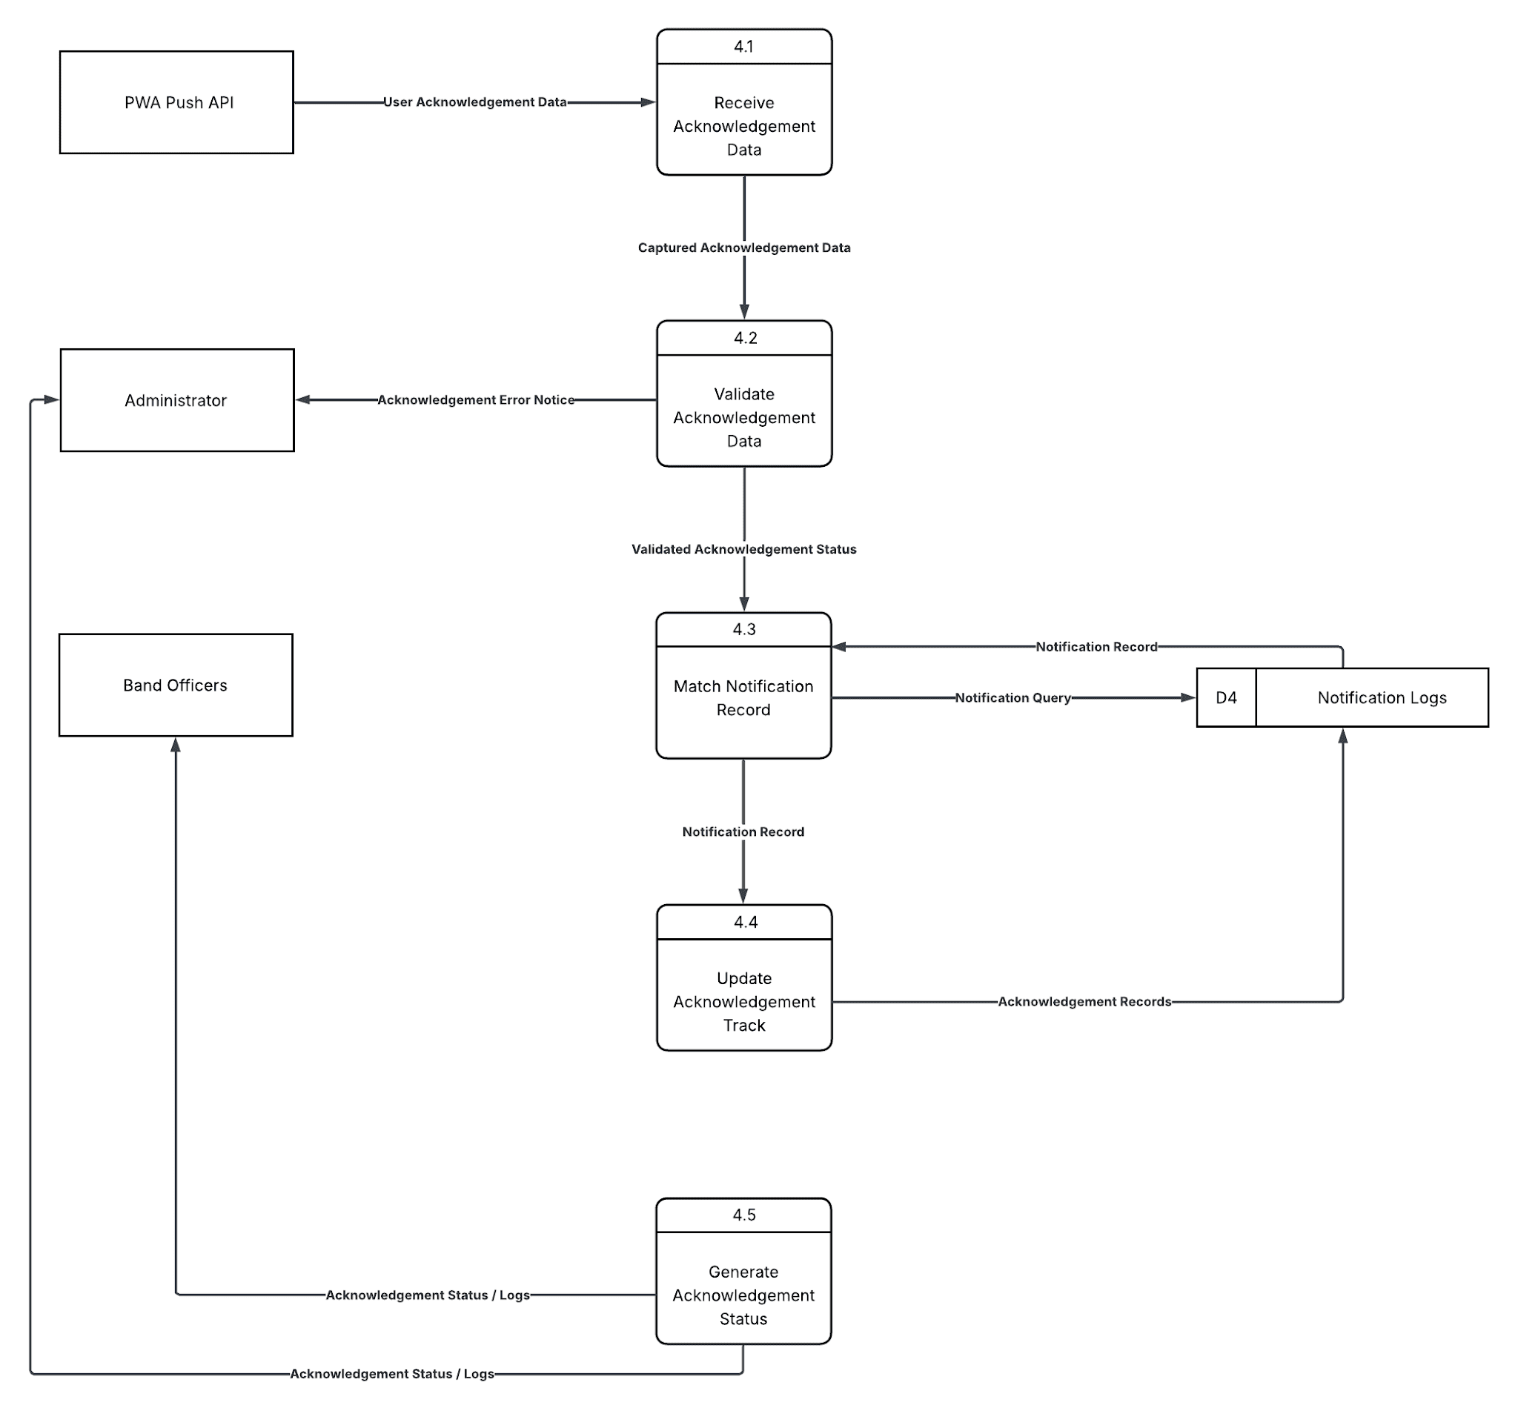

DATA FLOW DIAGRAM LVL 2:
Send Notifications 5.0
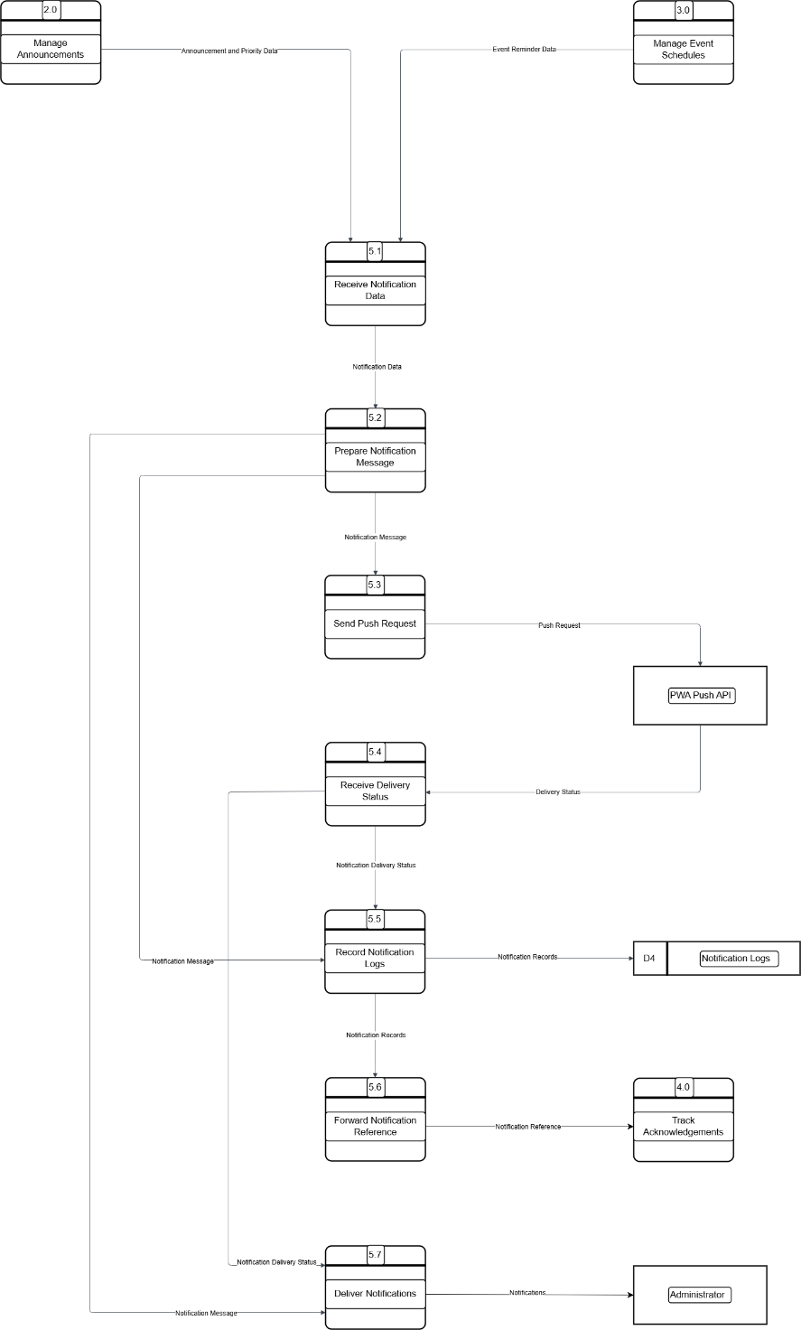
APPENDIX G
Class Diagram
